






Recruit and select staff
D1.HML.CL10.15
D1.HRM.CL9.10
D2.TRM.CL9.20
Trainer Guide

Recruit and select staff

D1.HML.CL10.15
D1.HRM.CL9.10
D2.TRM.CL9.20

Trainer Guide





Project Base
William Angliss Institute of TAFE
555 La Trobe Street
Melbourne 3000 Victoria
Telephone: | (03) 9606 2111
Facsimile: | (03) 9670 1330
Acknowledgements
Project Director: | Wayne Crosbie
Chief Writer: | Alan Hickman
Subject Writer: | Alan Hickman
Project Manager: | Alan Maguire
Editor: | Nick Hyland
DTP/Production | Daniel Chee, Mai Vu, Kaly Quach

The Association of Southeast Asian Nations (ASEAN) was established on 8 August 1967. The Member States of the Association are Brunei Darussalam, Cambodia, Indonesia, Lao PDR, Malaysia, Myanmar, Philippines, Singapore, Thailand and Viet Nam.
The ASEAN Secretariat is based in Jakarta, Indonesia.
General Information on ASEAN appears online at the ASEAN Website: www.asean.org.
All text is produced by William Angliss Institute of TAFE for the ASEAN Project on “Toolbox Development for Priority Tourism Labour Division”.
This publication is supported by the Australian Government’s aid program through the ASEAN-Australia Development Cooperation Program Phase II (AADCP II).
Copyright: Association of Southeast Asian Nations (ASEAN) 2012.
All rights reserved.
Disclaimer
Every effort has been made to ensure that this publication is free from errors or omissions. However, you should conduct your own enquiries and seek professional advice before relying on any fact, statement or matter contained in this book. The ASEAN Secretariat and William Angliss Institute of TAFE are not responsible for any injury, loss or damage as a result of material included or omitted from this course. Information in this module is current at the time of publication. Time of publication is indicated in the date stamp at the bottom of each page.
Some images appearing in this resource have been purchased from stock photography suppliers Shutterstock and iStockphoto and other third party copyright owners and as such are non-transferable and non-exclusive. Clip arts, font images and illustrations used are from the Microsoft Office Clip Art and Media Library. Some images have been provided by and are the property of William Angliss Institute.
Additional images have been sourced from Flickr and SXC and are used under Creative Commons licence: http://creativecommons.org/licenses/by/2.0/deed.en

File name: TG_Recruit_&_select_staff_refined.docx





Table of contents
Competency Based Training (CBT) and assessment an introduction for trainers 1
Competency standard 11
Notes and PowerPoint slides 21
Recommended training equipment 255
Instructions for Trainers for using PowerPoint – Presenter View 257
Appendix – ASEAN acronyms 259

Competency Based Training (CBT) and assessment an introduction for trainers

Competency
Competency refers to the ability to perform particular tasks and duties to the standard of performance expected in the workplace.
Competency requires the application of specified knowledge, skills and attitudes relevant to effective participation, consistently over time and in the workplace environment.
The essential skills and knowledge are either identified separately or combined.
Knowledge identifies what a person needs to know to perform the work in an informed and effective manner.
Skills describe the application of knowledge to situations where understanding is converted into a workplace outcome.
Attitude describes the founding reasons behind the need for certain knowledge or why skills are performed in a specified manner.
Competency covers all aspects of workplace performance and involves:
- Performing individual tasks
- Managing a range of different tasks
- Responding to contingencies or breakdowns
- Dealing with the responsibilities of the workplace
- Working with others.

Unit of Competency
Like with any training qualification or program, a range of subject topics are identified that focus on the ability in a certain work area, responsibility or function.
Each manual focuses on a specific unit of competency that applies in the hospitality workplace.
In this manual a unit of competency is identified as a ‘unit’.
Each unit of competency identifies a discrete workplace requirement and includes:
- Knowledge and skills that underpin competency
- Language, literacy and numeracy
- Occupational safety and health requirements.
Each unit of competency must be adhered to in training and assessment to ensure consistency of outcomes.

Element of Competency
An element of competency describes the essential outcomes within a unit of competency.
The elements of competency are the basic building blocks of the unit of competency. They describe in terms of outcomes the significant functions and tasks that make up the competency.
In this manual elements of competency are identified as an ‘element’.

Performance criteria
Performance criteria indicate the standard of performance that is required to demonstrate achievement within an element of competency. The standards reflect identified industry skill needs.
Performance criteria will be made up of certain specified skills, knowledge and attitudes.

Learning
For the purpose of this manual learning incorporates two key activities:
- Training
- Assessment.
Both of these activities will be discussed in detail in this introduction.
Today training and assessment can be delivered in a variety of ways. It may be provided to participants:
- On-the-job – in the workplace
- Off-the-job – at an educational institution or dedicated training environment
- As a combination of these two options.
No longer is it necessary for learners to be absent from the workplace for long periods of time in order to obtain recognised and accredited qualifications.

Learning Approaches
This manual will identify two avenues to facilitate learning:
Competency Based Training (CBT)
This is the strategy of developing a participant’s competency.
Educational institutions utilise a range of training strategies to ensure that participants are able to gain the knowledge and skills required for successful:
- Completion of the training program or qualification
- Implementation in the workplace.
The strategies selected should be chosen based on suitability and the learning styles of participants.

Competency Based Assessment (CBA)
This is the strategy of assessing competency of a participant.
Educational institutions utilise a range of assessment strategies to ensure that participants are assessed in a manner that demonstrates validity, fairness, reliability, flexibility and fairness of assessment processes.

Flexibility in Learning
It is important to note that flexibility in training and assessment strategies is required to meet the needs of participants who may have learning difficulties. The strategies used will vary, taking into account the needs of individual participants with learning difficulties. However they will be applied in a manner which does not discriminate against the participant or the participant body as a whole.
Catering for Participant Diversity
Participants have diverse backgrounds, needs and interests. When planning training and assessment activities to cater for individual differences, trainers and assessors should:
- Consider individuals’ experiences, learning styles and interests
- Develop questions and activities that are aimed at different levels of ability
- Modify the expectations for some participants
- Provide opportunities for a variety of forms of participation, such as individual, pair and small group activities
- Assess participants based on individual progress and outcomes.
The diversity among participants also provides a good reason for building up a learning community in which participants support each other’s learning.
Participant Centred Learning
This involves taking into account structuring training and assessment that:
- Builds on strengths – Training environments need to demonstrate the many positive features of local participants (such as the attribution of academic success to effort, and the social nature of achievement motivation) and of their trainers (such as a strong emphasis on subject disciplines and moral responsibility). These strengths and uniqueness of local participants and trainers should be acknowledged and treasured
- Acknowledges prior knowledge and experience – The learning activities should be planned with participants’ prior knowledge and experience in mind
- Understands learning objectives – Each learning activity should have clear learning objectives and participants should be informed of them at the outset. Trainers should also be clear about the purpose of assignments and explain their significance to participants
- Teaches for understanding – The pedagogies chosen should aim at enabling participants to act and think flexibly with what they know
- Teaches for independent learning – Generic skills and reflection should be nurtured through learning activities in appropriate contexts of the curriculum. Participants should be encouraged to take responsibility for their own learning
- Enhances motivation – Learning is most effective when participants are motivated. Various strategies should be used to arouse the interest of participants
- Makes effective use of resources – A variety of teaching resources can be employed as tools for learning
- Maximises engagement – In conducting learning activities, it is important for the minds of participants to be actively engaged
- Aligns assessment with learning and teaching – Feedback and assessment should be an integral part of learning and teaching
- Caters for learner diversity – Trainers should be aware that participants have different characteristics and strengths and try to nurture these rather than impose a standard set of expectations.
Active Learning
The goal of nurturing independent learning in participants does not imply that they always have to work in isolation or solely in a classroom. On the contrary, the construction of knowledge in tourism and hospitality studies can often best be carried out in collaboration with others in the field. Sharing experiences, insights and views on issues of common concern, and working together to collect information through conducting investigative studies in the field (active learning) can contribute a lot to their eventual success.
Active learning has an important part to play in fostering a sense of community in the class. First, to operate successfully, a learning community requires an ethos of acceptance and a sense of trust among participants, and between them and their trainers. Trainers can help to foster acceptance and trust through encouragement and personal example, and by allowing participants to take risks as they explore and articulate their views, however immature these may appear to be. Participants also come to realise that their classmates (and their trainers) are partners in learning and solving.
Trainers can also encourage cooperative learning by designing appropriate group learning tasks, which include, for example, collecting background information, conducting small-scale surveys, or producing media presentations on certain issues and themes. Participants need to be reminded that, while they should work towards successful completion of the field tasks, developing positive peer relationships in the process is an important objective of all group work.

Competency Based Training (CBT)
Principle of Competency Based Training
Competency based training is aimed at developing the knowledge, skills and attitudes of participants, through a variety of training tools.
Training Strategies
The aims of this curriculum are to enable participants to:
- Undertake a variety of subject courses that are relevant to industry in the current environment
- Learn current industry skills, information and trends relevant to industry
- Learn through a range of practical and theoretical approaches
- Be able to identify, explore and solve issues in a productive manner
- Be able to become confident, equipped and flexible managers of the future
- Be ‘job ready’ and a valuable employee in the industry upon graduation of any qualification level.
To ensure participants are able to gain the knowledge and skills required to meet competency in each unit of competency in the qualification, a range of training delivery modes are used.
Types of Training
In choosing learning and teaching strategies, trainers should take into account the practical, complex and multi-disciplinary nature of the subject area, as well as their participant’s prior knowledge, learning styles and abilities.
Training outcomes can be attained by utilising one or more delivery methods:
Lecture/Tutorial
This is a common method of training involving transfer of information from the trainer to the participants. It is an effective approach to introduce new concepts or information to the learners and also to build upon the existing knowledge. The listener is expected to reflect on the subject and seek clarifications on the doubts.
Demonstration
Demonstration is a very effective training method that involves a trainer showing a participant how to perform a task or activity. Through a visual demonstration, trainers may also explain reasoning behind certain actions or provide supplementary information to help facilitate understanding.
Group Discussions
Brainstorming in which all the members in a group express their ideas, views and opinions on a given topic, is a free flow and exchange of knowledge among the participants and the trainer. The discussion is carried out by the group on the basis of their own experience, perceptions and values. This will facilitate acquiring new knowledge. When everybody is expected to participate in the group discussion, even the introverted persons will also get stimulated and try to articulate their feelings.
The ideas that emerge in the discussions should be noted down and presentations are to be made by the groups. Sometimes consensus needs to be arrived at on a given topic. Group discussions are to be held under the moderation of a leader guided by the trainer. Group discussion technique triggers thinking process, encourages interactions and enhances communication skills.
Role Play
This is a common and very effective method of bringing into the classroom real life situations, which may not otherwise be possible. Participants are made to enact a particular role so as to give a real feel of the roles they may be called upon to play. This enables participants to understand the behaviour of others as well as their own emotions and feelings. The instructor must brief the role players on what is expected of them. The role player may either be given a ready-made script, which they can memorise and enact, or they may be required to develop their own scripts around a given situation. This technique is extremely useful in understanding creative selling techniques and human relations. It can be entertaining and energising and it helps the reserved and less literate to express their feelings.

Simulation Games
When trainees need to become aware of something that they have not been conscious of, simulations can be a useful mechanism. Simulation games are a method based on "here and now" experience shared by all the participants. The games focus on the participation of the trainees and their willingness to share their ideas with others. A "near real life" situation is created providing an opportunity to which they apply themselves by adopting certain behaviour. They then experience the impact of their behaviour on the situation. It is carried out to generate responses and reactions based on the real feelings of the participants, which are subsequently analysed by the trainer.
While use of simulation games can result in very effective learning, it needs considerable trainer competence to analyse the situations.
Individual /Group Exercises
Exercises are often introduced to find out how much the participant has assimilated. This method involves imparting instructions to participants on a particular subject through use of written exercises. In the group exercises, the entire class is divided into small groups, and members are asked to collaborate to arrive at a consensus or solution to a problem.
Case Study
This is a training method that enables the trainer and the participant to experience a real life situation. It may be on account of events in the past or situations in the present, in which there may be one or more problems to be solved and decisions to be taken. The basic objective of a case study is to help participants diagnose, analyse and/or solve a particular problem and to make them internalise the critical inputs delivered in the training. Questions are generally given at the end of the case study to direct the participants and to stimulate their thinking towards possible solutions. Studies may be presented in written or verbal form.
Field Visit
This involves a carefully planned visit or tour to a place of learning or interest. The idea is to give first-hand knowledge by personal observation of field situations, and to relate theory with practice. The emphasis is on observing, exploring, asking questions and understanding. The trainer should remember to brief the participants about what they should observe and about the customs and norms that need to be respected.
Group Presentation
The participants are asked to work in groups and produce the results and findings of their group work to the members of another sub-group. By this method participants get a good picture of each other's views and perceptions on the topic and they are able to compare them with their own point of view. The pooling and sharing of findings enriches the discussion and learning process.
Practice Sessions
This method is of paramount importance for skills training. Participants are provided with an opportunity to practice in a controlled situation what they have learnt. It could be real life or through a make-believe situation.

Games
This is a group process and includes those methods that involve usually fun-based activity, aimed at conveying feelings and experiences, which are everyday in nature, and applying them within the game being played. A game has set rules and regulations, and may or may not include a competitive element. After the game is played, it is essential that the participants be debriefed and their lessons and experiences consolidated by the trainer.
Research
Trainers may require learners to undertake research activities, including online research, to gather information or further understanding about a specific subject area.

Competency Based Assessment (CBA)
Principle of Competency Based Assessment
Competency based assessment is aimed at compiling a list of evidence that shows that a person is competent in a particular unit of competency.
Competencies are gained through a multitude of ways including:
- Training and development programs
- Formal education
- Life experience
- Apprenticeships
- On-the-job experience
- Self-help programs.
All of these together contribute to job competence in a person. Ultimately, assessors and participants work together, through the ‘collection of evidence’ in determining overall competence.
This evidence can be collected:
- Using different formats
- Using different people
- Collected over a period of time.
The assessor, who is ideally someone with considerable experience in the area being assessed, reviews the evidence and verifies the person as being competent or not.
Flexibility in Assessment
Whilst allocated assessment tools have been identified for this subject, all attempts are made to determine competency and suitable alternate assessment tools may be used, according to the requirements of the participant.
The assessment needs to be equitable for all participants, taking into account their cultural and linguistic needs.
Competency must be proven regardless of:
- Language
- Delivery Method
- Assessment Method.
Assessment Objectives
The assessment tools used for subjects are designed to determine competency against the ‘elements of competency’ and their associated ‘performance criteria’.
The assessment tools are used to identify sufficient:
- Knowledge, including underpinning knowledge
- Skills
- Attitudes
Assessment tools are activities that trainees are required to undertake to prove participant competency in this subject.
All assessments must be completed satisfactorily for participants to obtain competence in this subject. There are no exceptions to this requirement, however, it is possible that in some cases several assessment items may be combined and assessed together.
Types of Assessment
Allocated Assessment Tools
There are a number of assessment tools that are used to determine competency in this subject:
- Work projects
- Written questions
- Oral questions
- Third Party Report
- Observation Checklist.
Instructions on how assessors should conduct these assessment methods are explained in the Assessment Manuals.
Alternative Assessment Tools
Whilst this subject has identified assessment tools, as indicated above, this does not restrict the assessor from using different assessment methods to measure the competency of a participant.
Evidence is simply proof that the assessor gathers to show participants can actually do what they are required to do.
Whilst there is a distinct requirement for participants to demonstrate competency, there are many and diverse sources of evidence available to the assessor.
Ongoing performance at work, as verified by a supervisor or physical evidence, can count towards assessment. Additionally, the assessor can talk to customers or work colleagues to gather evidence about performance.
A range of assessment methods to assess competency include:
- Practical demonstrations
- Practical demonstrations in simulated work conditions
- Problem solving
- Portfolios of evidence
- Critical incident reports
- Journals
- Oral presentations
- Interviews
- Videos
- Visuals: slides, audio tapes
- Case studies
- Log books
- Projects
- Role plays
- Group projects
- Group discussions
- Examinations.
Recognition of Prior Learning
Recognition of Prior Learning is the process that gives current industry professionals who do not have a formal qualification, the opportunity to benchmark their extensive skills and experience against the standards set out in each unit of competency/subject.
Also known as a Skills Recognition Audit (SRA), this process is a learning and assessment pathway which encompasses:
- Recognition of Current Competencies (RCC)
- Skills auditing
- Gap analysis and training
- Credit transfer.
Assessing competency
As mentioned, assessment is the process of identifying a participant’s current knowledge, skills and attitudes sets against all elements of competency within a unit of competency. Traditionally in education, grades or marks were given to participants, dependent on how many questions the participant successfully answered in an assessment tool.
Competency based assessment does not award grades, but simply identifies if the participant has the knowledge, skills and attitudes to undertake the required task to the specified standard.
Therefore, when assessing competency, an assessor has two possible results that can be awarded:
- Pass Competent (PC)
- Not Yet Competent (NYC).
Pass Competent (PC)
If the participant is able to successfully answer or demonstrate what is required, to the expected standards of the performance criteria, they will be deemed as ‘Pass Competent’ (PC).
The assessor will award a ‘Pass Competent’ (PC) if they feel the participant has the necessary knowledge, skills and attitudes in all assessment tasks for a unit.
Not Yet Competent’ (NYC)
If the participant is unable to answer or demonstrate competency to the desired standard, they will be deemed to be ‘Not Yet Competent’ (NYC).
This does not mean the participant will need to complete all the assessment tasks again. The focus will be on the specific assessment tasks that were not performed to the expected standards.
The participant may be required to:
a) Undertake further training or instruction
b) Undertake the assessment task again until they are deemed to be ‘Pass Competent’.

Competency standard
UNIT TITLE: RECRUIT AND SELECT STAFF |  |  |  | NOMINAL HOURS: | 65
UNIT NUMBER: D1.HML.CL10.15 D1.HRM.CL9.10 D2.TRM.CL9.20
UNIT DESCRIPTOR: This unit deals with skills and knowledge required to enable a supervisor to identify future staffing needs and take appropriate action to employ workers to meet these human resource needs including implementation of induction and orientation programs.
ELEMENTS AND PERFORMANCE CRITERIA | UNIT VARIABLE AND ASSESSMENT GUIDE
Element 1: Identify staffing needs  - Obtain and read enterprise policies and procedures in relation to the staffing process  - Identify internal factors that impact on staffing needs  - Identify external factors that impact on staffing needs  - Describe techniques to monitor workplace performance  - Consult with stakeholders to determine staffing needs  - Describe and quantify staffing requirements by position and locate them within an organisational chart  - Undertake a job analysis of each identified position  - Prepare job specifications and job descriptions for identified positions | Unit Variables  The Unit Variables provide advice to interpret the scope and context of this unit of competence, allowing for differences between enterprises and workplaces. It relates to the unit as a whole and facilitates holistic assessment  This unit applies to organizations that are involved in recruiting and selecting staff to work within the labour divisions of the hotel and travel industries and may include:  1. Front Office  2. Housekeeping  3. Food and Beverage Service  4. Food Production  5. Travel Agencies  6. Tour Operation  Enterprise policies and procedures in relation to the staffing process may include:  Details of information that may and may not be used in a job advertisement
Element 2: Recruit staff  - Identify and quantify positions to be advertised  - Develop key selection criteria for each position to be advertised  - Obtain authority to recruit staff  - Identify sources of staff  - Develop and lodge job advertisements/notices with identified sources of staff  Element 3: Interview staff  - Accept job applications  - Short-list applicants  - Check references and referees  - Notify applicant of interview  - Conduct job interview  - Apply relevant testing procedures  - File application and interview documentation | Staff promotion policies, especially internal promotions  Staff training  Remuneration  Probationary periods  Terms and conditions of employment  Benefits  Every individual staff policy, such as uniform, personal presentation, smoking, tact and diplomacy, sickness, attendance and punctuality, use of company property  Composition of interview and selection panels  Designated authorities for hiring staff  Discretionary power in relation to negotiating staff conditions and remuneration  Industrial relations, equal opportunity and diversity legislation.  Internal factors that impact on staffing needs may include:  Budget  Level, number and competency levels of current staff
Element 4: Select staff  - Choose successful applicant/s using pre-defined criteria  - Notify successful applicants and make formal job offer  - Notify unsuccessful applicants  - Follow-up as required | Service standards, opening hours, volume of customers, peak demands, nature and type of customers  Direction of business and established business reputation  Type of service being offered and equipment being used  Promises made to customers by the enterprise  Anticipated or unpredictable staff turnover.
Element 5: Implement induction and orientation session or program  - Plan the induction and orientation session/s  - Conduct the induction and orientation session/s  - Review the induction and orientation session/s | External factors that impact on staffing needs may include:  The external business, economic and competitive environment  Activities being undertaken by competitors  Customer expectations  Emerging trends  Changes in legislation and technology  Availability of appropriately qualified staff to recruit across all identified staffing positions.  Techniques to monitor workplace performance may include:  Statistical analysis of labour and revenue figures  Quantitative and qualitative research and analysis  Internal and external research/benchmarking  Consideration of different formal and informal research methods including customer-focused research/feedback.  Stakeholders may include:  Owners  Boards of directors  Shareholders  Senior management, including Head Office  Supervisors  Staff  Customers  Suppliers.
Staffing requirements may include:
Preparation of an organization chart showing every position within the host enterprise
Allocation of a title to every position on the organization chart.
Job analysis refers to:
The function of gathering all the relevant facts, details and information about a job.
Job specification refers o:
All the information about the type of employee needed to do a particular job effectively
The job description refers to:
All the information about the job itself.
Key selection criteria may relate to:
Experience
Competencies
Qualifications
Compatibility.
Sources of staff may include:
Media advertisements
Job and recruitment agencies
Internet
Internal advertising including internal promotions
Schools and trade colleges
Industry network contacts
Other employers.
Job advertisements/notices may relate to:
Production of media advertisements
Providing information to job agencies
Compliance with legislation regarding the advertising for staff.
Short-list applicants refers to:
Development of a list of applicants who will proceed through to the interview stage of the selection process.
Check references and referees refers to:
Reading written references submitted as part of the application
Verifying written references
Validating the claims made at interview by the job applicant by contacting people and organizations for whom they have previously worked that are listed in their application.
Job interview may include:
One-on-one and face-to-face interviews
Panel interviews
Group interviews
Over-the-phone interviews
First, second and/or third interviews
Applying appropriate questioning and listening techniques
Recording answers supplied by applicants
Responding to applicant questions
Equity and compliance issues
Devising questions to be asked of all applicants.
Testing procedures may relate to:
Trade or technical tests to determine competency
Psychometric testing and/or profiling
Medical examinations
Drug and alcohol tests.
Choose successful applicant/s may relate to:
Rating applicants against selection criteria
Obtaining feedback and consensus from all interviewers
Considering test results
Ranking interviewees.
Follow up successful applicants may relate to:
Obtaining original copies of documents presented at interviews
Explaining details of the job offer, contract or employment instrument
Confirming acceptance of the job offer
Offering the job to another applicant if the first choice refuses the offer.
Plan the induction may relate to:
Identifying the topics to be covered which may include:
- Completion of necessary paperwork
- Provision of ‘need to know’ information
- Tour of premises/department
- Meeting with management and introduction to staff
- Allocation of uniform and badges
- Detailed work role induction including explanation of relevant policies and procedures, company expectations, job descriptions, roster, individual and shared responsibilities and supervision
- Explanation of enterprise aims, directions, plans and objectives
- Explanation of key performance indicators (KPIS)
- Explanation of occupational safety and health (OSH) issues
- Explanation of enterprise benefits and ‘reward and recognition’ schemes
- Provision of practical demonstration/training to enable required service delivery
- Culture of the organization
- Communication channels
Sequencing the content of the induction
Allocating time and resources to the induction
Arranging for the necessary other staff and personnel to be present at induction
Minimizing operational disruption
Optimizing effectiveness.
Assessment Guide
The following skills and knowledge must be assessed as part of this unit:
The enterprise’s policies and procedures in regard to staff recruitment, selection and inductions
Knowledge of the industrial relations and equal opportunity of the host country
Ability to draft job advertisements and liaise with employment agencies and the media
Interviewing, negotiation, communication and inter-personal skills
Knowledge of the operational aspects of the areas for which staff are being recruited and selected
Knowledge of industrial relations, equal opportunity and other employment-related legislation of the host country.
Linkages To Other Units
Develop and implement a business plan
Maintain a paper-based filing and retrieval system
Develop and implement operational procedures
Develop and supervise operational approaches
Establish and maintain a safe working environment
Manage the effective use of human resources
Monitor staff performance
Roster staff
Manage workplace diversity
Manage and maintain effective workplace relations.
Critical Aspects of Assessment
Evidence of the following is essential:
Demonstrated ability to identify staffing needs for a designated venue/department given certain trading and other conditions and limitations
Demonstrated ability to draft a print media advertisement for a nominated job
Demonstrated ability to prepare a job description, a job specification and a set of key selection criteria for a nominated work position
Demonstrated ability to short-list a set number of written job applications by assessing the suitability of the applicant’s qualifications and experience against the designated key selection criteria
Demonstrated ability to interview a set number of applicants for a given job and evaluate their suitability for the position using designated key selection criteria
Demonstrated ability to explain and effectively defend the rationale for selecting the successful applicant
Demonstrated ability to make a formal job offer to a successful job applicant
Demonstrated ability to organize, conduct and review an orientation and induction program for a new employee for a designated job position.
Context of Assessment
Assessment must ensure:
Actual or simulated workplace conditions on which to base the preparation/recruitment activities, and a realistic workplace context in which to conduct the job interview.
Resource Implications
Training and assessment must include the use of appropriate industry sector terminology, employment terms, pay rates, terms and conditions of employment and reference to all legislation as applicable to the relevant industry sector of the host country in actual or simulated workplace conditions; and access to workplace standards, procedures, policies, guidelines, tools and equipment.
Assessment Methods
The following methods may be used to assess competency for this unit:
Observation of practical candidate performance
Role plays
Case studies
Oral and written questions
Third party reports completed by a supervisor
Project and assignment work
Simulations.
Key Competencies in this Unit
Level 1 = competence to undertake tasks effectively
Level 2 = competence to manage tasks
Level 3 = competence to use concepts for evaluating
 | Key Competencies | Level | Examples
 | Collecting, organizing and analysing information | 2 | Gather information to use as the basis of job descriptions, specifications and analyses; read, digest and rank job applications
 | Communicating ideas and information | 2 | Interview applicants; develop job-related documents in conjunction with others; operate as a member of a panel interview
 | Planning and organizing activities | 2 | Arrange and schedule interviews and inductions
 | Working with others and in teams | 2 | Cooperate with others in development of job-related documentation, interviews and inductions
 | Using mathematical ideas and techniques | 2 | Statistical analysis of labour and revenue figures; quantitative research
 | Solving problems | 1 | Conduct and follow-up on reference checks; deal with situations where successful applicant rejects job offer
 | Using technology | 1 | Enter data into in-house systems

Notes and PowerPoint slides
Slide

Slide No | Trainer Notes
 | Trainer welcomes trainees to class.

Slide
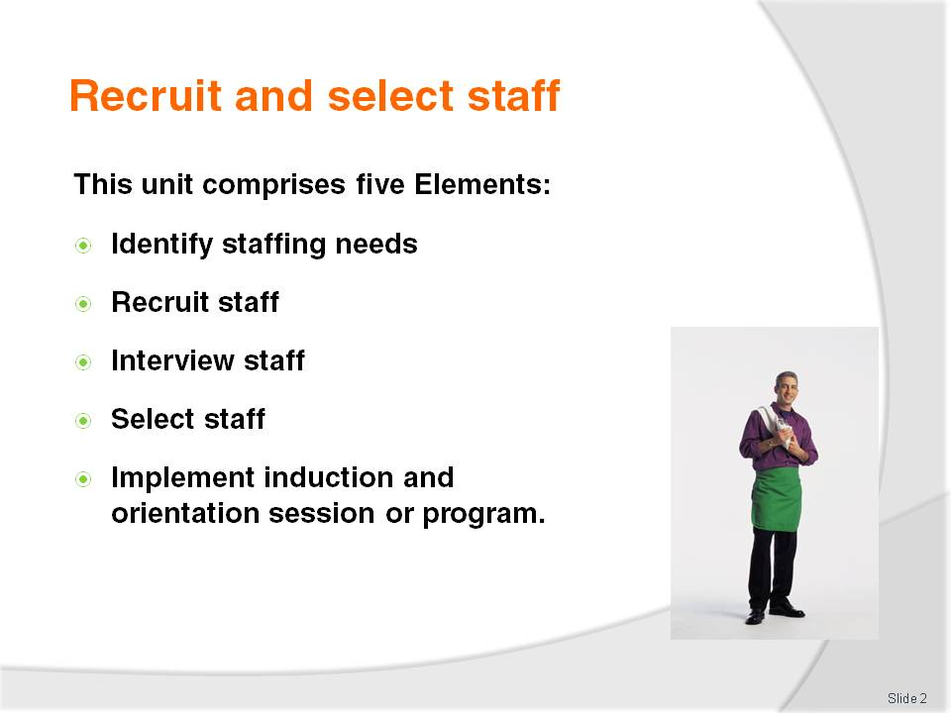
Slide No | Trainer Notes
Trainer advises trainees this Unit comprises five Elements, as listed on the slide explaining:
Each Element comprises a number of Performance Criteria which will be identified throughout the class and explained in detail
Trainees can obtain more detail from their Trainee Manual
At times the course presents advice and information about various protocols. Where their workplace requirements differ to what is presented, the workplace practices and standards, as well as policies and procedures must be observed.

Slide
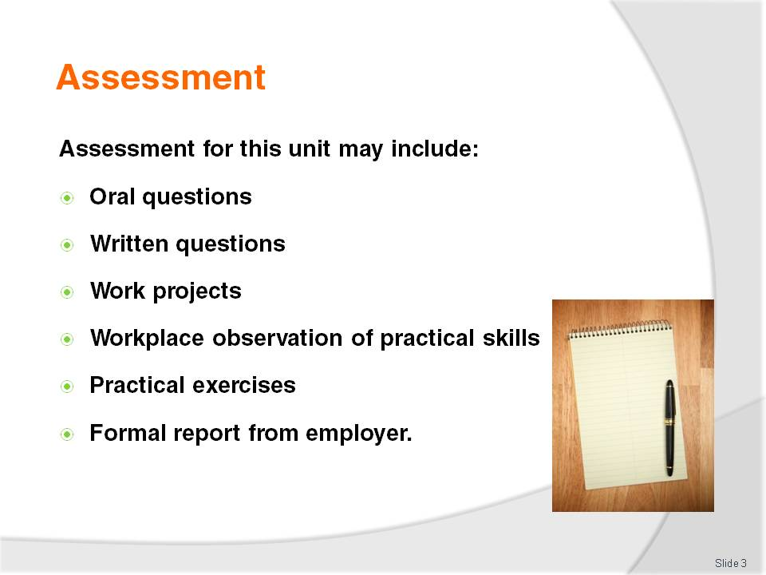
Slide No | Trainer Notes
Trainer advises trainees that assessment for this Unit may take several forms. All are aimed at verifying they have achieved competency for the Unit as required.
Trainer indicates to trainees the methods of assessment that will be applied to them for this Unit.

Slide
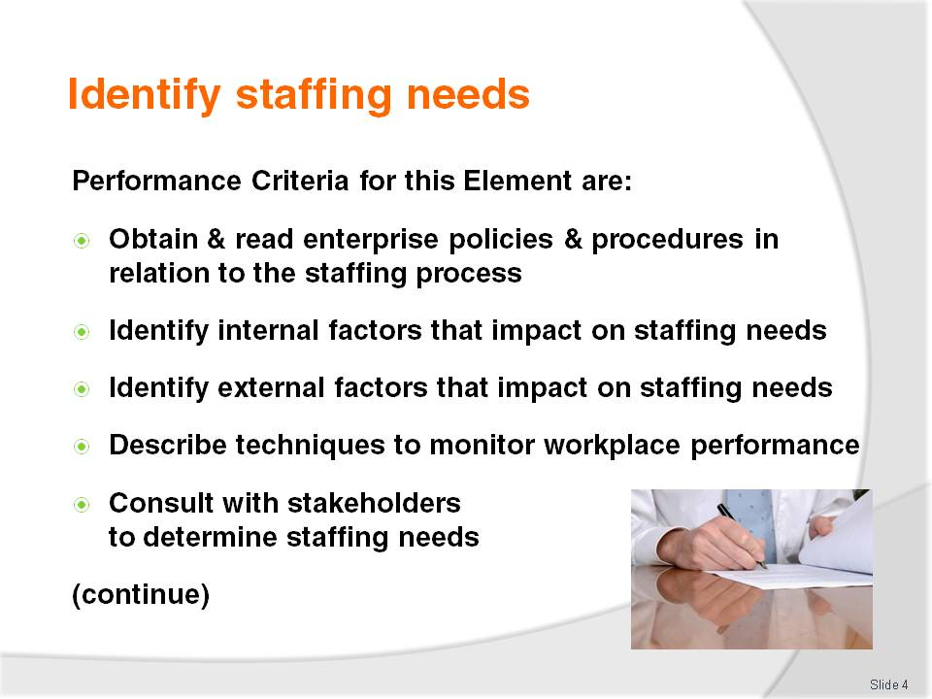
Slide No | Trainer Notes
 | Trainer identifies for trainees the Performance Criteria for this Element, as listed on the slide.

Slide
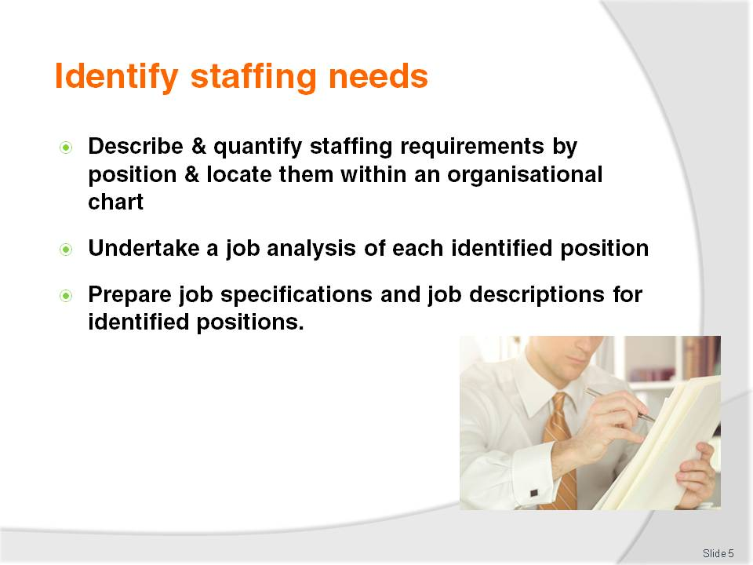
Slide No | Trainer Notes
Trainer continues to identify for trainees the Performance Criteria for this Element, as listed on the slide.
Class Activity – General Discussion
Trainer leads a general class discussion on identifying staffing needs by asking questions such as:
What policies and procedures do you think apply in workplaces to the staffing process?
What do you think is ‘the staffing process?
What internal factors within businesses might impact on staffing needs?
What factors outside a business might affect staffing requirements?
What experience do you have with workplace monitoring of staff performance? How was it undertaken? Why do you think it was done?
What do you think is an ‘organisational chart’? Why might a business create an organisational chart?
What is a ‘job analysis’ and why would a business undertake them?
What is a ‘job description’ and how does it differ to a ‘job specification’?
Why would a business create a job description and a job specification for job vacancies?

Slide
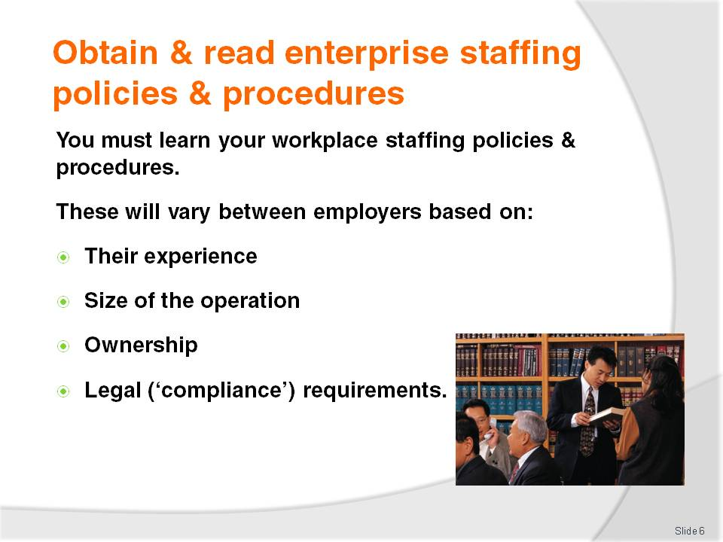
Slide No | Trainer Notes
Trainer instructs trainees no effective action in relation to the recruitment and selection of staff can occur until the enterprise policies and procedures relating to the staffing process are understood.
Staffing policies and procedures will vary between workplaces based on:
Their previous experiences with staff recruitment and selection – previous experience will influence what is contained in the policies and procedures. The current policies will be drafted to prevent repeating mistakes made before
The size of the business – smaller businesses tend to be more informal whilst larger businesses tend to be more regimented
Personal preferences of the owner – an owner-operated business will reflect the personal orientations of the owner, a company-owned business is likely to have more structured and more formal policies and procedures
Legal requirements applying to individual business types or industry sectors – to ensure compliance with relevant employment laws.

Slide
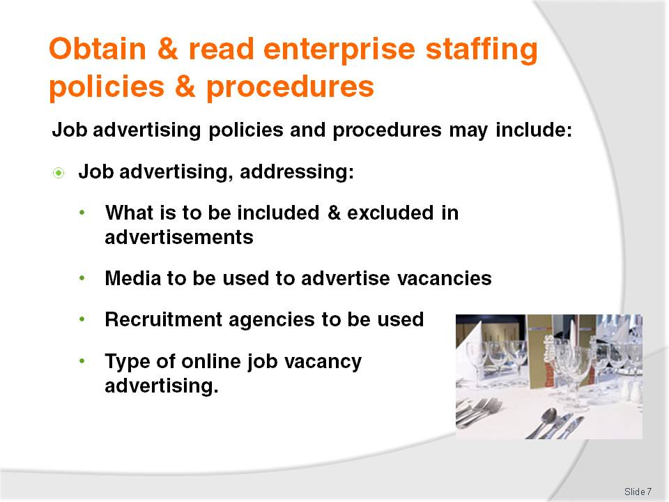
Slide No | Trainer Notes
Trainer presents to trainees examples of possible staffing policies and procedures used by employers:
Job advertising
This may address:
- Information that may and may not be included in a job advertisement – some employers:
- Will not want the name of their business included in advertisements – so applicants and others do not know who is advertising for staff
- Will not want their telephone number included – to avoid the need to respond to numerous calls enquiring about the job
- Will not want their address included – to prevent applicants calling in in-person to make enquiries
The newspapers in which job advertisements are to be lodged – including:
- Type and size of advertisements
- Use of company logo
- Days of the week the advertisement is to run
- Duration of advertising period – for example, one week or a fortnight
Job recruitment agencies to be used – and the information to be given to them about the vacancy
Online recruitment to be undertaken – identifying websites to be used and not to be used.
Class Activity – Handout and Discussion
Trainer obtains sample staffing policy and procedures relating to the above staffing topic, and:
Distributes to trainees
Discusses contents explaining why policy requirements are included in the document.

Slide
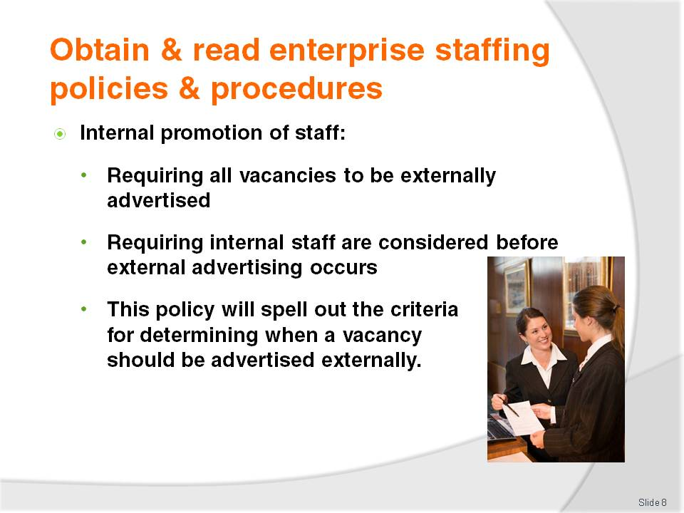
Slide No | Trainer Notes
Trainer continues to present and explain to trainees possible workplace staffing policies and procedures:
Internal staff promotions
This may address:
- A statement all vacant positions must be advertised externally. This is done to ensure the company cannot be accused of failing to address EO obligations or to source the most suitable employee
- A statement the enterprise will attempt to fill all vacant positions from within before advertising externally. This alternative is designed to demonstrate to staff the employer will reward staff effort and excellence, recognise training, responsibilities undertaken and qualifications and abilities of staff. This gives staff a career path within the business and helps the employer retain staff
- Criteria for determining whether a job should be advertised externally or not.
Class Activity – Handout and Discussion
Trainer obtains sample staffing policy and procedures relating to the above staffing topic, and:
Distributes to trainees
Discusses contents explaining why policy requirements are included in the document.

Slide
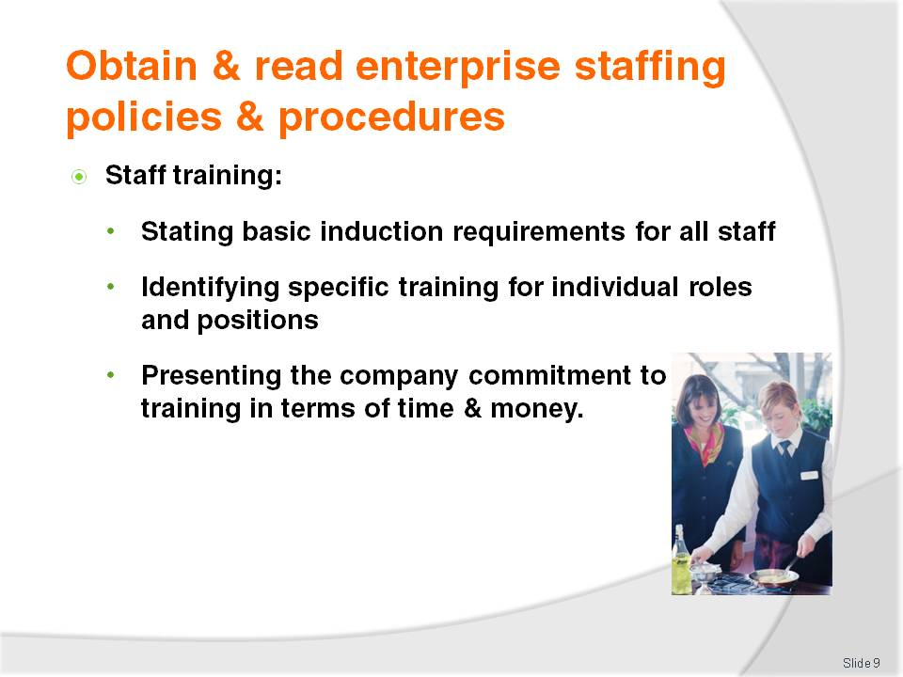
Slide No | Trainer Notes
Trainer continues to present and explain to trainees possible workplace staffing policies and procedures:
Staff training
This will cover:
- The basic induction training all new employees are required to undertake on joining the enterprise
- Pre-requisite training for nominated positions to ensure staff have:
- Complied with legally imposed training or certification requirements
- Learned the necessary basic skills and knowledge to enable them to discharge their designated tasks and responsibilities. This may include:
- Customer service skills
- Technical work such as operating equipment and systems
- Completing documentation
- Cash handling
- Workplace security
- Occupational health and security
- The commitment of the enterprise towards training – in terms of time allowed for staff to undertake training, training costs the enterprise will pay for if staff attend external training.
Class Activity – Handout and Discussion
Trainer obtains sample staffing policy and procedures relating to the above staffing topic, and:
Distributes to trainees
Discusses contents explaining why policy requirements are included in the document.

Slide
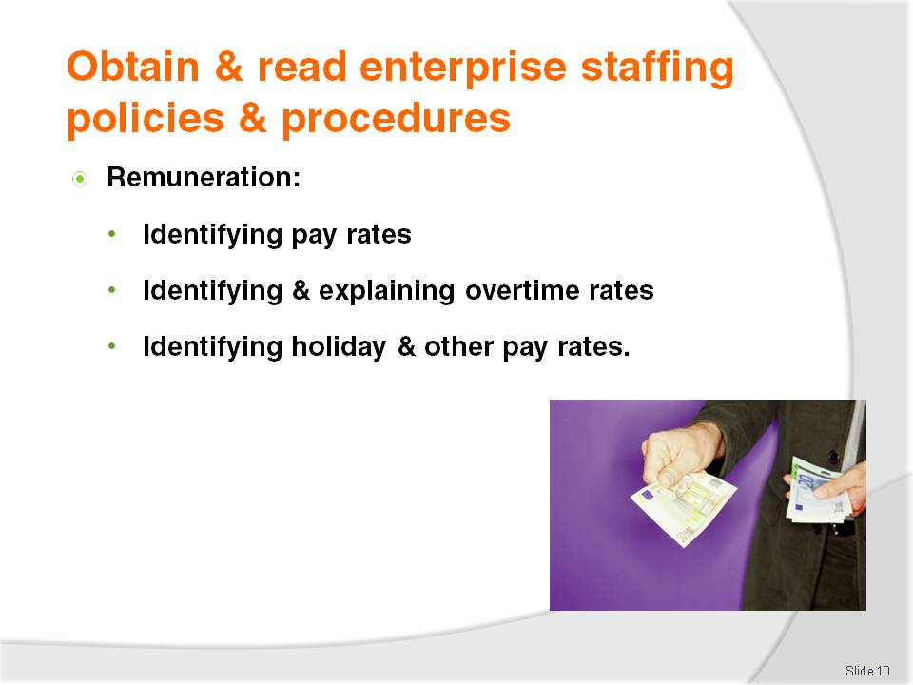
Slide No | Trainer Notes
Trainer continues to present and explain to trainees possible workplace staffing policies and procedures:
Remuneration
This may provide details on:
- Pay rates for different staff – on an hourly, weekly, fortnightly or annual basis
- Overtime payments – including when they apply
- Pay rates for holiday periods – and any designated ‘penalty periods’ (which may include weekend work, late night work, early morning work).
Class Activity – Handout and Discussion
Trainer obtains sample staffing policy and procedures relating to the above staffing topic, and:
Distributes to trainees
Discusses contents explaining why policy requirements are included in the document.

Slide
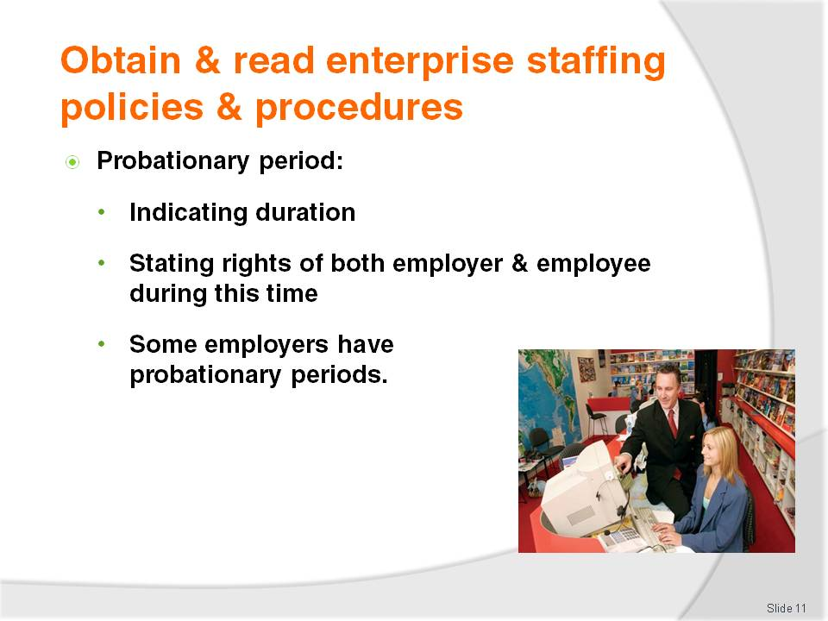
Slide No | Trainer Notes
Trainer continues to present and explain to trainees possible workplace staffing policies and procedures:
Probationary period
The probationary period occurs when a new employee starts work with an employer. It is commonly a three month period during which:
- The employer can determine whether or not they are going to continue employing the new staff member
- The new employee is ‘on probation’ – their work and they themselves are under scrutiny to see if they measure up
- The employer is entitled to dismiss them without being concerned about unfair dismissal accusations being levelled at them
- The employee can elect to leave the employer
Some enterprises do not have probationary periods, and some have periods longer than three months.
Class Activity – Handout and Discussion
Trainer obtains sample staffing policy and procedures relating to the above staffing topic, and:
Distributes to trainees
Discusses contents explaining why policy requirements are included in the document.

Slide
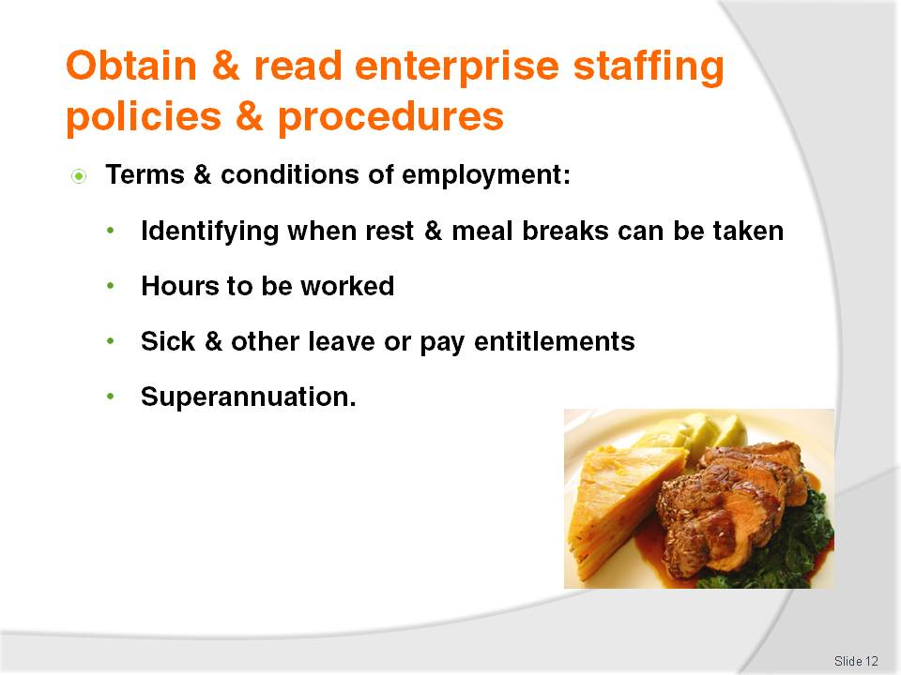
Slide No | Trainer Notes
Trainer continues to present and explain to trainees possible workplace staffing policies and procedures:
Terms and conditions of employment
These set out the working conditions of the staff such as:
- When they are entitled to rest breaks and meal breaks
- Length of the working day – hours worked per week
- Entitlements to sick leave – both paid and unpaid
- Holiday entitlements and annual leave
- Superannuation.
Class Activity – Handout and Discussion
Trainer obtains sample staffing policy and procedures relating to the above staffing topic, and:
Distributes to trainees
Discusses contents explaining why policy requirements are included in the document.

Slide

Slide No | Trainer Notes
Trainer continues to present and explain to trainees possible workplace staffing policies and procedures:
Benefits
Not all enterprises offer ‘benefits’ to workers. Where benefits are offered:
There is usually a qualifying period – commonly the employee must have completed their probation period, or have worked for one year
They may relate to:
- Discounts when buying enterprise products or services
- Access to certain products or services in the workplace
- Additional training or opportunities
- Workplace awards and rewards – for effort or achievement.
Class Activity – Handout and Discussion
Trainer obtains sample staffing policy and procedures relating to the above staffing topic, and:
Distributes to trainees
Discusses contents explaining why policy requirements are included in the document.

Slide
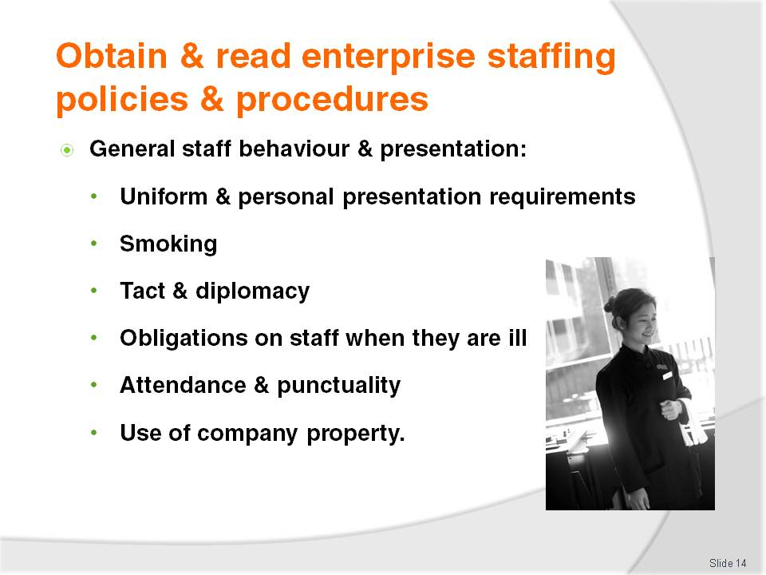
Slide No | Trainer Notes
Trainer continues to present and explain to trainees possible workplace staffing policies and procedures:
General staff behaviour and presentation – may be two separate policies
There is commonly a raft of policies dictating enterprise expectations in relation to:
- Uniform – wearing, cleaning, laundering and replacement of uniform
- Personal presentation –personal hygiene, hair, facial hair, wearing of make-up and jewellery, grooming and deportment
- Smoking – some businesses will ban smoking totally during work hours, some venues will require staff to brush their teeth or use mints after smoking and before serving customers
- Tact and diplomacy – this is especially important for staff who have direct contact with customers and the common requirement is all employees are expected to use tact and discretion when dealing with all people (including suppliers, agents, other staff)
- Sickness – every enterprise will require staff to notify the business as soon as possible if they are unable to attend work for any reason, including illness. Some enterprises may require staff who are unable to work due to illness to provide a medical certificate proving they were ill. In food handling situations, many employers require those directly involved in the handling of food (other than food in sealed containers) to supply a medical certificate stating as a food worker they are fit to return to work and food handling duties
- Attendance and punctuality – most venues will require employees to:
- Come to work on time as indicated by the official roster
- Remain at work until their rostered time for breaks or departure
- Work reasonable amounts of overtime as requested by their employer
- Not leave work when dealing with a customer
- Notify management as soon as possible if unable to attend work for any reason
- Use of company property – most venues prohibit staff from using company property for personal use or gain. This means:
- Workplace telephones cannot be used for private calls
- Workplace computers and internet cannot be used for private purposes
- Products and services (such as but not limited to food, beverages, stationery, tickets, complimentary guest items) cannot be used or taken by staff – this is regarded as stealing and may lead to instant dismissal and criminal; prosecution.
Class Activity – Handout and Discussion
Trainer obtains sample staffing policy and procedures relating to the above staffing topic, and:
Distributes to trainees
Discusses contents explaining why policy requirements are included in the document.

Slide
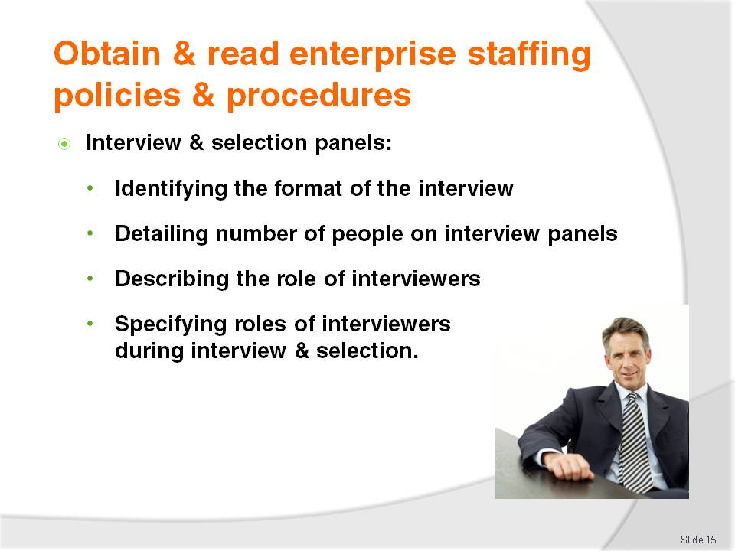
Slide No | Trainer Notes
Trainer continues to present and explain to trainees possible workplace staffing policies and procedures:
Composition of interview and selection panels
Enterprises often provide explicit direction regarding:
- The number of people who must be present when a job interview is conducted – the number may vary with the type of job for which the interview is being conducted
- The experience or position of those who are to comprise the interview panel
- The role to be played by each person on the panel.
Class Activity – Handout and Discussion
Trainer obtains sample staffing policy and procedures relating to the above staffing topic, and:
Distributes to trainees
Discusses contents explaining why policy requirements are included in the document.

Slide
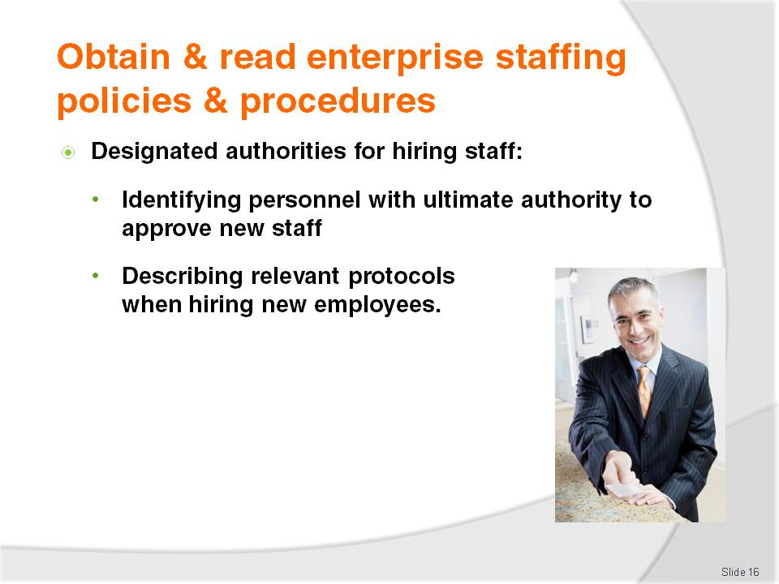
Slide No | Trainer Notes
Trainer continues to present and explain to trainees possible workplace staffing policies and procedures:
Designated authorities for hiring staff
When job interviews have been conducted and a decision has been made about who to hire, a recommendation may need to be passed to a higher authority (such as the business owner or manager) so they can make the final hiring decision
Policies and procedures in this regard may stipulate:
- Timeframe for notification
- Information/documentation to accompany the recommendation – such as CV, results of tests administered, interview sheets
- Nominated persons with authority to make the ultimate hiring decision.
Class Activity – Handout and Discussion
Trainer obtains sample staffing policy and procedures relating to the above staffing topic, and:
Distributes to trainees
Discusses contents explaining why policy requirements are included in the document.

Slide
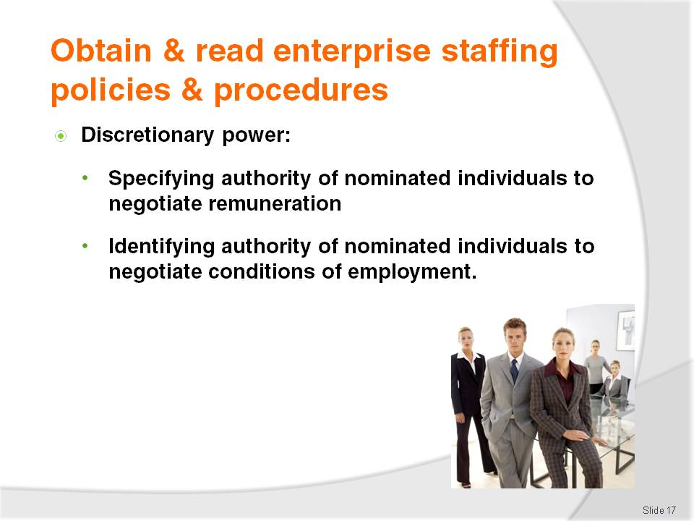
Slide No | Trainer Notes
Trainer continues to present and explain to trainees possible workplace staffing policies and procedures:
Discretionary power
In some enterprises nominated people (such as Supervisors, Department Managers and Heads of Divisions) may be given discretionary power to make on-the-spot decisions in an interview situation (or as part of employment negotiations) to:
- Negotiate remuneration with individual applicants – where, for example, the enterprise wants to engage an applicant who appears reluctant or who has skills, experience and ability the business desperately wants to obtain
- Negotiate conditions of employment – which may embrace issues such as:
- Bonuses – sometimes linked to negotiated KPIs
- Days and hours of work – to accommodate those with other commitments, or a need to only work a limited number of hours per week
- Benefits – which can cover a wide range of items depending on the job (such as such as travel, a car, telephone allowance, uniform/dress allowance, accommodation, subscription to magazines, attendance at conferences).
Class Activity – Handout and Discussion
Trainer obtains sample staffing policy and procedures relating to the above staffing topic, and:
Distributes to trainees
Discusses contents explaining why policy requirements are included in the document.

Slide
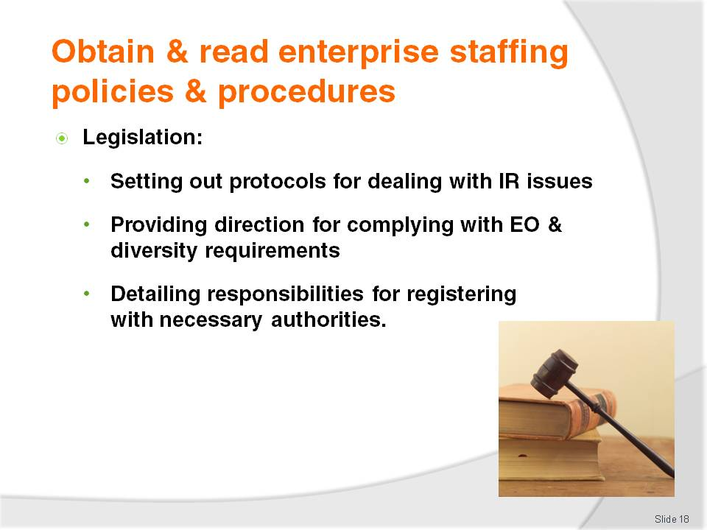
Slide No | Trainer Notes
Trainer continues to present and explain to trainees possible workplace staffing policies and procedures:
Legislation
All enterprises will make statements requiring their operations to align with relevant in-country legislation at it applies to matters such as:
- Industrial relations (IR) – setting out the protocols for dealing with industrial disputes and pay claims
- Equal opportunity and diversity – to ensure workers are free from discrimination in relation to:
- Employment
- Promotion
- Training
- Discipline
- Dismissal
Employers will want staff to be treated fairly regardless of their age, ethnicity, gender or age.
- Registration for insurance and superannuation – and payment of relevant premiums and contributions.
Class Activity – Handout and Discussion
Trainer obtains sample staffing policy and procedures relating to the above staffing topic, and:
Distributes to trainees
Discusses contents explaining why policy requirements are included in the document.

Slide
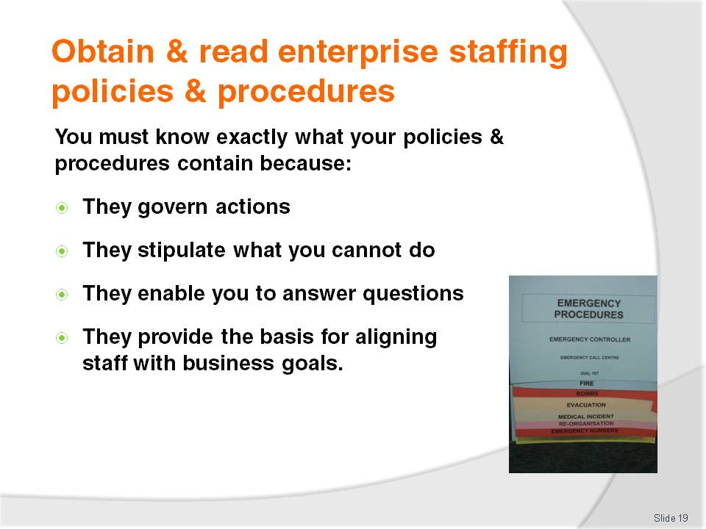
Slide No | Trainer Notes
Trainer explains to trainees it is important for them understand enterprise policies and procedures as they provide guidance for their thinking and action. They also give parameters within which they are expected to operate.
A sound knowledge of these policies and procedures will:
Enable them to make decisions in relation to staff recruitment and selection – through knowing what is or not allowed
Allow them to answer questions about employment in the workplace – such as those asked by job applicants, staff seeking promotion or management who question workplace decisions made by supervisors
Ensure staffing activities align with enterprise requirements – which are embodied in the policies and procedures and which, in turn, reflect the strategic goals and direction of the enterprise.

Slide
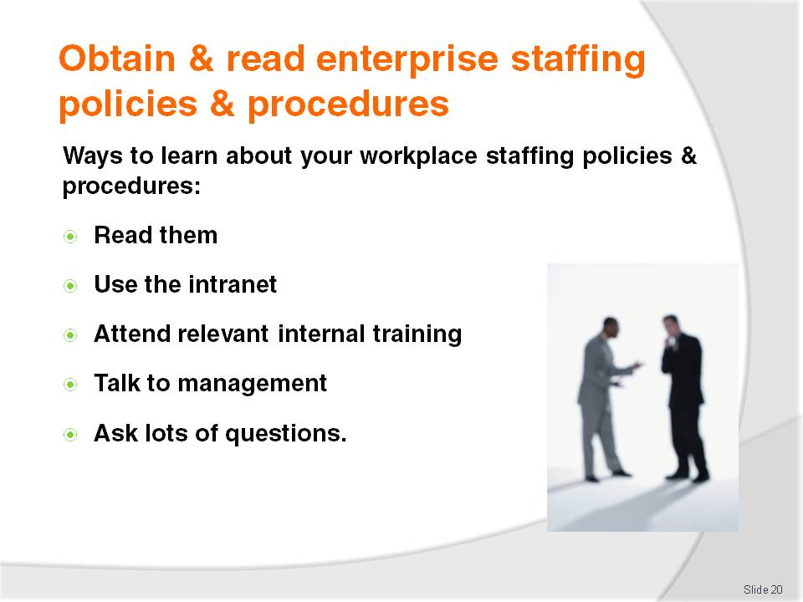
Slide No | Trainer Notes
Trainer advises trainees they can obtain a detailed understanding of the policies and procedures at their workplace by a combination of the following approaches:
Reading hard copy policies and procedures provided by the enterprise – such as in Employee Handbooks and Policy and Procedure Manuals
Accessing the intranet – of enterprises where internal company information is available electronically
Attending internal training sessions – focussing on interpreting and applying enterprise policies and procedures
Talking to Managers and more experienced staff – to gain an appreciation of their understanding of what is required
Asking questions – to help understand any ambiguous aspects.

Slide
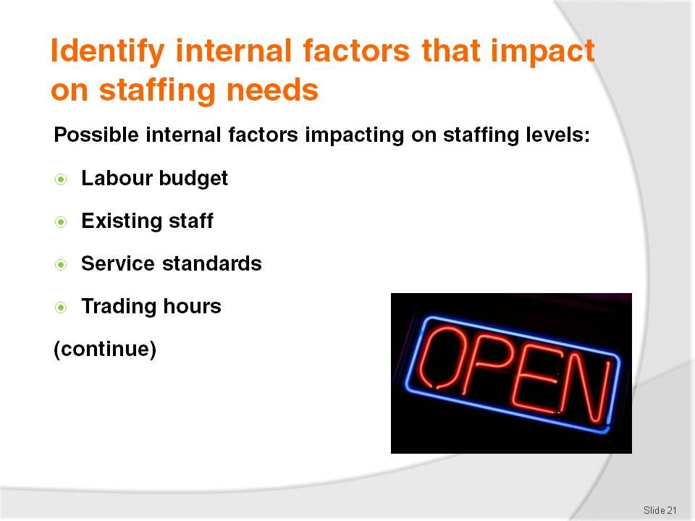
Slide No | Trainer Notes
Trainer states to trainees before staff are hired or dismissed there must be an analysis of internal and external factors impacting the business and the need for staff.
Whenever staff are engaged or made redundant, there must be a valid reason for that action.
Trainer explains this Section identifies internal issues within a business:
Labour budget – it is important to know:
- How much is available?
- Can more be spent on wages if revenue increases?
- Can more be spent next period if savings have been made previously?
- Can more be spent in one department if savings have been made in another department?
- What impact does a public holiday have on the money allocated to wages? Is extra money allocated to allow for payment of penalty rates?
- What is the wages period? A week, fortnight or other?
Existing staff:
- Who are they?
- How many are there?
- How many hours do they work?
- What can they do and not do?
Service standards:
- What do management expect and what do customers expect?
- What are non-negotiable requirements regarding staffing levels? For example, one waiter to every 15 guests; one Room Attendant for every 12 rooms to be cleaned; ‘No customer should wait more than 30 seconds before being served’
Trading hours:
- When does the business open and shut?
- Can staff be ‘staggered’ at opening and closing times?

Slide
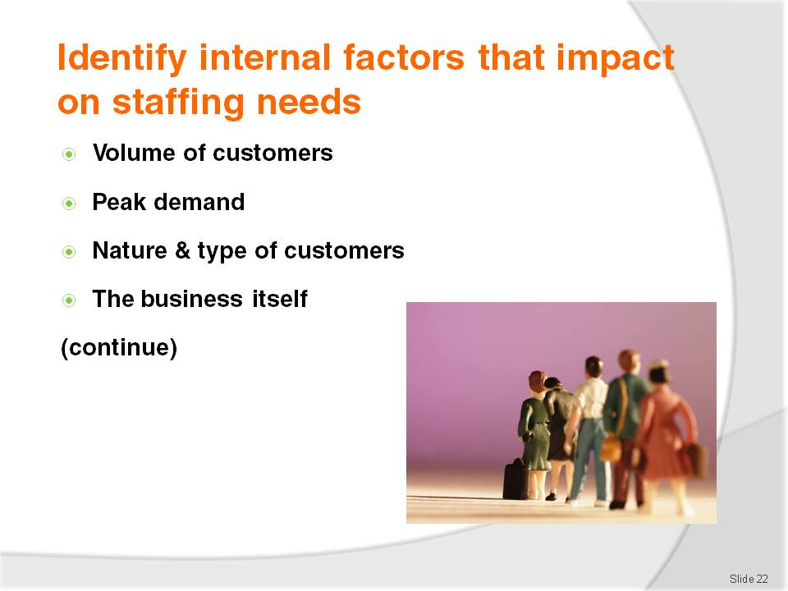
Slide No | Trainer Notes
Trainer continues to explain and identify internal issues impacting on staffing needs for a business or department:
Volume of customers:
- The aim should be to match the number of staff to the number of customers needing to be served. Proper staffing is often referred to as the ‘art of having the right people, in the right place, in the right numbers, at the right time.’
- The aim of this focus is ‘to serve the customer’ as distinct from ‘take money’
- In many cases, there will be a need for staff to be working even where no immediate revenue is generated, such as when:
- Providing sales advice – which may or may not result in a sale
- Promoting products and services – where the intention may be to raise awareness as opposed to generate sales
- Providing service expected by customers as part of something they have already purchased – for example, security and maintenance is expected by customers when they buy an accommodation package but these departments do not generate revenue.
Peak demand:
- May occur on an hourly basis, certain days of the week, time of the month or year, or a particular season
- Service standards must be considered – if a waiting time of three minutes before being attended to by a sales adviser is acceptable then the level of staff needs to reflect this rather than provide an ‘immediate’ service with no waiting
- Low demand periods should reflect correspondingly reduced staffing levels – it is inadvisable to only consider ‘peak’ demand without identifying and responding to low demands times
Nature & type of customers:
- Issues to be considered in this regard include:
- Safety – most businesses require a minimum of two staff after a certain time at night for the safety of employees
- Whether alcohol is involved – where liquor service and consumption occurs this can indicate:
- A need for more staff
- A need for security staff
- Age of customers – where young people are targeted there can be a need for more staff because:
- They tend to spend more than other customers
- They demand faster service
- They tend to cause more problems in liquor venues
- The potential for repeat business – where there is a chance the current customers will become repeat customers, venues tend to provide more staff to provide better service. Where customers are not expected to become repeat customers, there can be a case for the provision of fewer staff meaning slower service
- Business people demand more prompt attention than other customers because their time is more valuable
The business itself:
- There is always a need to consider the business itself when identifying internal factors impacting on staffing. Important considerations are:
- Directions the business wishes to take – this relates to departures from their past activities in terms of:
- Target markets – different markets require different skill sets from staff
- Service levels and standards – higher service standards generally require more staff and better trained staff
- Services and products provided – an increased number or type of products and services requires staff with commensurate skills to provide them
- The existing reputation and image of the business – in general (unless the business has set itself new directions, or been taken over by new owners) most enterprises will seek to maintain their reputation and image, meaning:
- Great attention needs to be paid to monitoring changes in staffing levels to determine how these are impacting on customer perceptions about service delivery. Are customers still happy with service levels? Or have they noticed a drop in standards since one less staff member was rostered to serve them?
- Special attention needs to be paid to staffing levels (and personnel) when new opposition businesses open up, and when existing competition businesses launch new promotional campaign. It is often at these times when existing customers can be persuaded to leave and try the other business, especially if they believe the service they have receiving is sub-standard.

Slide
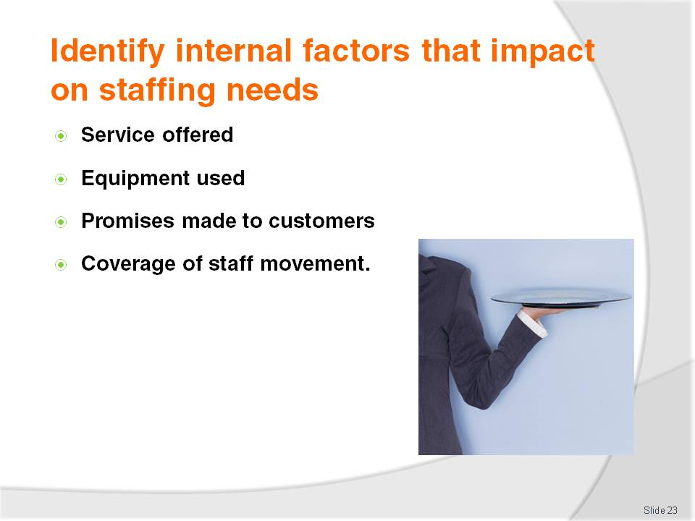
Slide No | Trainer Notes
Trainer continues to explain and identify internal issues impacting on staffing needs for a business or department:
Service offered:
- The style of service offered can determine the need for certain numbers of staff or the skills they require.
For example:
- Plated service – is the most common service style where food is placed onto plates in the kitchen and carried to the tables by waiting staff
- Silver service – is a high quality service style requiring more staff (and crockery, cutlery and equipment) where an empty plate is placed in front of the guest and food is silver served (using tongs or spoon and fork) from service trays onto the individual guest plates
- Gueridon service – includes (but is not limited to) the cooking of dishes at the table and the silver service of vegetables, sauces and garnishes onto individual guest plates at the table
- Smorgasbords or buffets – allow, or require, guests to serve themselves. This service style can require less waiting staff but may not be exactly what target market wants in terms of food service
Equipment used:
- There is a need to ensure sufficient suitably trained and competent staff to operate whatever systems, technology or equipment in use at the venue. Factors involved are:
- The need for sufficient original training – and up-date training as required
- The need to train sufficient numbers to ensure the systems, technology or equipment can be operated when required
- The need for trained staff in order to meet:
- Warranty and guarantee requirements
- Compliance requirements
- Safety and insurance requirements
- The need for planned transitions – from existing systems, technology or equipment to new systems, technology or equipment, allowing time for staff to become familiar with new or upgraded items
Promises made:
- There must always be sufficient and competent staff to:
- Keep promises made in advertisements about service offering
- Enable contractual obligations to be complied with
Coverage of staff movement:
- There must always be plans in place to address expected staff absences (due to leave entitlements, training, rostered time off) and unexpected staff absences (such as illness, accidents at work, the need to transfer staff to another department).

Slide
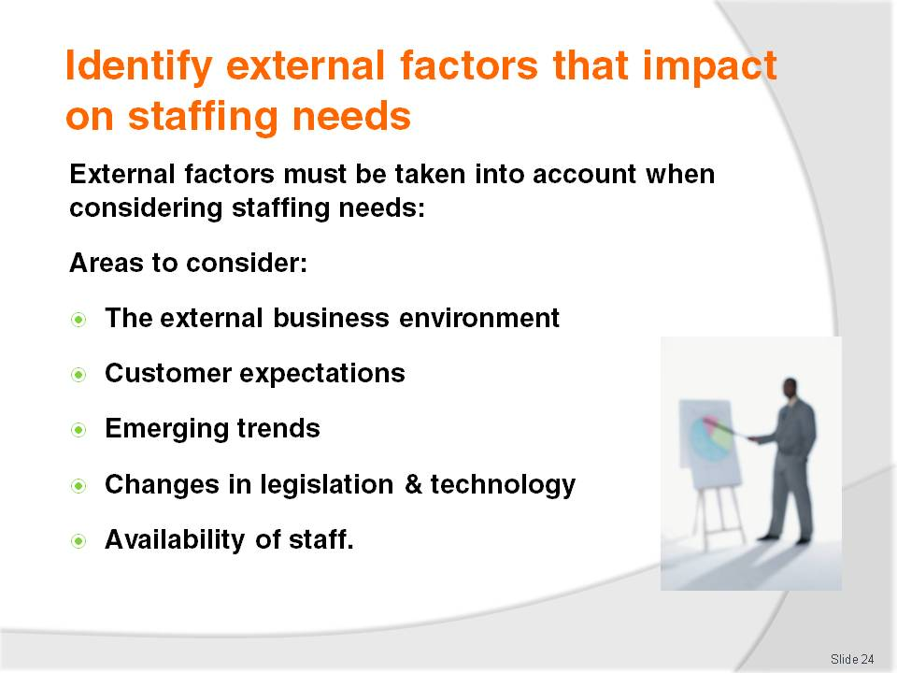
Slide No | Trainer Notes
Trainer mentions to trainees external factors must also be considered when considering staffing needs explaining there is a need to look at:
The external business environment – see following slide
Customer expectations – covered on later slides
Emerging trends – covered on later slides
Changes in legislation and technology – covered on later slides
Availability of staff – covered on later slides.

Slide
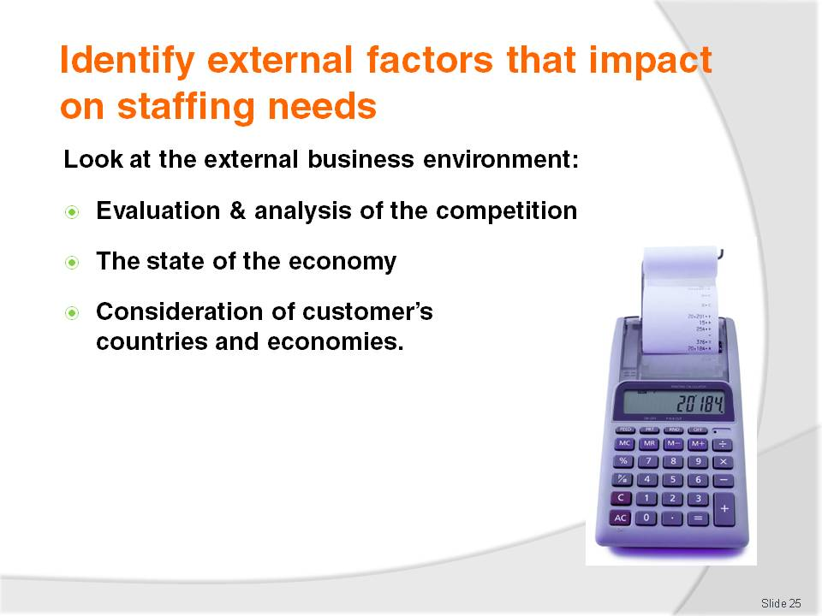
Slide No | Trainer Notes
Trainer tells trainees when considering staffing needs they must always look outside the organisation. An important consideration is the external business environment in which the enterprise is operating in:
Evaluation and analysis of the competition – questions to be answered include:
- Is competition growing, staying the same or decreasing?
- What activities are being undertaken by the competition to increase their market share?
- Are they cutting prices?
- Are they advertising more?
- Are they offering a better service or products?
- What does it appear needs to be done to combat this opposition activity? Is the answer really a staffing response (more staff, more qualified staff, more personable staff, more competent staff), or is the answer totally unrelated to staffing. Therefore other issues need to be addressed (lower prices, increased value-for-money, better inclusions in packages)
The state of the economy – taking into consideration:
- Local employment rates
- Availability of credit
- Exchange rates
- Levels of disposable income
Consideration of the countries and economies of the countries from which customers are drawn. Where the enterprise relies heavily on revenue from international customers, the state of their currency and economy are important issues to take into account.

Slide
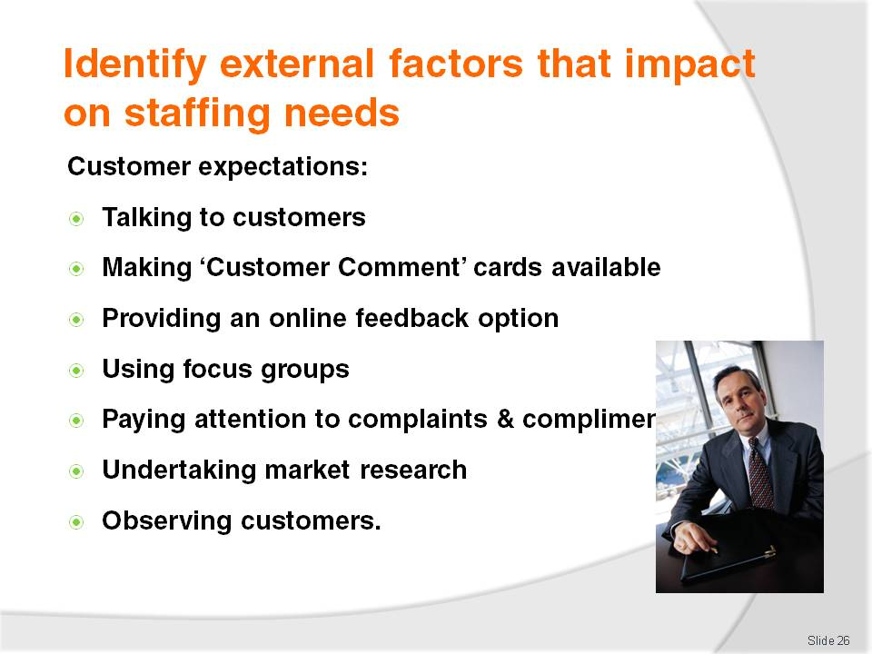
Slide No | Trainer Notes
Trainer states to trainees all businesses should strive to be customer-focused.
All efforts should be concentrated on delivering products and services deemed by the customers to be important to them.
Trainer highlights being customer-focused is a very marketing oriented way to do business. It requires the enterprise to engage in market research to help a business stay in touch with its customers and determine what it is they need – ways to capture this information from customers include:
Talking to customers – to get their input and feedback
Offer ‘Customer Comment’ cards for customers to complete – and encourage them to fill them in, and read them when they are submitted
Have a ‘Contact Us’ facility on the website
Use focus groups – to discuss targeted issues
Pay attention to complaints made and compliments given
Produce and administer questionnaires
Observe customers – look at their body language and listen to comments they make.

Slide
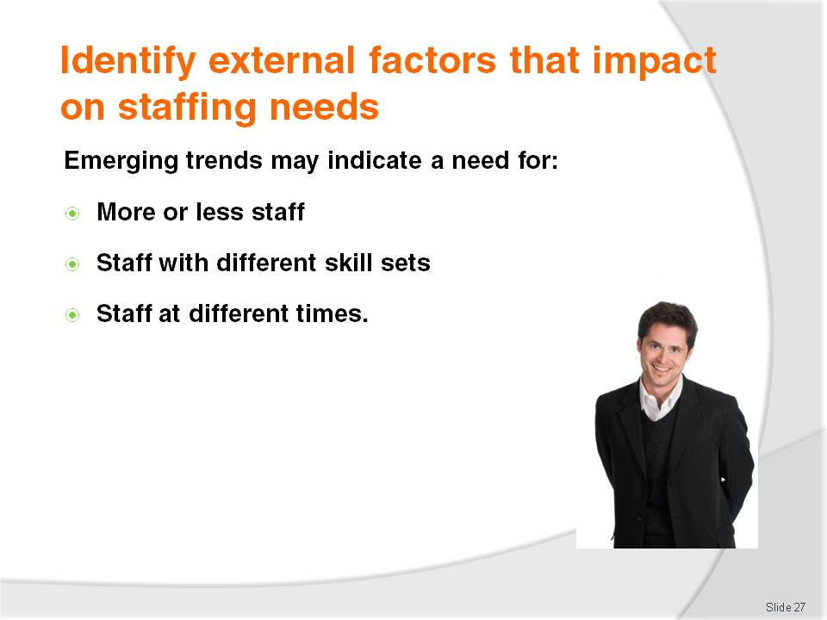
Slide No | Trainer Notes
Trainer indicates to trainees they must be constantly looking to identify new and emerging trends in the marketplace so they can take advantage of opportunities highlighting many of these trends require:
More staff – or loess staff. For example, self-catering may allow fewer cooks or waiters to be hired
Staff with different skill sets – different skills, experience, knowledge and abilities
Staff at different times of the day – to meet differing customer needs at different times.
Trainer identifies examples of recent trends:
Increase in international travel and tourism
Increase in frequent short holidays rather than a single, longer duration holiday
Increase in women who are travelling for business
Growth in new tourism markets – such as eco-tourism, action tourism, medical tourism.

Slide
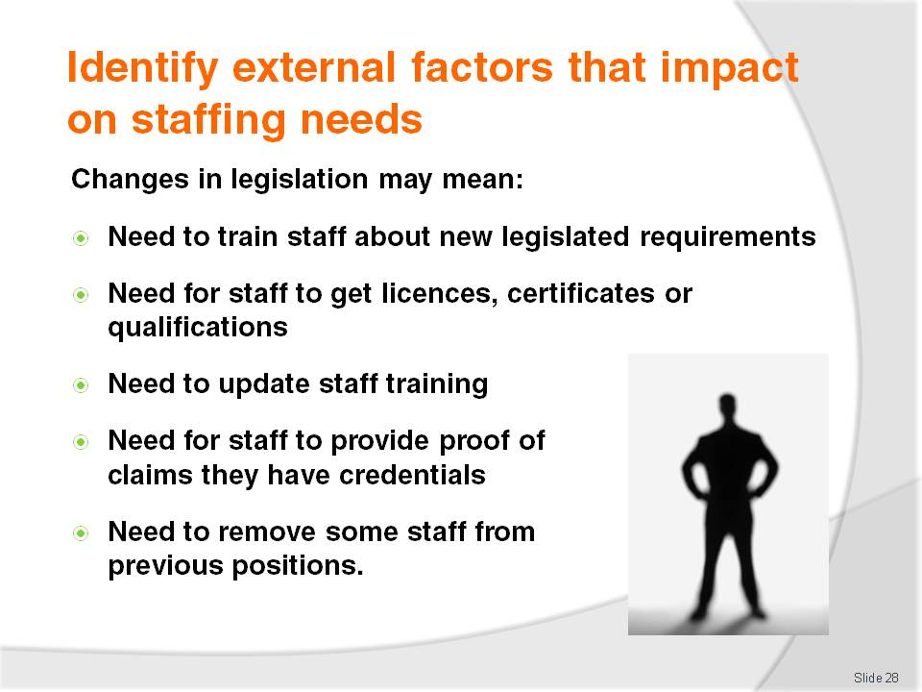
Slide No | Trainer Notes
Trainer explains to trainees changes in legislation have the potential to impact on staffing as follows:
There can be a need to train staff about the new legislation – what it means to their everyday workplace responsibilities, what different compliance obligations are provided for, and how their work needs to change to comply
There can be a need for staff to obtain mandatory licences, certificates or qualifications
There may be a need for staff to update or refresh existing licences, certificates or qualifications
There may be a need for staff to provide evidence they have completed mandatory training courses
Staff who were previously employed in a legal capacity may need to be removed from their position – where legislation means their age prohibits them from working as a result of legislative changes, or their qualification is now deemed to be out-of-date or no longer recognised.

Slide
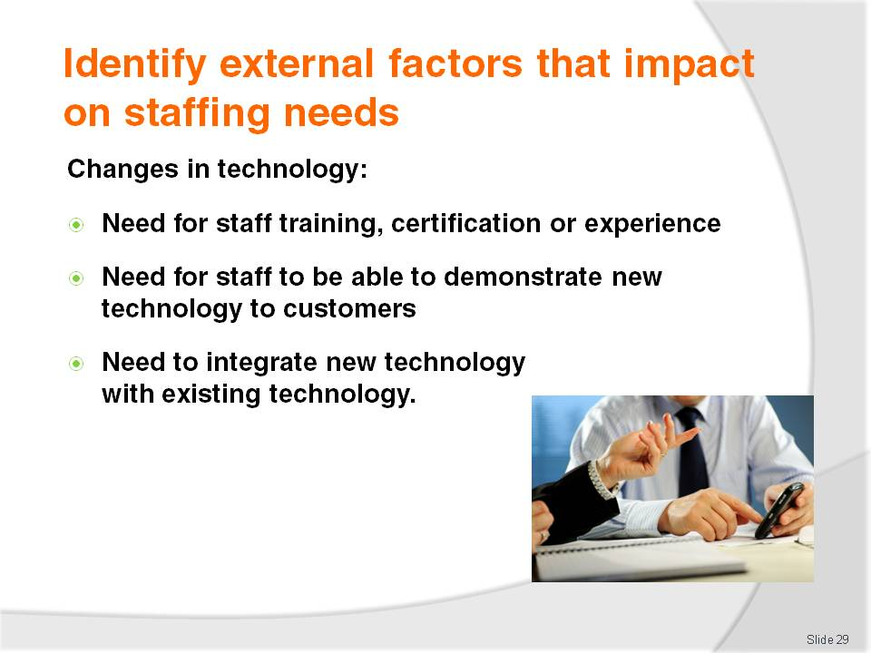
Slide No | Trainer Notes
Trainer explains to trainees changes in technology have the potential to impact on staffing as follows:
The need for training, certification and experience on the new equipment, technology or systems – this may involve:
- In-house training
- External training by a private training provider
- Arrangements with suppliers for them to provide on-site training and commissioning of the new system or equipment
The need for staff to be able to explain new equipment, technology or systems to customers – and help them use it
The need for integrating existing work practices into the requirements of the new equipment, technology or systems.

Slide
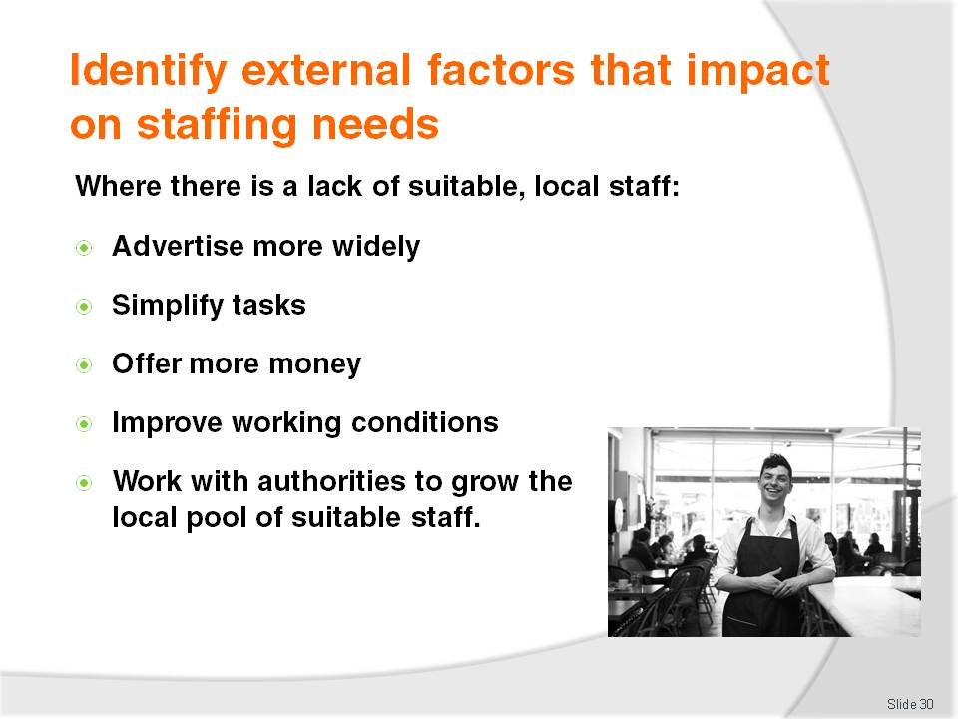
Slide No | Trainer Notes
Trainer identifies to trainees there is a need to consider the type and amount of suitable staff available to undertake the required tasks as and when required.
Trainer explains when there is a lack of suitable local staff this may mean a need for trainees to:
To advertise for staff more widely – such as internationally or out of the local area
To simplify tasks – so less qualified or experienced people can undertake them
To offer more money – to attract suitable applicants
To improve working conditions – to make the workplace more attractive for the right staff
There is a need to offer more in-house training – to develop a body of suitable trained staff
A need to work with authorities, local employer bodies and agencies to:
- Promote vocational training
- Encourage people to engage with vocational training
- Offer more vocational training
- Facilitate the movement of trained, experienced and qualified people into the local industry.

Slide
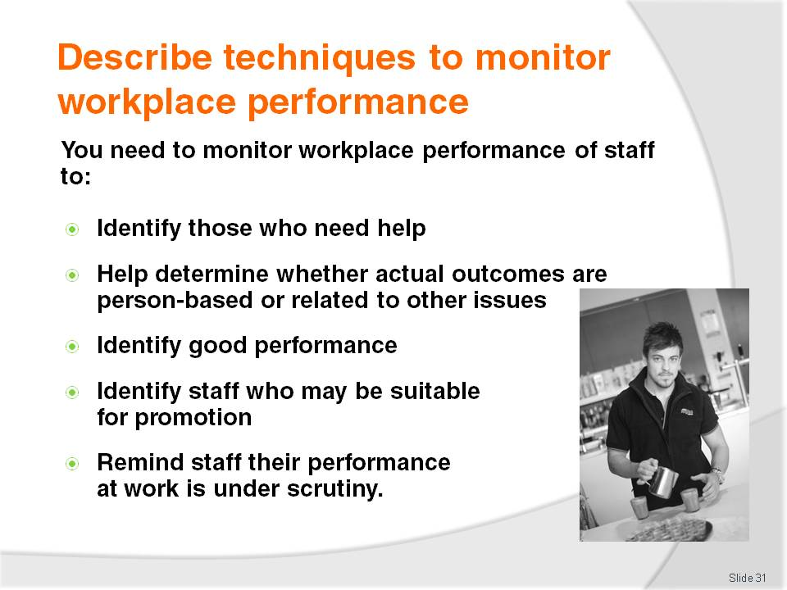
Slide No | Trainer Notes
Trainer advises trainees the study of workplace performance is a field in its own right however it is important for them to monitor the workplace performance of their staff to:
Identify those who need help – or training or support
Help determine whether actual outcomes are person-based or related to other issues – such as poor layout, malfunctioning equipment, ineffective SOPs
Identify good performance – so it can be recognised or rewarded
Identify staff who may be suitable for promotion – or extra responsibilities or a new position
Remind staff their performance at work is under scrutiny – which encourages them to perform at their best.

Slide
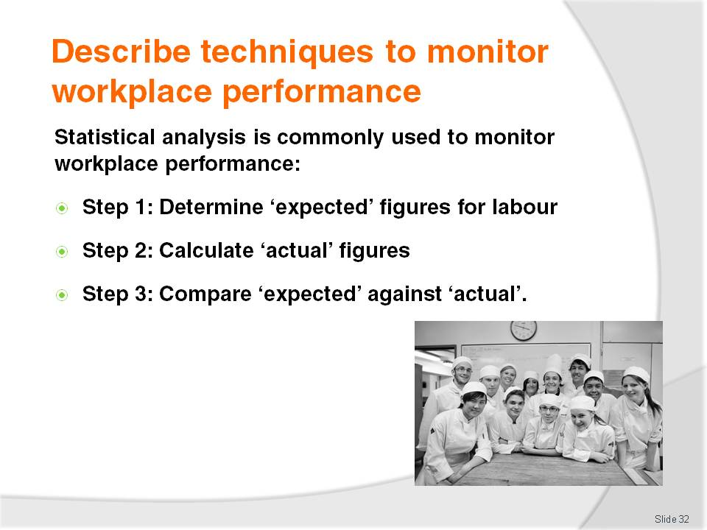
Slide No | Trainer Notes
Trainer indicates to trainees ‘statistical analysis’ is a very common approach taken by workplaces to monitor staff performance, presenting the three basic steps used in this approach:
Step 1: Determine ‘expected’ (or ‘projected’) figures for labour – which may include consideration of a multitude of staff-related expenditures and associated issues such as:
- Wage costs – what will they be for the period under consideration (the forecast period). This occurs before the period in question occurs
- Training costs
- Uniform costs
- Number of staff employed and hours worked
- Number of staff achieving nominated licences, certificates or qualifications in a given period
Step 2: Calculate the ‘actual’ figures for the nominated areas – based on actual information and data. This occurs after the period in question occurs
Step 3: Compare ‘expected’ figures against ‘actual’ figures – to determine the extent to which targets were achieved and where the figures were above or below projections.

Slide
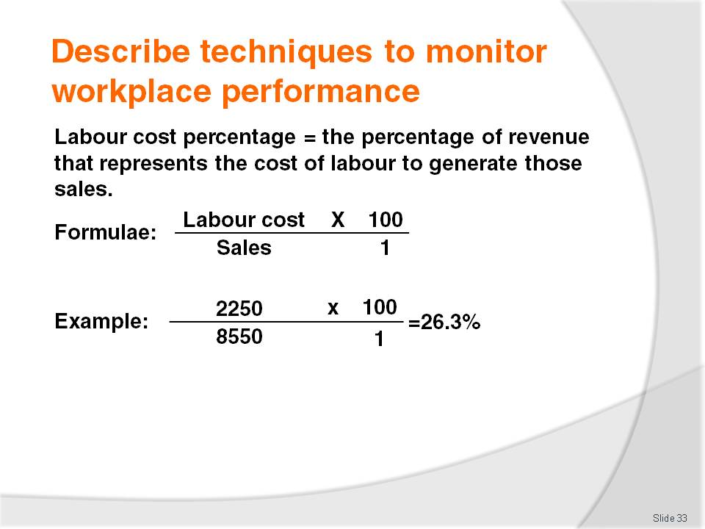
Slide No | Trainer Notes
Trainer explains to trainees the ability to calculate ‘labour cost percentage’ is vital for anyone with staffing-related responsibilities, identifying:
Labour cost percentage is the percentage of revenue that represents the cost of labour to generate those sales
The formulae for calculating labour cost percentage is:
Labour cost | X | 100
Sales |  | 1
An example of calculating labour cost percentage – assume 2250 is cost of labour for the period; sales were 8550:

2250 | x | 100 | =26.3%
8550 |  | 1

Class Activity – Individual exercises
Trainer develops a series of exercises (10 – 15) for trainees to calculate labour cost percentages, and:
Distributes them to trainees
Provides calculators
Asks trainees to calculate the labour cost percentages for the given exercises
Assists trainees as required
Provides answers.

Slide
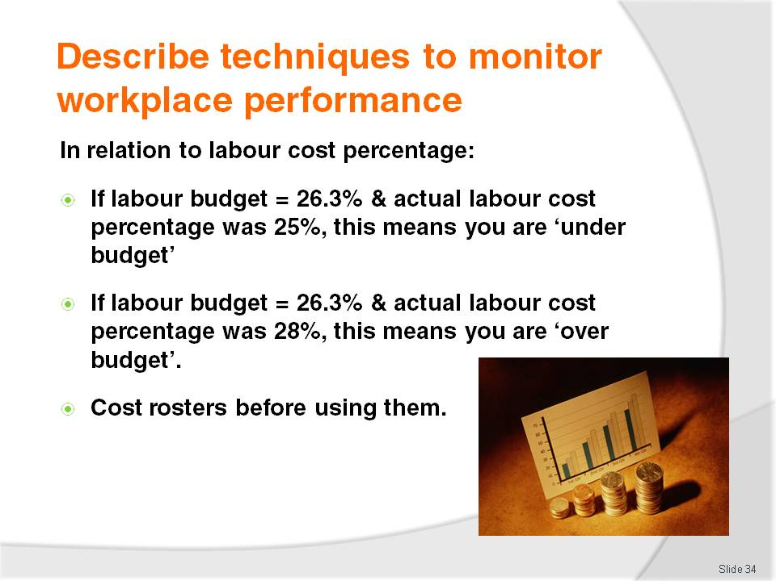
Slide No | Trainer Notes
Trainer provides information to trainees about labour cost percentages:
Identifying instances where labour cost percentages are ‘over budget’ and ‘under budget’
Highlighting all rosters should be costed before being distributed to staff – to ensure they fall within allowable labour cost limits.

Slide
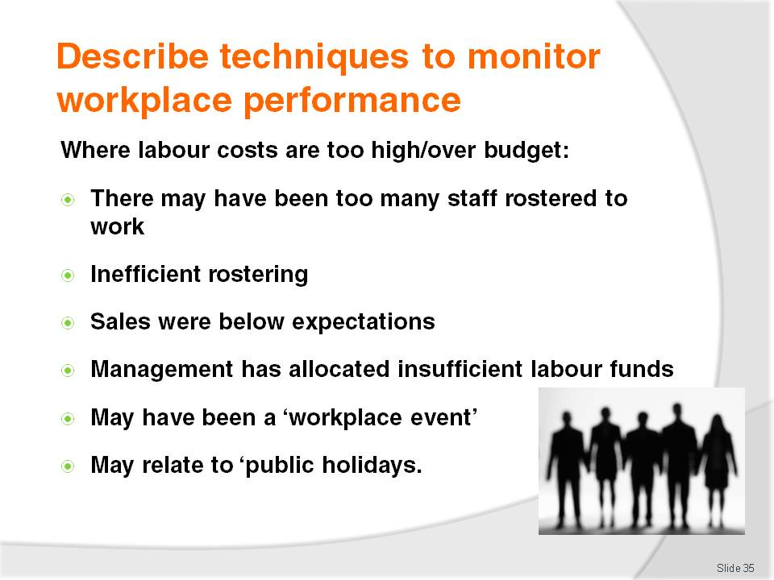
Slide No | Trainer Notes
Trainer provides information to trainees about situations where labour cost percentages are too high/over budget.
Possible causes are:
There are too many staff –all staff have started work at the same time instead of using ‘staggered’ starts, the estimation of staff numbers required were wrong
The way they are rostered is inefficient – staff are being paid excessive overtime or penalty rates because they are being asked to work hours outside those normally provided for
Revenue has not matched expectations – the business has not attracted the sales anticipated for the period in question
Insufficient allocation of funds for labour – in reality, the department or workplace may be under-resourced in terms of staff and the work they are expected to do and the standard they are expected to maintain
An unexpected workplace event – such as an accident, emergency, incident involving an injury to staff (meaning they have had to leave work) resulting in a situation where staff have had to be paid overtime or penalty rates
Public holidays – requiring the business to pay higher hourly rates to staff.

Slide
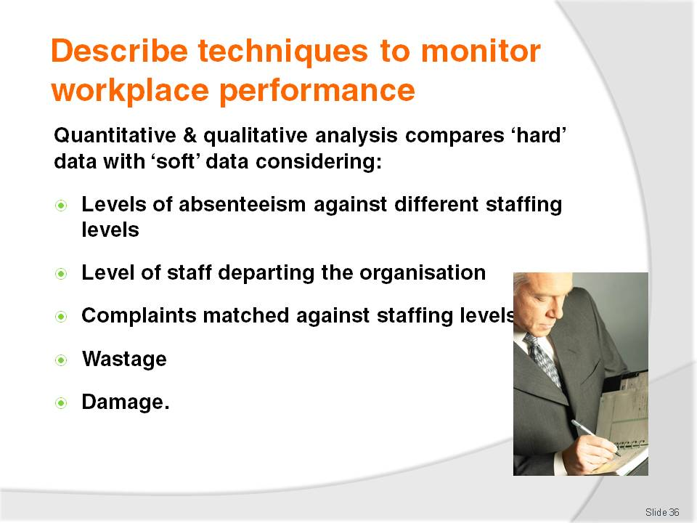
Slide No | Trainer Notes
Trainer explains to trainees ‘quantitative and qualitative analysis’ compares statistical data against soft data.
This differs from labour cost percentage which is a purely statistical analysis.
This style of analysis may consider issues such as:
Level of absenteeism compared to different staffing levels – asking questions such as ‘Is the high workload when staffing levels have been cut causing staff to stay away from work?’
Level of staff departure – ‘Are reduced staffing levels forcing staff to leave and go and work elsewhere?’
Type of customer complaints when staffing levels are varied – ‘Is there a reduction in complaints or a change in the nature of the complaints when extra staff are employed?’
Wastage – ‘is there more/less waste when staffing levels change?’ ‘Are different things wasted?’
Damage – ‘What happens to levels and types of damage done to workplace equipment when staffing levels change?’

Slide
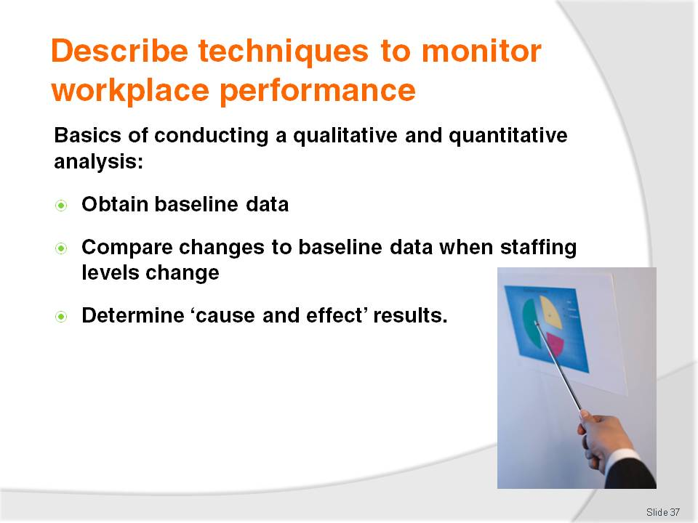
Slide No | Trainer Notes
Trainer tells trainees the basics of conducting a qualitative and quantitative analysis are:
Obtain baseline data from the venue or department for a known situation – where staff levels, workload and revenue is known. This data should cover:
- Quantitative data – figures, statistics, percentages, totals, ratios
- Qualitative data – input as a result of discussions with staff and customers
Compare this data to data produced when staffing levels or the mix of staff changes (names of staff, age of staff, gender of staff, new staff and experienced staff)
Determine ‘cause and effect’ results – identifying how changes to staff levels impact workplace issues.

Slide
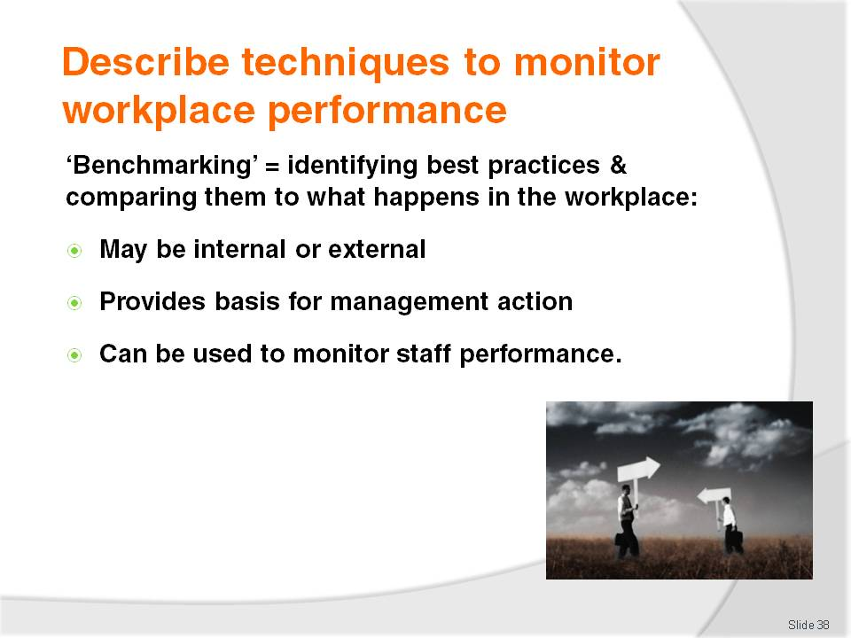
Slide No | Trainer Notes
Trainer tells trainees benchmarking is the process of identifying the best practices and standards that apply to their industry, and comparing what happens in their workplace against that ‘benchmark’:
Comparing the workplace to world standards and practices = external benchmarking
Internal benchmarking refers to using the same approach but comparing current evidence against previous evidence from the enterprise, or against data from other properties in the chain to which the venue belongs
The results of the comparison provide the basis for remedial, or other action, as required so the organisation can attain the standard represented by the adopted benchmark
Benchmarking is very popular and effective as it is one way of judging the organisation against the reality of the marketplace, and against previous performance
Benchmarking could be used to monitor staff performance as follows:
- Comparing the number of rooms serviced by room attendants against the number of room serviced by room attendants in another venue
- Comparing the number of customers or tables served by the waiting staff at the venue against the statistics for service provided across the chain by Head Office
- Comparing the number or value sales made by staff against statistics released by an industry peak body or as a result of research by a government agency.
Class Activity – Guest Speaker
Trainer arranges for a suitable and senior industry person with experience at managing staff to attend and talk to trainees about:
Their role and responsibilities
How they obtained the job they now have
How they determine staffing requirements for nominated areas for given times (covering internal and external factors they consider)
How they establish and monitor staff budgets.

Slide
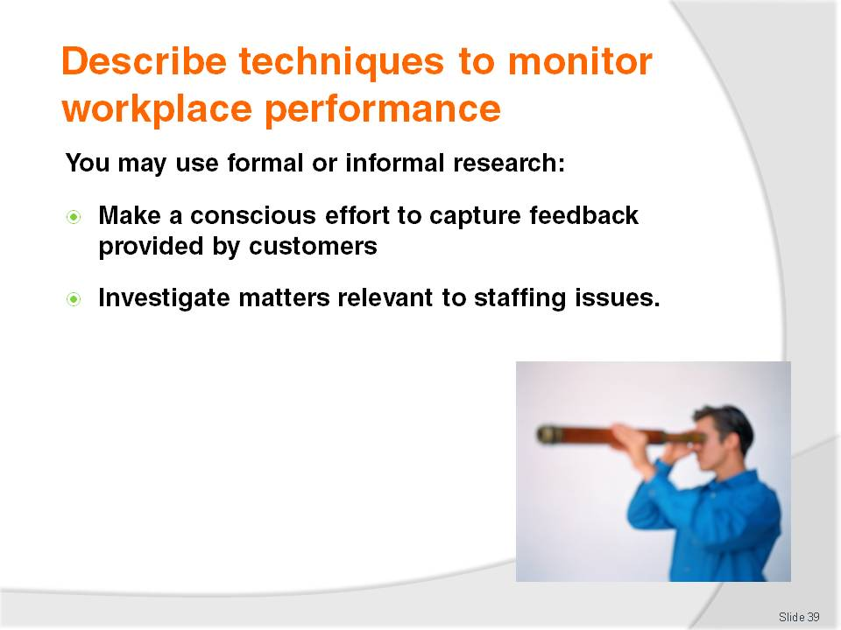
Slide No | Trainer Notes
Trainer advises trainees they may also undertake formal or informal research to monitor workplace staffing performance.
This technique requires them to do one or both of the following:
Make a conscious effort to capture feedback provided by customers – this refers to unsolicited feedback provided (for example):
- When talking with customers
- Overheard from guest conversations
- Provided on Customer Comment cards, or on the website
- In the form of compliments or complaints
Deliberately investigate matters relevant to identified staffing issues – this may include:
- Using focus groups to discuss service levels at different staffing levels
- Observing service delivery provided by staff at different staffing levels – to identify how changes in staff levels impact on interpersonal skills used by workers, the customer experience, delays in service
- Reading trade magazines and research reports relating to staffing and its relation to a variety of issues such as service standards, repeat business, customer satisfaction, staff or customer attrition rates.

Slide
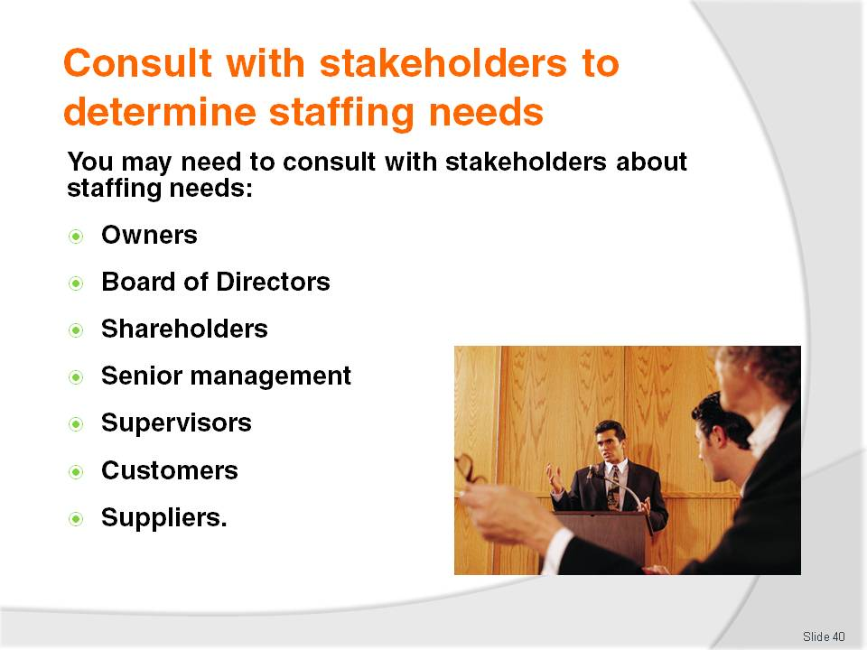
Slide No | Trainer Notes
Trainer states to trainees from time to time, it can be beneficial or necessary to consult with ‘other stakeholders’ in relation to staffing needs.
‘Stakeholders’ can include:
Owners
Board of Directors
Shareholders
Senior management
Supervisors
Staff
Customers
Suppliers.

Slide
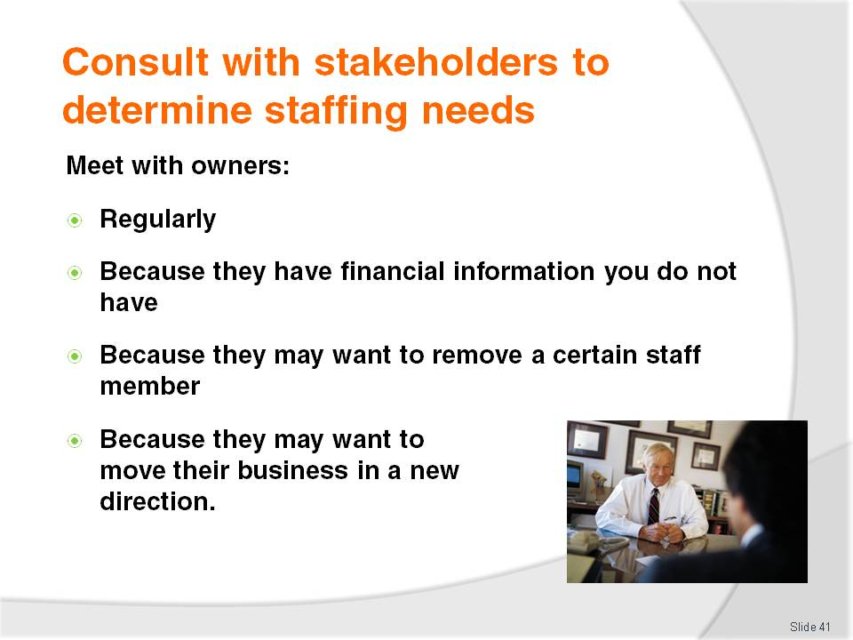
Slide No | Trainer Notes
Trainer notes to trainees many SMEs are owner-operated. It is often the owner who makes most of the operational decisions regarding the business.
Some of these decisions are based on sound reason, facts and strategic thinking, and many others are based on simple personal preference or an individual desire to do something.
Where trainees work for an owner-operator it is a sound plan to meet regularly with this person to share concerns and idea. A meeting once per week is good – a daily meeting is even better.
Owners should be consulted in relation to staff because they may:
Know the financial state of the business and whether or not is can afford to hire extra staff – or whether it needs to shed staff
Have a personal desire to get rid of a certain staff member – and replace them with someone else they have identified
Have a plan to take the business in a new direction – which could implications for numbers of staff required, their experience and skill sets.

Slide
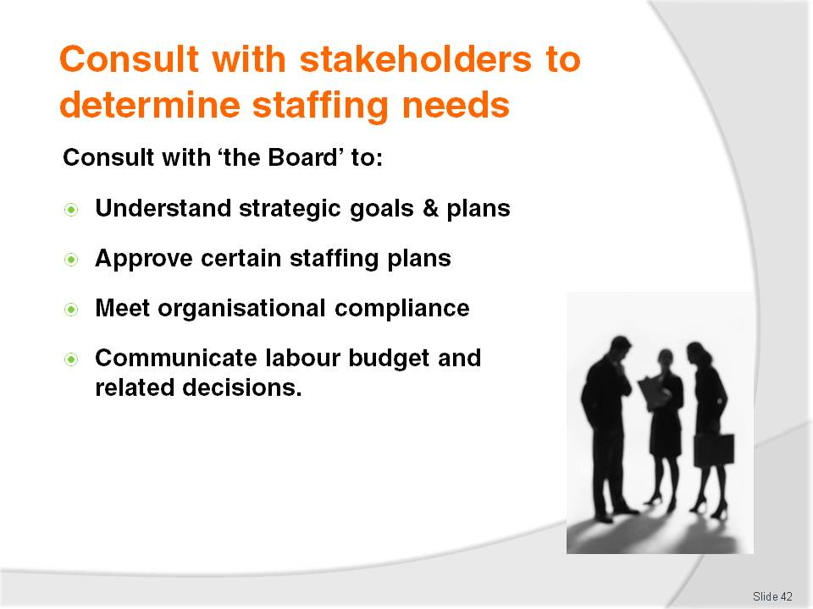
Slide No | Trainer Notes
Trainer tells trainees the Board of Directors (‘the Board’) has responsibility for the long-term performance and viability of the business. The day-to-day running of the enterprise rests with managers and middle level management.
Trainer explains the Board of Directors should be consulted in relation to staffing needs because:
They will know the strategic plans, goals and objectives for the business – and staffing efforts must align with and support these. For example, they may be:
- Down-sizing the business because of concerns about the state of the economy or other considerations
- Expanding the business – on the basis of various identified opportunities
- Changing the positioning of the business in the marketplace – requiring a different approach in terms of staff attitude, experience capability
- Introducing new departments, products, services or facilities into the venue – requiring staff with different skill sets
They may need to approve certain staffing plans – after they have analysed them
There can be a requirement to make a formal presentation to the Board on nominated occasions – such as at all Board Meetings, specified meetings or the AGM
The labour budget is frequently one of the biggest, ongoing expenses any enterprise runs – so they have a distinct interest in how these budgets are performing:
- Against projections
- Against same time, last year figures
- Against revenue
- By comparison with other properties in the same chain
- In total – on an YTD basis.

Slide
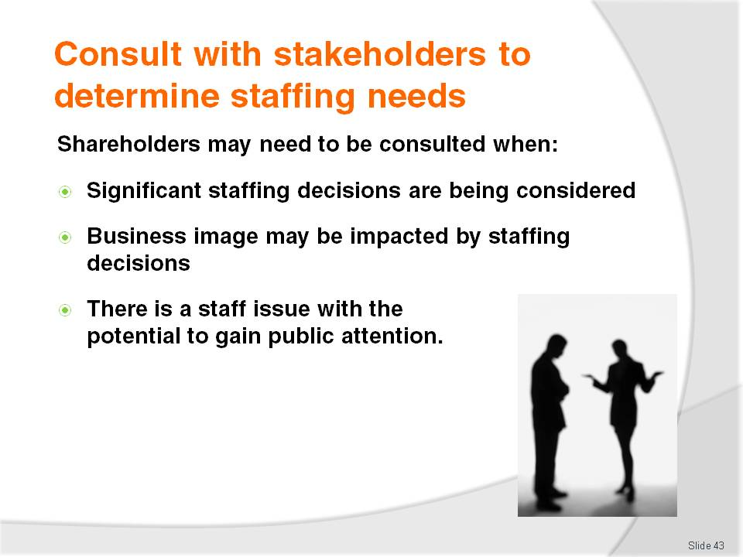
Slide No | Trainer Notes
Trainer tells trainees ‘shareholders’ may be public or private, explaining:
Public shareholders are those who have bought shares in the business on the Stock Exchange. It will never be trainees job to report to these people, or consult with them. The Board of Directors will do this
Private shareholders are individual who have a stake in the business – they are often family of the person who founded the business or friends or selected investors
Trainer states there may be a need to consult with these people when:
- Significant events relating to staffing are being considered – such as:
- Large scale redundancies
- Response to a major industrial relations issue
- Across-the-board pay rises
- Costly improvements to working conditions
The reputation or image of the enterprise is likely to be impacted by the staffing decisions being considered due to personal image and reputation
A staffing issue arises with the potential to gain external attention – and impact on how ‘the public’ regard the enterprise. This may be an unfair dismissal allegation, an allegation of harassment or an alleged breach of EO legislation and requirements.

Slide
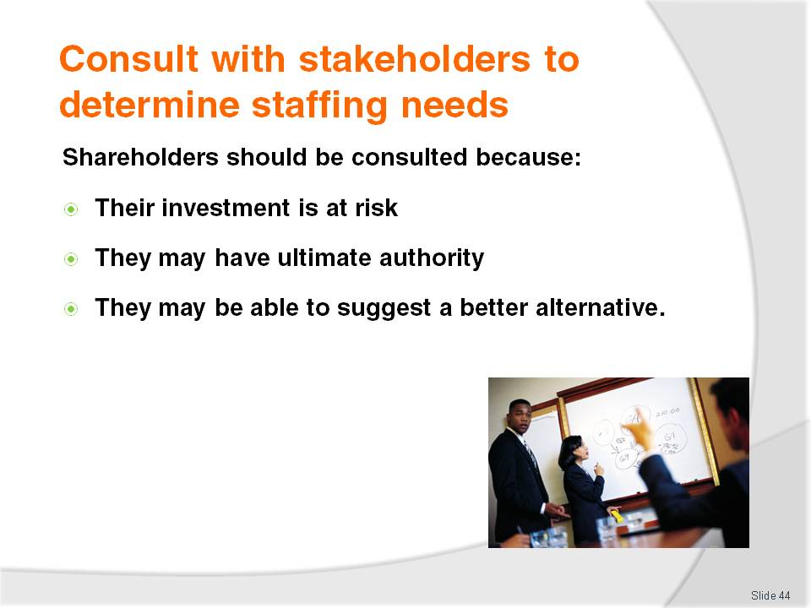
Slide No | Trainer Notes
Trainer suggests to trainees shareholders should be consulted because:
It is their money at risk – and they are therefore entitled to an opinion
They can have ultimate authority – to approve or reject proposed action
They may be able to provide valuable alternate insight into an issue – and contribute a different way of thinking throwing a fresh perspective on a topic.

Slide
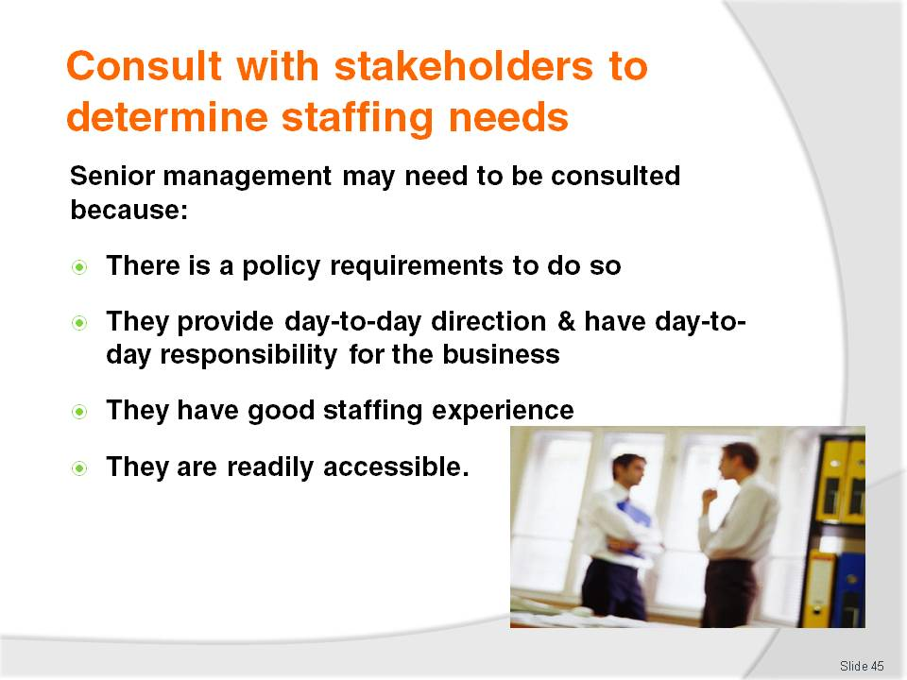
Slide No | Trainer Notes
Trainer identifies for trainees senior management can include:
Department managers
Division or section managers
Nominated managers from Head Office
Supervisors are not senior managers.
Trainer recommends to trainees senior management may need to be consulted over staffing needs because:
Enterprise policy dictates they must be consulted with – on nominated issues, or on a regular basis (say, every three or six months)
They form the nucleus of the group who provide direction for the day-to-day operation of the business – balancing the:
- Strategic goals and objectives of the business, and
- Day-to-day imperatives of the workplace
They usually have extensive experience in relation to staffing – either at the venue, elsewhere within the industry or at other properties within the chain
They are more readily available and accessible than the Board of Directors – buy usually have similar knowledge and information that the Board does.

Slide
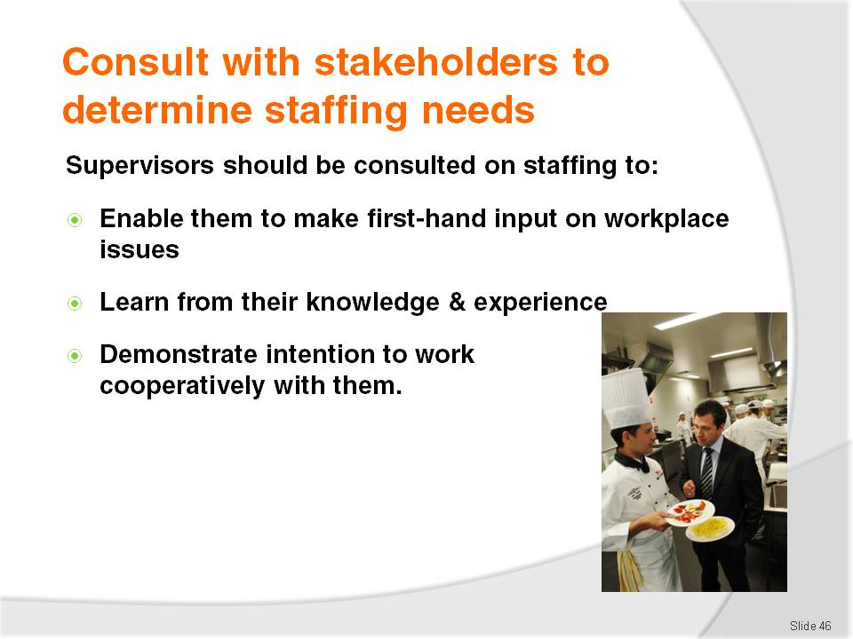
Slide No | Trainer Notes
Trainer informs trainees supervisors may be regarded as middle-level managers.
They should be consulted regarding staffing matters in their area to:
Enable them to provide first-hand and relevant information about:
- Workplace needs
- Service provision
- Allied issues not already considered –they may be able to show how reducing the hours of a certain staff member is likely to have flow-on, unseen impacts in other important areas
- Feedback from staff about staffing action – that has been proposed, or has been implemented
Learn from their knowledge and experience relating to the staffing topic being considered – most supervisors have an extensive working knowledge about the area for which they have responsibility
Demonstrate intention to work with them and include them in decision making impacting their staff – it is best to work with these people in a cooperative and collaboratively manner. In many cases, when a supervisor is convinced a staffing change is a good idea, they will convince their staff likewise. Unfortunately, the reverse is also true!

Slide
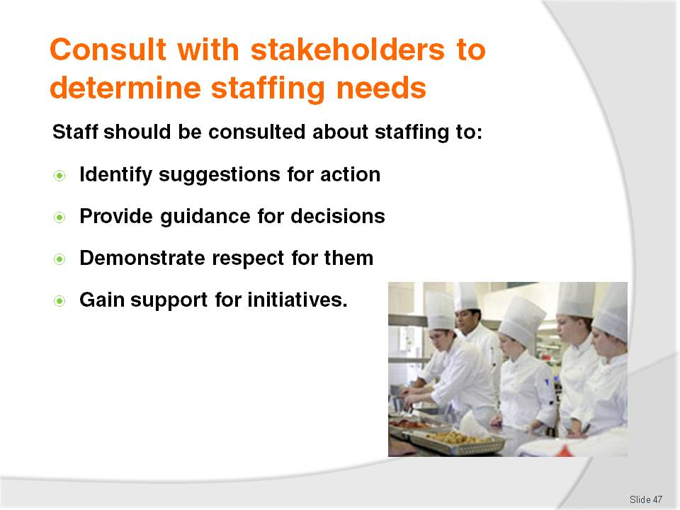
Slide No | Trainer Notes
Trainer advises trainees workers are often the forgotten stakeholders when staffing decisions are made.
Too many people make staffing decisions and then impose these on employees, on a take-it-or-leave-it’ basis, and this is to be avoided.
Trainer tells trainees staff impacted by staffing decisions should be consulted to:
Identify suggestions they have for action – arguably staff are best placed to identify staffing issues and make recommendations for how they can best be addressed
Provide guidance for the final decision – in terms of:
- How to effectively implement new ideas relating to staffing levels or changes to staffing
- When to introduce changes and new ideas
- Identification of potential problems related to change and how to overcome them
Demonstrate respect for them as a valuable resource – many businesses will state staff are their most important asset but do relatively little to demonstrate this orientation
Gain support for a staffing initiative – by explaining the proposal and explaining how it benefits staff (by making their work easier, safer; by saving resources; by providing increased job security, or potential for more hours, overtime or promotion.

Slide
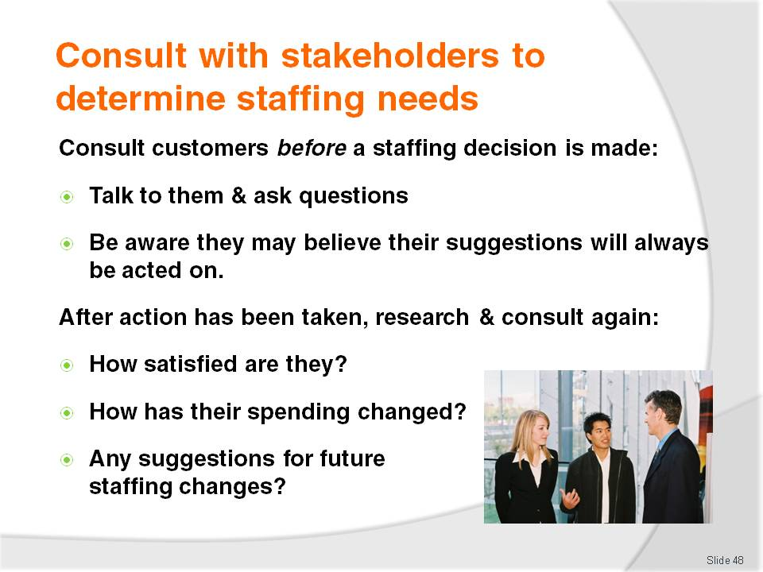
Slide No | Trainer Notes
Trainer instructs trainees that for some staffing considerations it can be useful to consult with stakeholders before or after making the necessary decisions.
Trainer states before making a staffing decision (such as reducing or increasing staffing levels, hiring someone in a new role, training staff in nominated new skills):
It can be worthwhile talking to customers and asking them:
- What they want
- How the changes would impact on their relationship with the enterprise
- How the changes would impact their spending or attendance patterns
Always be alert to the potential customers to believe their contributions will be acted on once they have made them. Customers can become disappointed and resentful if what they contribute does not materialise into reality. In short, consulting with has the capacity to be counter-productive.
Trainer further states after staffing changes have been implemented, customer can be re-interviewed to determine:
Levels of satisfaction – are they more or less satisfied? About what? Why?
Changes in spending as a result – are they buying the same or different things as a result of staffing changes? Are they spending more or less? Why?
Suggestions for further staffing-related change – what do they think needs to change to make things better?

Slide
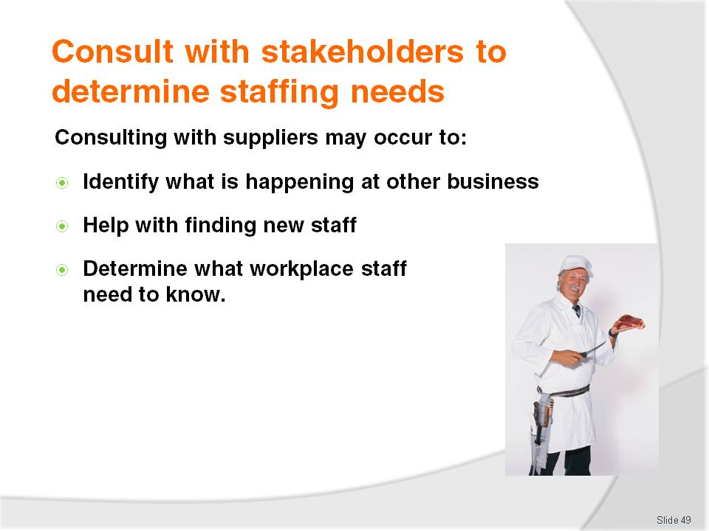
Slide No | Trainer Notes
Trainer tells trainees suppliers are rarely consulted in relation to staffing needs but may be contacted in relation to:
Identifying what is happening in other businesses – the fact suppliers deal with so many similar businesses means they can provide useful insight into what others are doing and not doing
Sourcing staff – to perform designated tasks. Staff who are dissatisfied often tell delivery drivers and sales representatives and these people can be effective in finding suitable staff
Providing information about what workplace staff (those who order stock, and deal with accounts) need to know – in order to facilitate a better relationship and smoother work flow between the business and theirs. Demonstrating willingness to work with suppliers usually means they will respond by being more willing to do likewise.

Slide
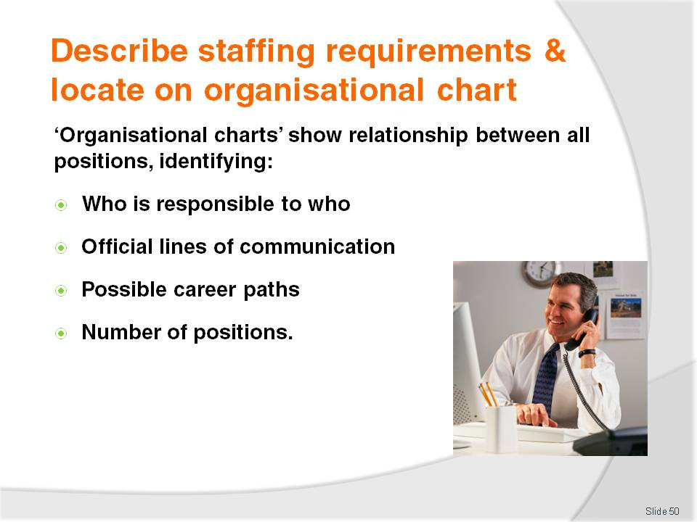
Slide No | Trainer Notes
Trainer states to trainees an organisational chart (sometimes known as an ‘organisation chart’) is a paper-based or electronic document setting out the hierarchical relationship between all the working positions within the enterprise identifying:
Who is responsible to who – the ‘lines of authority’
The official lines of communication within the venue – the ‘lines of communication’
Possible career paths for people within the enterprise
The positions within the business – by title
The numbers of positions – some charts identify the number of identical positions and some do not. Charts may show six separate boxes for six food waiters or there may be one box stating ‘Food waiters (6)’.

Slide
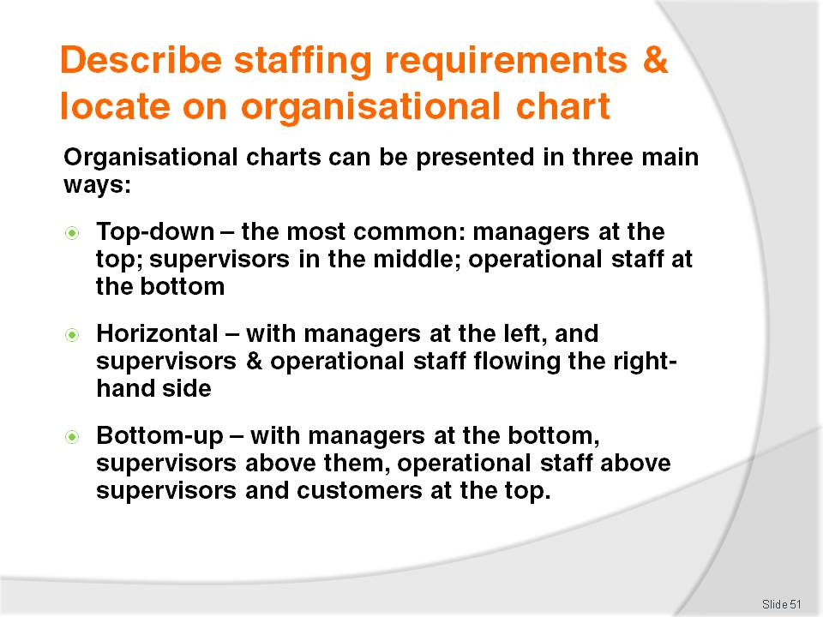
Slide No | Trainer Notes
Trainer tells trainees more about organisational charts advising:
Most establishments have a ‘top down’ organisational chart with senior management at the top of the chart and lower-level managers, supervisors and other employees shown below them. This is the traditional approach to creating organisational charts. It is arguably the most common
More modern thinking prefers the organisational chart to be a more ‘equitable’ in nature and features senior management on the left-hand side of the chart with lower-level managers, supervisors and other employees shown fanning out to the right-hand side. This indicates a less hierarchical approach to the business and intends to demonstrate the team-orientation to the operation of the business
Some business prepare an inverted organisational chart with senior management at the bottom of the chart and a pyramid of lower-level managers, supervisors and other employees shown rising up from them and showing ‘Customers’ at the top This is intended to indicate that it is the staff who are the keys to the organisation and that management exists to support their endeavours – as opposed to traditional organisational charts.
Class Activity – Handouts
Trainer obtains a range of different organisational charts and different types of organisational charts and:
Distributes same to trainees
Discusses same with the reference to:
- Positions identified
- Relationships between positions
- Terminology used
- Number of positions identified
- Lines of authority and communication shown.

Slide
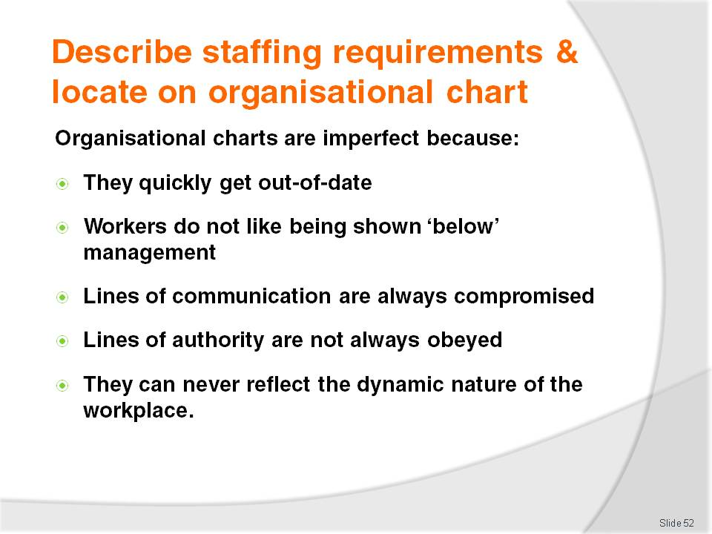
Slide No | Trainer Notes
Trainer explains organisational charts can be imperfect because:
Businesses often change their workforce structure but forget to update their organisational chart to reflect these changes meaning:
- It is often out-of-date
- People have little faith in something that is partially quite obviously wrong
Workers do not like been depicted as being below management – where a top-down structure is used
The lines of communication indicated by the organisational chart are always compromised – by the ‘Grapevine’ (see later slide)
The lines of authority shown on the chart are not always complied with – because adhering to them would take too long to make decisions that are required immediately
No chart can ever reflect the dynamic nature and personal working relationships that exist in any workplace – the lines shown on a chart can never illustrate the level of cooperation between two positions or departments.

Slide
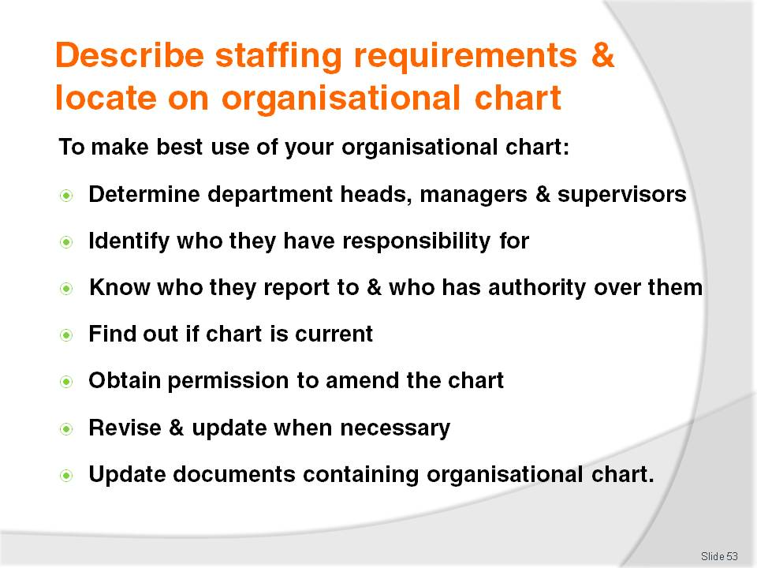
Slide No | Trainer Notes
Trainer tells trainees to make use of their organisational chart effectively they need to:
Know who the department heads, managers and supervisors are – these are the key players to consult with and obtain advice and input from
Know the actual positions and people they have responsibility for – so personal knowledge is embedded in the reality of the workplace and does not simply exist as a disembodied and impersonal chart
Know who they report to and who has authority over them – in case there is a need to go above them for help or approval
Know if the chart is current – an out-dated chart is confusing and can be worse than no chart at all
Obtain permission to alter the organisational chart – never make changes unless they have been approved by the owner, senior management or the Board
Strive to balance responsibilities – try not to over-load one position with too many responsibilities or tasks on the chart. Prepare a draft first and be prepared to revise it
Revise and update the chart whenever staff changes are made – in terms of:
- Staff numbers – where these are listed on the organisational chart. It should be a standard rule staff numbers are shown somewhere on the chart
- Names given to positions – existing positions can sometimes be re-titled
- New positions added to the chart
- Positions removed from the chart – including those where positions may have been combined
Making sure revised charts are:
- Included in Staff Handbooks
- Posted in required locations throughout the business
- Provided to management.

Slide
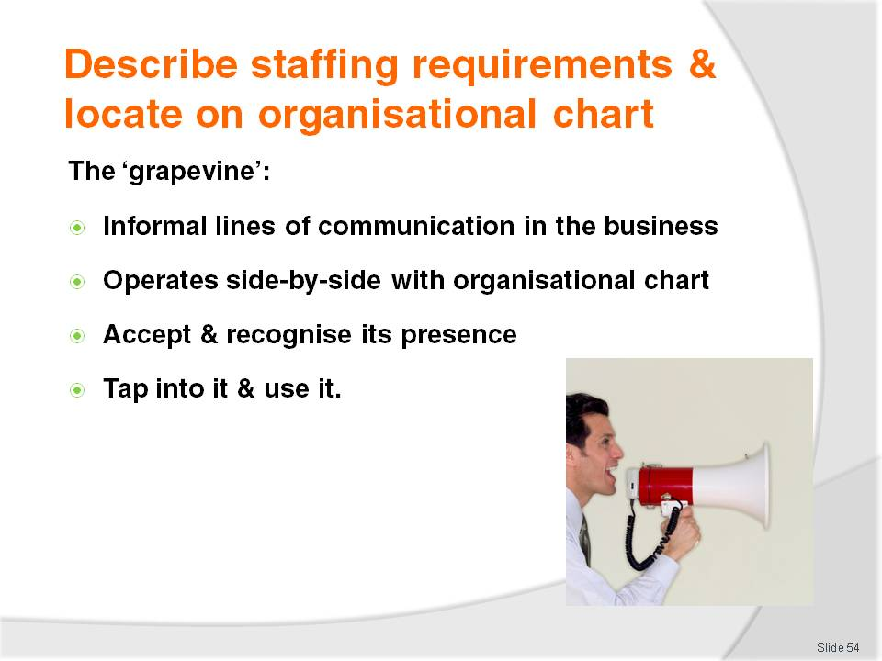
Slide No | Trainer Notes
Trainer provides advice to trainees about ‘the grapevine’.
The grapevine is the term used to refer to the informal lines of communication within a business. It is an effective informal network of communication that many believe is essential for success of any organisation:
The grapevine operates side-by-side with the formal lines of communication and allows staff to communicate informally with each other. It speeds up many essential communications and ensures no gaps exist in the formal structure through which excellent customer service, vital internal information, or communication may fall. Specific job descriptions may not show anyone or any position is specifically responsible for (for example) opening doors for customers but the grapevine will see this as necessary and ensure it gets done – all without management input
- As another example, there may be an emergency in the establishment. It would take too long for management to communicate with staff through the official lines of communication as shown on the organisational chart but the grapevine will pick up on the crisis, and deal with it instantaneously
An effective manager accepts the presence of the grapevine and learns to use it their advantage by tapping into it, using it and supplying it with information.

Slide
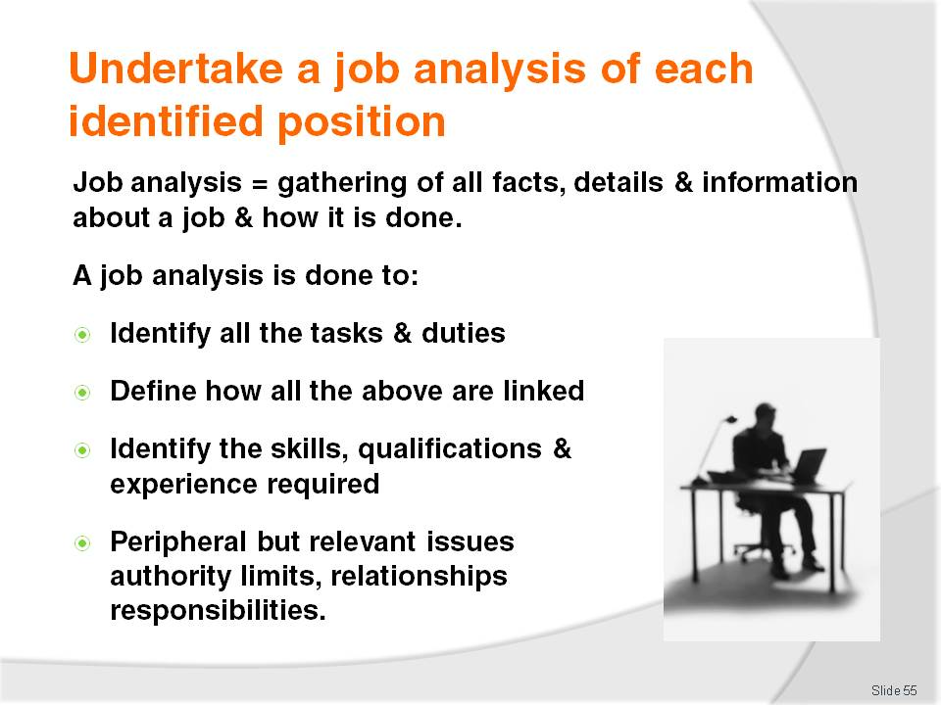
Slide No | Trainer Notes
Trainer states to trainees a standard requirement to undertake a job analysis for every position identified on the organisational chart.
A job analysis is the gathering all the relevant facts, details and information about a job and it is done to:
Identify all the tasks and duties – involved in carrying out the job in question
Determine and describe how all those tasks are linked together – and executed
Identify the precise nature of the skills, qualifications and experience – needed to do the job
Identify peripheral – but nonetheless vital issues – such as:
- Authority limits of the job – scope of authority
- Operational relationships between the job and other departments
- Positional responsibilities accompanying the job.

Slide
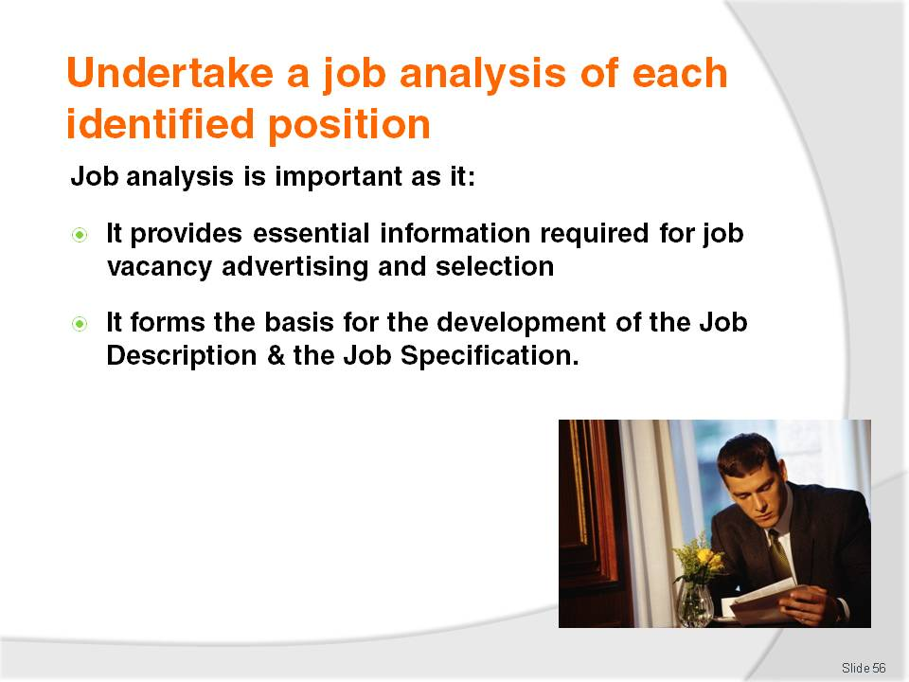
Slide No | Trainer Notes
Trainer explains to trainees why they need to undertake a job analysis for every position highlighting:
Knowledge about the requirements of a job is critical to selecting the right person for the job – correct selection can never occur unless there is comprehensive and current knowledge about the job to be done. The job forms the basis of Key Selection Criteria for the job, which in turn forms the basis for recruitment advertising
The results of a job analysis forms the basis for creating a Job Statement –a Job Description and Job Specification combined.

Slide
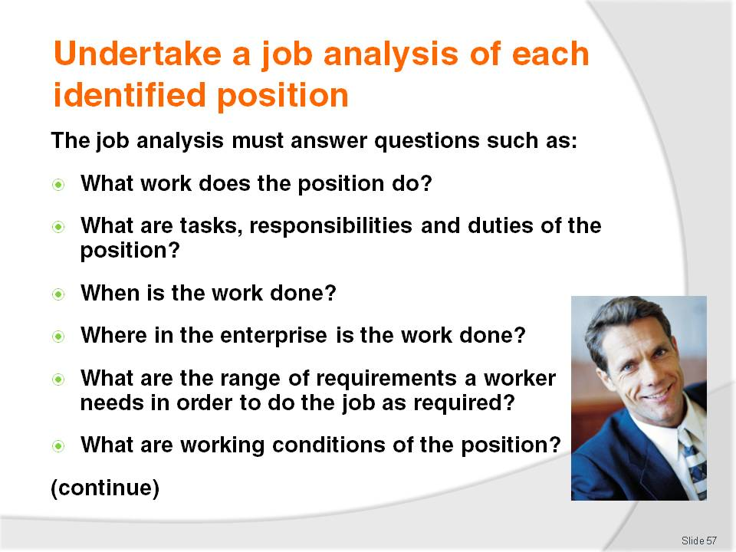
Slide No | Trainer Notes
Trainer encourages trainees to ensure the end result of any job analysis they undertake should give them comprehensive and current answers to the following:
What work does the position do? What are tasks, responsibilities and duties of the position?
When is the work done? Or when does it need to be done?
Where in the enterprise is the work undertaken?
What are the range of requirements a worker needs in order to do the job as required?
What are the working conditions relating to the position?
Class Activity – Handouts
Trainer obtains a range of job analysis documents and:
Distributes same to trainees
Discusses them
Highlights points of similarity and difference.

Slide
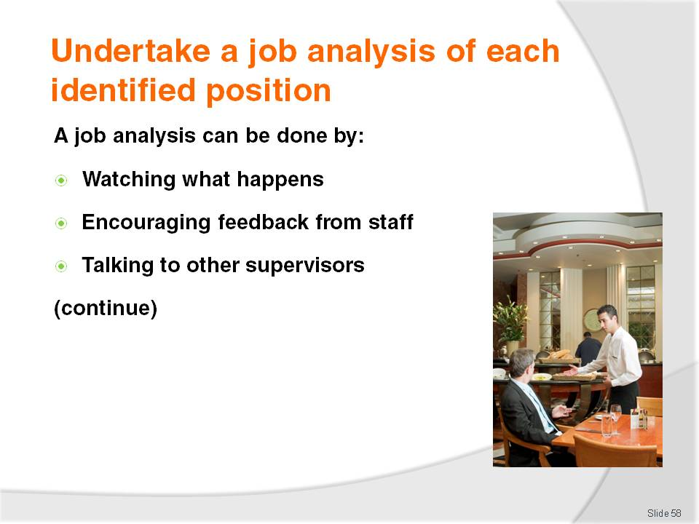
Slide No | Trainer Notes
Trainer teaches trainees there are several ways to produce an effective and comprehensive job analysis.
Each option is easy to apply and does not require special knowledge or skills but there is a need for a genuine desire to obtain the necessary information.
Trainer presents the following techniques for gathering relevant information stressing a combination of techniques always produces the best result:
Personal observation
This involves watching the job as it happens and taking notes to record the duties and tasks involved
It sounds a very basic thing to do, but it is surprising how revealing this exercise can be because the nature jobs tend to change over time.
Encouraging feedback from staff
This requires talking to staff to get their inside views of the task(s) involved. Questions should include:
- How has the job changed?
- What does the job entail now?
- What tasks have to be completed?
- How is time spent in the job today compared to previously?
- What skills and knowledge are needed to do the job well?
These questions may be asked verbally or answered may be captured using a question sheet which the staff are asked to reply to.
Talking to supervisors and others within the management network
This entails seeking information from management level personnel about what happens in the department. Questions should address:
- What do they need from the department in terms of service and products?
- How do they depend on a department and what it produces in order for them to be able to do their job properly?
- What needs changing in order for there to be an improvement?

Slide
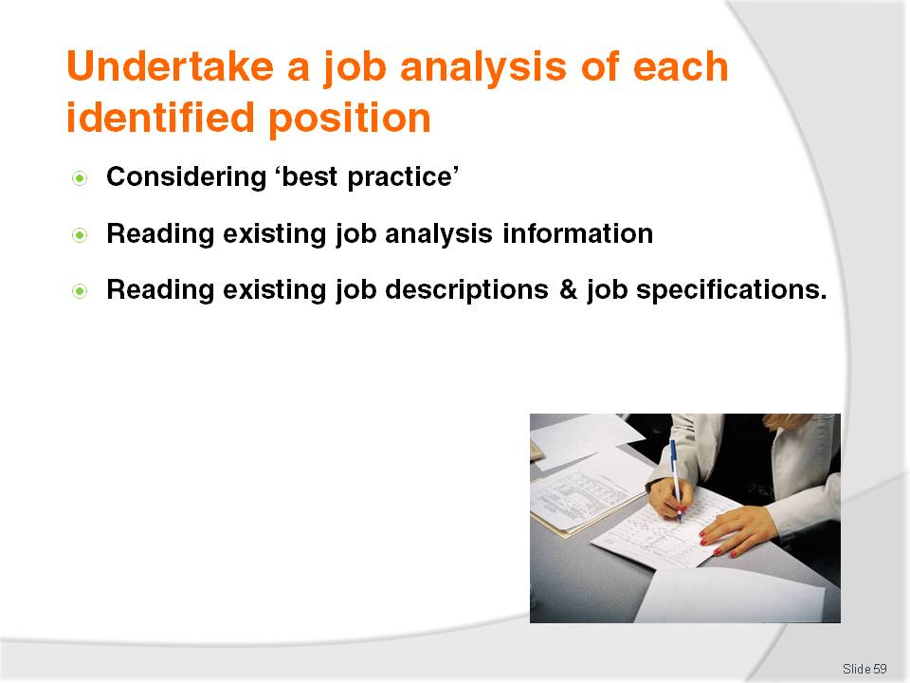
Slide No | Trainer Notes
Trainer continues to present to trainees techniques for undertaking an effective and current job analysis:
Considering ‘best practice’
This means investigating industry-recognised or approved steps, procedures, and protocols seen as producing the best available result in terms of (for example) productivity, safety, waste elimination, service standards, speed or cost saving
Consideration of what currently exists elsewhere as best practice should address:
- What could/should change in the workplace in terms of what is currently occurring?
- What would be involved in making these changes (cost, time, resources, training)?
- How can these changes be implemented or introduced?
Reading existing job analysis documentation
This is done to help determine how the current job has altered in terms of what is happening now
The previous job analysis gives a useful reference point, or baseline on which to evaluate the changes that have taken place in terms of the requirements for each position.
Reading existing job specifications and job descriptions
These documents provide excellent detail regarding individual jobs for the purposes of comparison with what is currently happening
See slides in following Section (‘Prepare job specifications and job descriptions for identified positions’) for more detail
Two important points to bear in mind when deciding to use these as a means of undertaking a job analysis are:
- They often do not exist – many job positions operate quite effectively within a venue without their being any formal job specification or job description for the role
- Many are out-of-date – it is important to check when they were produced as it is common for the position to have changed significantly without any similar change to the job documentation.

Slide
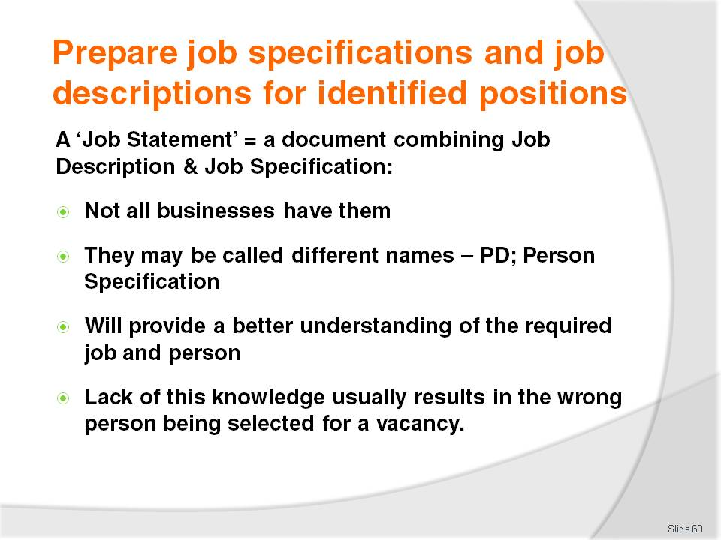
Slide No | Trainer Notes
Trainer tells trainees in order to gain a definite understanding about any position in the organisation it is imperative a current job specification and description are produced based on information identified in the job analysis.
Trainer presents the concept of ‘Job Statement’ to trainees:
The Job Statement is a document combining the Job Description and Job Specification
Not all enterprises have a Job Statement even though they may have both a Job Description and Job Specification
The Job Description may be known as the ‘Position Description’ (or PD)
The Job Specification is also known as the Person Specification
When a comprehensive and accurate Job Statement has been developed the business will be in a much better position to determine what type of worker to recruit because there will have a much better understanding of what the job entails and the requirements needing to be filled
Lack of sound, comprehensive and current knowledge about a position means a business risks starting the recruitment process with only a vague idea of what it is the person is required to do and this is obviously not a good idea.

Slide
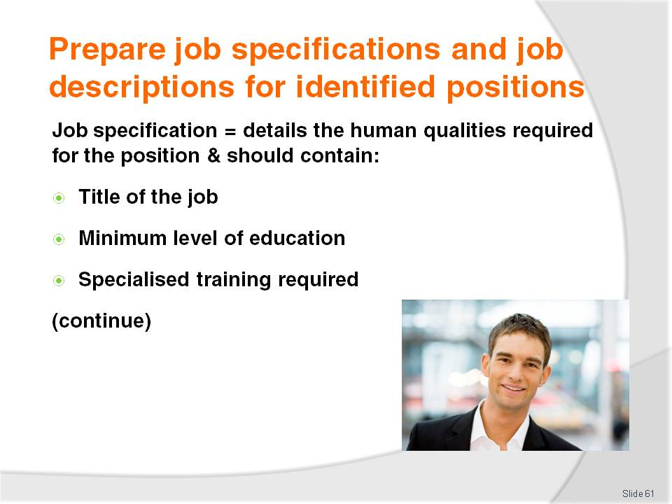
Slide No | Trainer Notes
Trainer tells trainees the job analysis helps describe the type of person best suited to the job under consideration.
It addresses the human qualities the best person for the job would possess.
Following are examples of what might be contained in a job specification:
Title of the job – to ensure everyone can identify the job being talked about
Minimum level of education – what level of secondary, or tertiary schooling is required, if indeed there is such a requirement? What level of literacy or numeracy does the position demand?
Any specialised education or training – is there a need for a special Certificate or trade qualifications?
Class Activity – Handouts
Trainer obtains a number of Job Statements, Job Descriptions and Job Specifications for relevant labour divisions, and:
Hands them out to trainees
Identifies, describes and discusses documentation
Questions trainees regarding:
How accurate do they think they are?
What information do they contain that the trainees did not think they would contain?
Why is the information provided actually listed in each document?

Slide
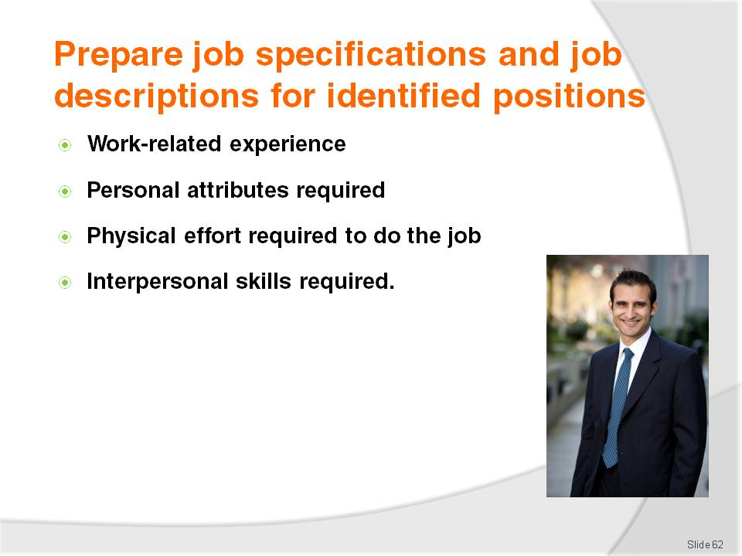
Slide No | Trainer Notes
Trainer continues telling trainees about job specifications:
Work experience – is actual, practical work experience necessary? If so, where should this experience have been gained and how much of it should there be? Should the person have had a set amount of experience in a certain business, department, trade or establishment type? Must they be familiar with certain things, certain pieces of equipment, or particular brands of machines?
Personal attributes – is it important they have, for example, attention to detail? Must they be ‘self-starters’? Must they be able to work unsupervised? Be reliable? Be prepared to work shift work?
Physical effort required – what degree of fitness or strength is needed? Is there heavy lifting? Will they have to spend time on their feet?
Interpersonal skills – our industry relies heavily on individuals who are ‘people persons’. Does this job call for a significant amount of this ability?
Class Activity – Individual Exercise
Trainer:
Hands out several examples of Job Specifications (these may ones used in previous Class Activity)
Identifies several job positions relevant to the labour division
Allocates one position to each trainee
Asks individual trainees to prepare a sample Job Specification for the position they have been allocated – trainees may be given access to text books, internet and other resources
Assists trainees as required
Provides feedback on their finished Job Specification.
Internet sites potentially useful to trainees may include:
http://openlearn.open.ac.uk/mod/oucontent/view.php?id=397321
http://www.businessballs.com/jobdescription.htm
http://humanresources.about.com/od/jobdescriptions/Job_Descriptions_Free_Samples_Examples.htm.

Slide
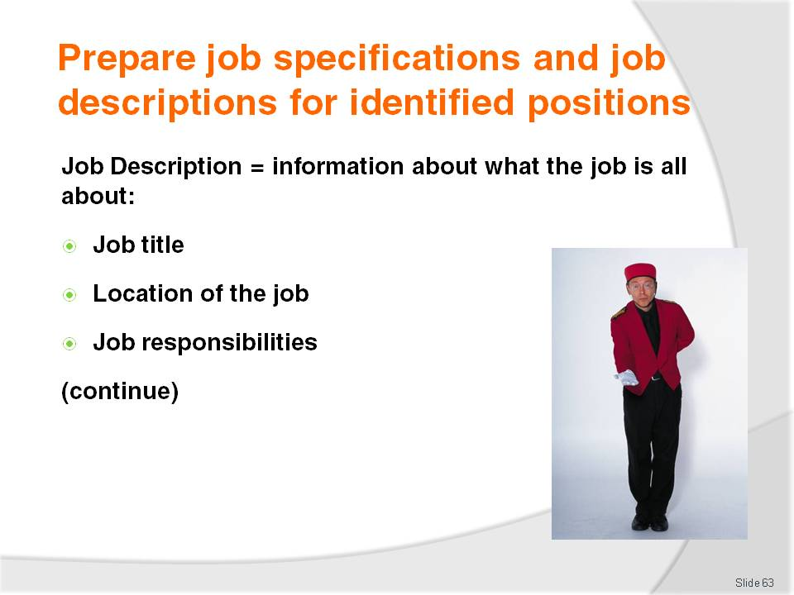
Slide No | Trainer Notes
Trainer explains to trainees another important document to be produced to assist with staffing is the Job Description.
These must be comprehensive, current and produced and updated on a regular basis.
A Job Description identifies what the job is all about:
Title of the job – to ensure everyone knows the exact position to which the description applies
Location of the job – a description of the department where the job is located. In some properties this may include the actual address of the job. There may be an added indication as to whether the position is front-of-house or back-of-house
Job responsibilities – this lists responsibilities which attach to the job including:
- Occupational safety and health responsibilities
- Supervision of others
- Performing banking duties
- Being responsible for ordering stock
- Balancing registers at the end of trade.

Slide
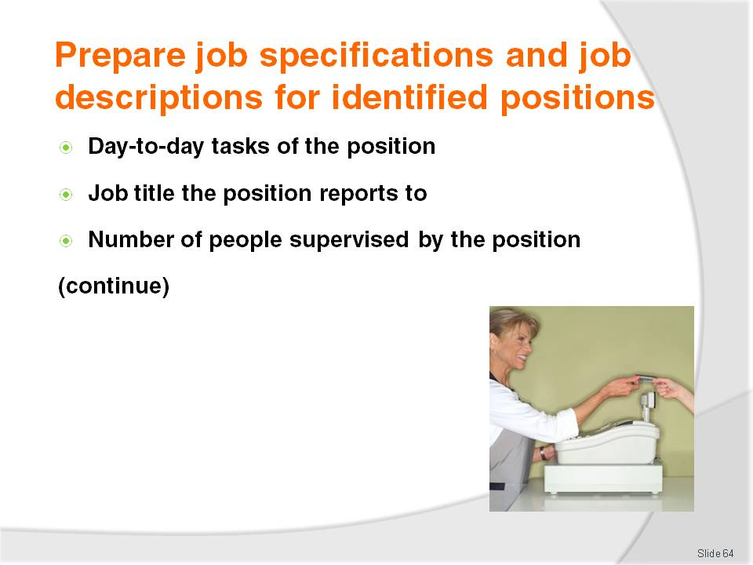
Slide No | Trainer Notes
Trainer continues explaining contents of Job Description:
Day-to-day duties of the job –it is a description of all work this position needs to do. Constructing this part of the Job Description will take a lot of time in order to determine the work requirements. The document should accurately reflect all the tasks the employee is expected to do in the course of their work. Examples include:
- Customer service
- Selling
- Cash register operation
- Stock-taking
- Pouring draught beer
- Tapping beer kegs and managing the cellar
- Stocking shelves
- Serving food
- Mixing drinks
Job title of the person the position reports to – this indicates who the position will be responsible to. This person should have had significant input into job analysis and subsequent construction of the Job Specification and Job Description
Number of people supervised – if the position is responsible to oversee the work of others, this section indicates the supervisory extent of the position.

Slide

Slide No | Trainer Notes
Trainer continues explaining contents of Job Description:
Working conditions – it may describe a location (an office, laundry, nightclub environment) and atmosphere (noisy, people-based/interactive, inside or outside)
Workplace hazards – specifying any potentially dangerous equipment, working conditions, working environment or work practices
Special work procedures to be followed –unique work and protocols designed to accommodate:
- Individual workplace layout
- Product standards or service levels
- Integration of one job or procedure with another in the workplace.

Slide
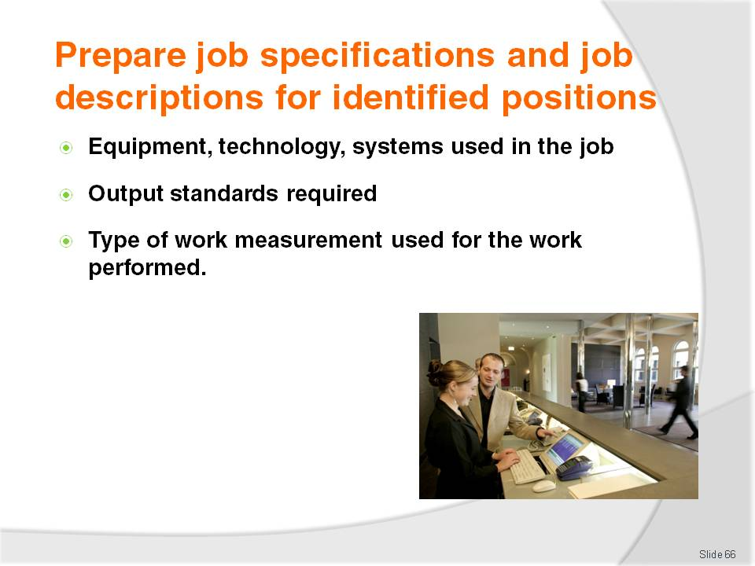
Slide No | Trainer Notes
Trainer continues explaining contents of Job Description:
Equipment used – this varies enormously and can involve specifying a certain type of equipment
Output standards required –identification of what is expected of each staff member in terms of quality and quantity standards relating to their workplace performance. This also informs potential staff members of what will be expected of them and lets them know in advance how their performance will be assessed
Type of work measurement methods used – this may not be so much a concern of small businesses but critical where pay rises are linked to productivity, so it is clear exactly how productivity will be judged when it comes time to assess worker issues such as individual contribution to overall performance and determine associated matters such as pay rises, promotions, extra hours, further responsibilities and training.
Class Activity – Individual Exercise
Trainer:
Hands out several examples of Job Descriptions (these may ones used in previous Class Activity)
Identifies several job positions relevant to the labour division
Allocates one position to each trainee
Asks individual trainees to prepare a sample Job Description for the position they have been allocated – trainees may be given access to text books, internet and other resources
Assists trainees as required
Provides feedback on their finished Job Description.

Slide
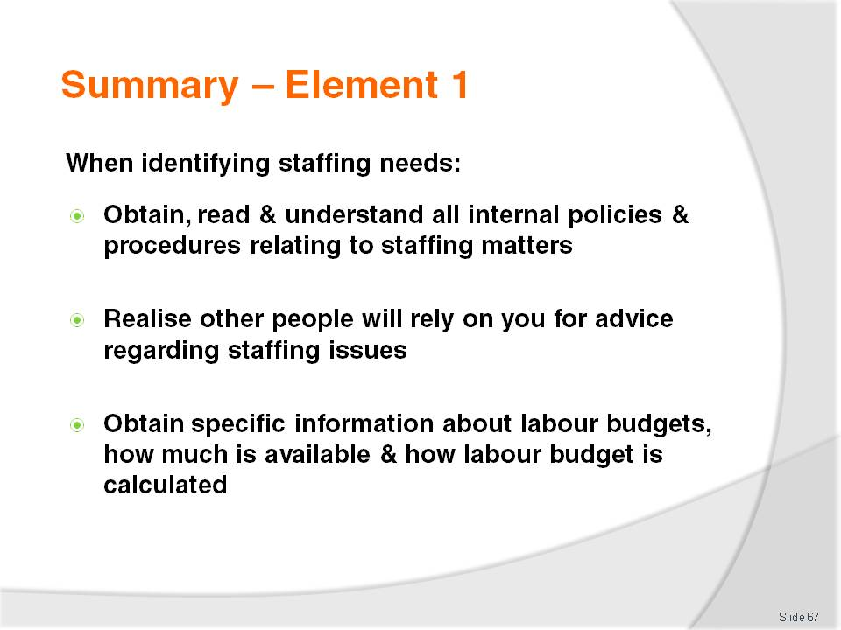
Slide No | Trainer Notes
 | Trainer provides a recap of the Element asking questions to check trainee understanding and responding to questions from trainees, as required.

Slide
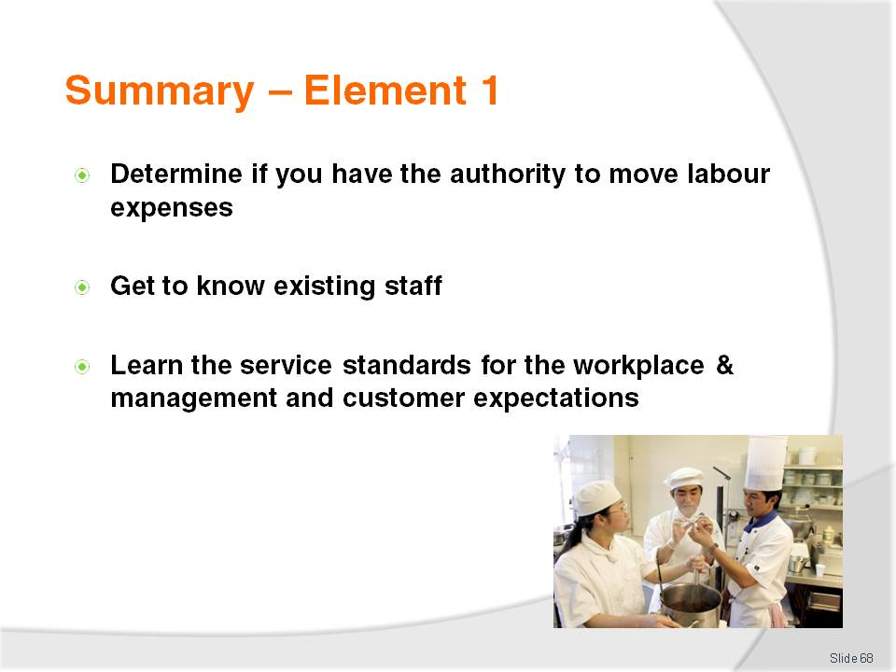
Slide No | Trainer Notes
 | Trainer provides a recap of the Element asking questions to check trainee understanding and responding to questions from trainees, as required.

Slide
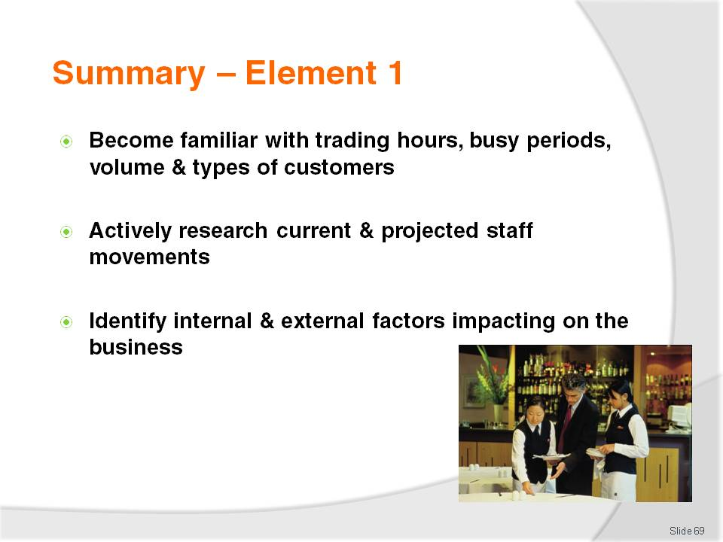
Slide No | Trainer Notes
 | Trainer provides a recap of the Element asking questions to check trainee understanding and responding to questions from trainees, as required.

Slide
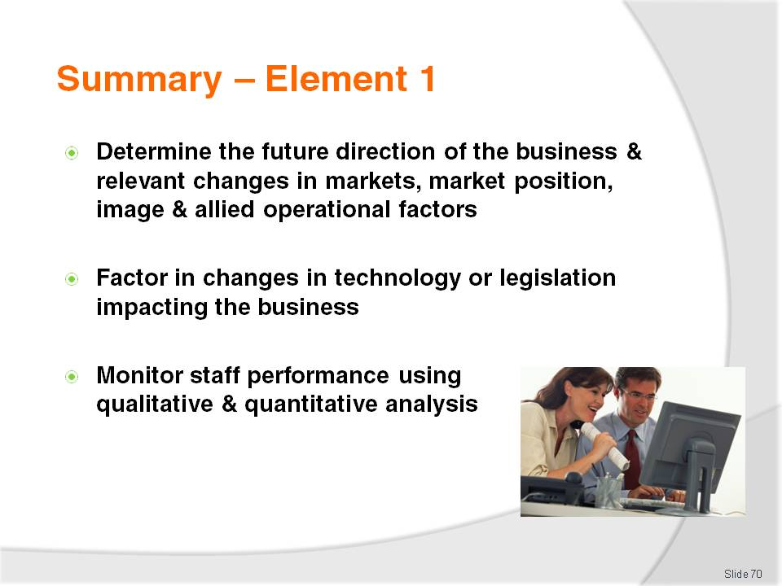
Slide No | Trainer Notes
 | Trainer provides a recap of the Element asking questions to check trainee understanding and responding to questions from trainees, as required.

Slide
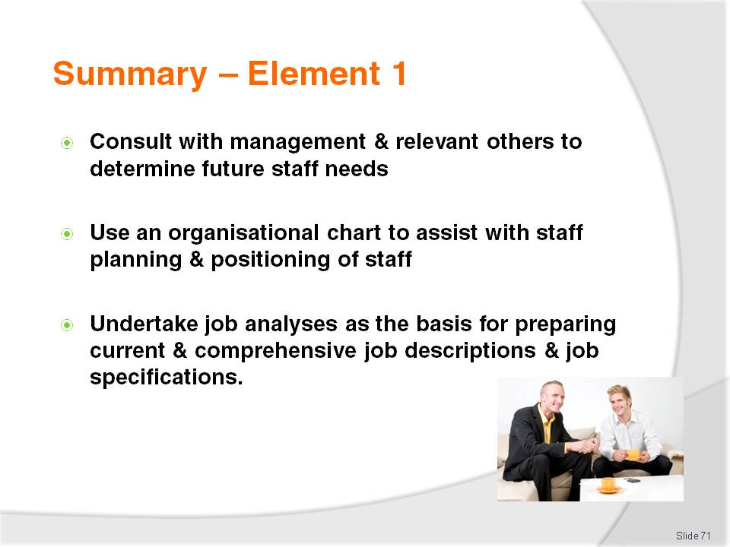
Slide No | Trainer Notes
 | Trainer provides a recap of the Element asking questions to check trainee understanding and responding to questions from trainees, as required.

Slide
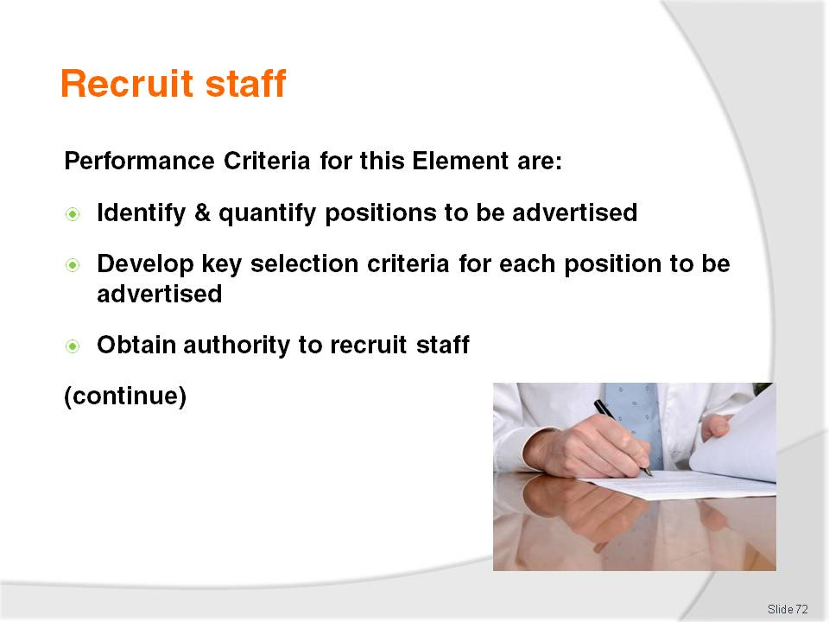
Slide No | Trainer Notes
 | Trainer identifies for trainees the Performance Criteria for this Element, as listed on the slide.

Slide

Slide No | Trainer Notes
Trainer identifies for trainees the Performance Criteria for this Element, as listed on the slide.
Class Activity – Discussion
Trainer asks trainees questions regarding staff recruitment:
What does ‘staff recruitment’ mean?
How might a business recruit staff? What potential sources of staff are there for organisations to tap into?
How do businesses advertise for staff?
What is a ‘recruitment agency? What do they do? How do they operate?
What is online recruitment? What experience have you had with it?
What do you think is meant by the term ‘key selection criteria’?
What types of job advertisements have you seen in newspapers? Can you think of any that were particularly good or bad? Why did you think they were good or bad?

Slide
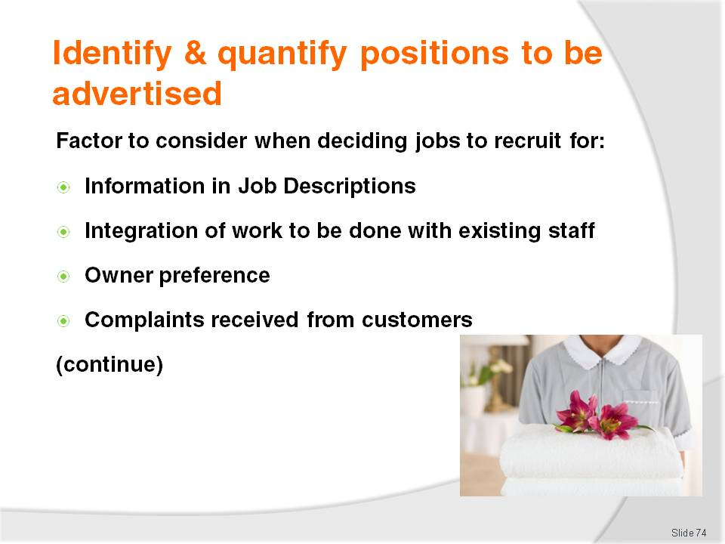
Slide No | Trainer Notes
Trainer advises trainees all staff recruitment must be targeted to identify needs.
The factors to be considered when deciding what types of jobs to recruit staff for include:
Information contained in the Job Descriptions – these are central to the decision and the primary tool to use
Integration of the required work to be done with other positions within the business to ensure:
- Seamless joining of new staff into the existing workplace and with current staff
- Optimisation of the use of equipment, time and other resources – the arrival of new staff should improve productivity and output rather than negatively impact it
Owner preference – in SMEs the business owner may have personal thoughts about staff required based on no other reason than a personal liking for a certain position
Complaints received from customers – where complaints have identified slow or poor service or products these are the areas to which attention should be focussed when hiring new staff.

Slide
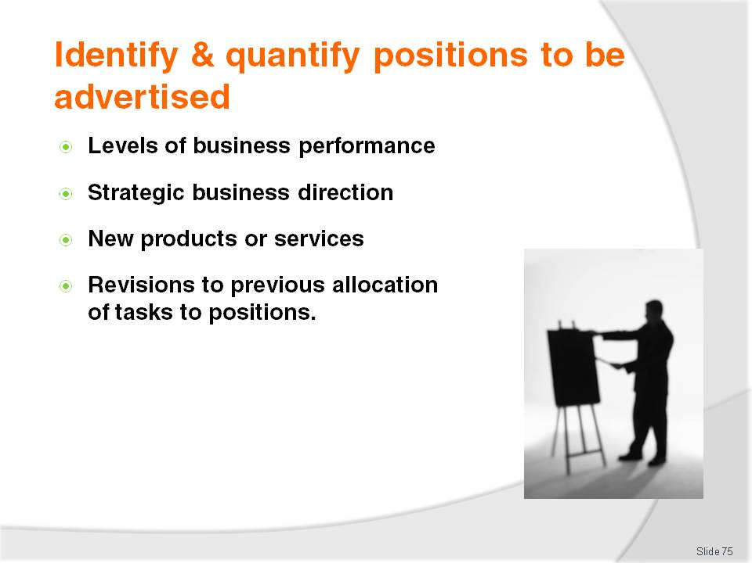
Slide No | Trainer Notes
Trainer continues to provide trainees with topics needing to be considered when identifying types of vacancies to be advertised:
Levels of business performance – checking internal records can reveal positions where recruitment needs to occur based on indicators such as falling sales, decreasing traffic, reduced bookings
Strategic business direction – where, for example, the enterprise has decided to enter into the fine dining market there can be a need to recruit waiters with silver service skills, waiters with gueridon service skills, a sommelier or a maître d’hôtel
New products and services – for example, providing:
- In-room service of meals (room service) will necessitate hiring staff able to serve breakfast, lunch, dinners and suppers to guests in their room
- Five-star service may mean the venue has to engage the services of a Concierge, porters, dining room hosts, lifeguards at the swimming pool and doormen
Revisions to previous allocation of responsibilities and tasks – while these should be reflected in revised job descriptions and specifications this is not always the case. For example, where a business is under new management, or decides to re-structure its organisational chart, there can be a need to recruit staff for certain departments who are multi-skilled to give the organisation more flexibility and cost-effective use of staff.

Slide
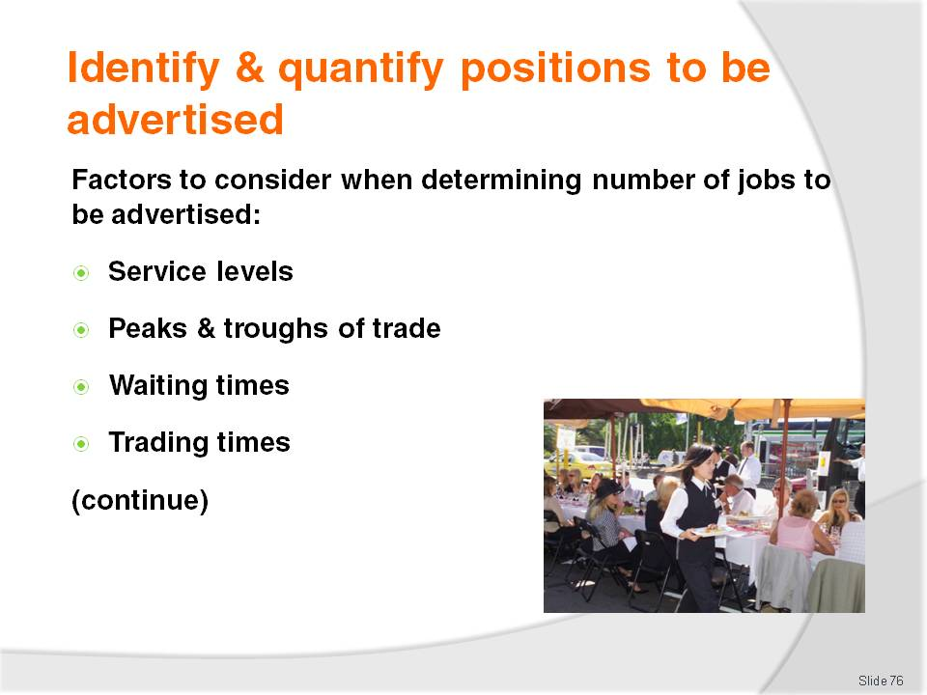
Slide No | Trainer Notes
Trainer presents to trainees factors to consider when determining the number of positions to be advertised and filled:
Advertised and expected service levels – there is a distinct relationship between staff levels and the standard of service provided to customers. If the business venue advertises high-quality service it will charge accordingly and customers expect this to be reflected in actual service delivery
Peaks and troughs of trade – recruitment of extra staff for high-demand times is to be expected
Waiting times – sufficient staff will need to be engaged to ensure the maximum acceptable waiting times for service to customers is not exceeded
Trading times – the longer the business is open, the greater the potential for more staff.

Slide
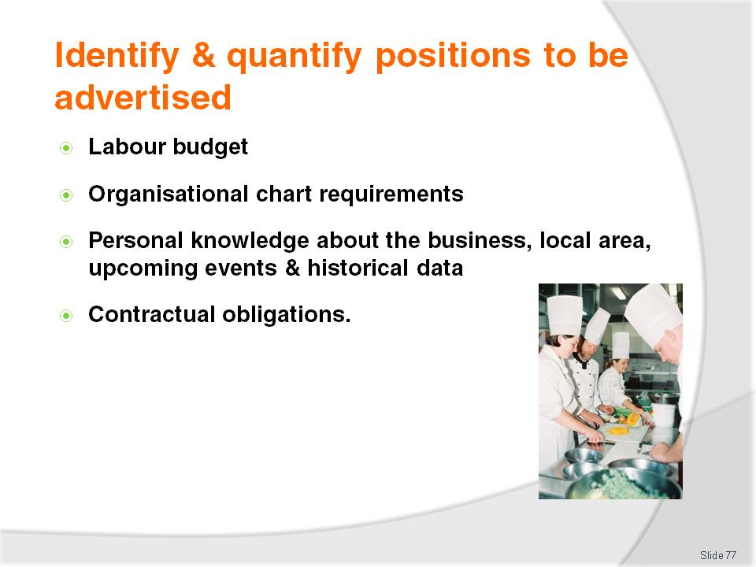
Slide No | Trainer Notes
Trainer continues to present to trainees factors to consider when determining the number of positions to be advertised and filled:
Labour budget – the link between staffing costs and revenue must always be a major consideration. No business ever has unlimited scope to hire and pay for staff
Statements made on the organisational chart – if the chart identifies twenty room attendants, then the maximum number who can be hired is twenty unless there is special dispensation from management to hire more
Personal knowledge about upcoming events –knowledge about other businesses in the industry, their activities, historical information, local events (business, sporting, religious) and customer demand on the venue at these times
Contractual obligations – where a business has entered into a contract with a customer, all promises made regarding type and numbers of staff must be met.
Class Activity – Guest Speaker
Trainer arranges for a senior industry person with experience with staffing matters to visit and:
Talk to trainees about their job, what it entails, what they do, who they liaise with
Explain challenges their job presents to them with reference to actual workplace events
Discuss the factors they take into account when determining the type and numbers of vacancies to advertise
Identify others they speak with before a final advertising decision for job vacancies is made
Describe the options they use for advertising vacancies and sourcing staff.

Slide
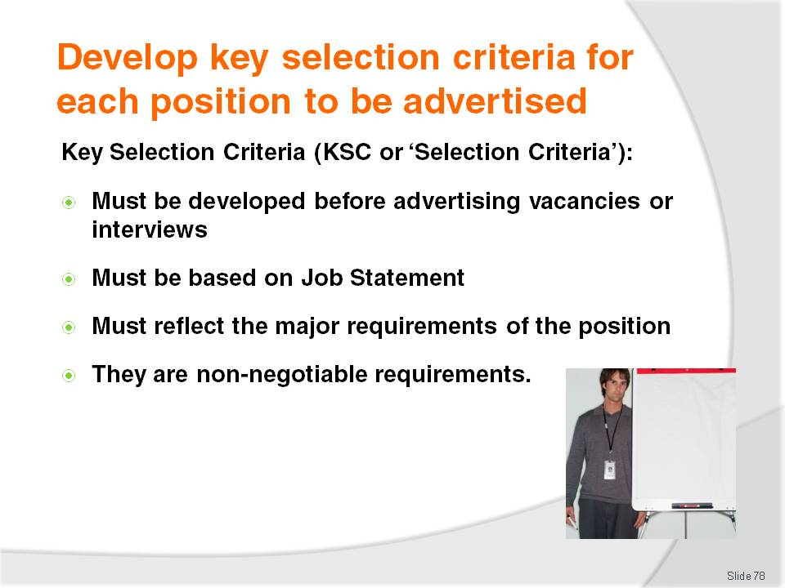
Slide No | Trainer Notes
Trainer explains to trainees before interviews for positions are conducted, key selection criteria for the vacancies must be developed highlighting:
Key selection criteria (KSC) are also known simply as ‘selection criteria’
During the job analysis, all the tasks involved in the position being analysed would have been identified – for every position these tasks could be classified as major tasks and lesser sub-tasks. The main tasks of the job will be used to determine the key selection criteria for the job. In effect KSC are the major elements of the position
KSC may include stand-alone requirements of the job or they can be a combination of Job Description and Job Specification information drawn together into a single statement. Other important aspects of the job can also form elements of the selection criteria, including:
- The need for a driver’s licence for some jobs
- Need for a Responsible Service of Alcohol certificate
- Ability to work weekends and nights
KSC can be seen as the non-negotiable elements of the job, the requirements which must be fulfilled by anyone obtaining the job
When the candidates for the position are being interviewed, their applications should be judged by how well they measure up to these criteria. The better the fit between the applicant and the selection criteria, the better the chances of them getting the job.

Slide

Slide No | Trainer Notes
Trainer provides trainees with additional information about KSC stating Key Selection Criteria should be:
Put in writing – giving clarity for each position. It is not enough they exist simply in the minds of managers, owners or supervisors
Developed in conjunction with:
- Management and owners
- Supervisors – of the department where the employee will work and other allied supervisors
- Staff – impacted by the work the position does
Shared with the people who will interview job applicants – and make the decision about the selection of the successful job applicant for the job vacancy so they know what these minimum requirements are.

Slide

Slide No | Trainer Notes
Trainer continues advising trainees about KSC explaining:
The exact nature of the KSC will vary between positions and between enterprises
In general KSC will address:
- Competencies – these are the skills required to discharge the requirements of the position as identified in the job analysis
- Experience – which can be written to reflect the needs of the position in terms of, as appropriate:
- Number of years experience – in an industry sector. Care must be exercised to ensure this KSC does not indirectly breach EO requirements (for example, a KSC requiring 20 years experience automatically excludes selection of people under the age of 40 years and thus is discriminatory)
- Time using a nominated system, item of equipment or technology
- Context – stating (for example) the successful candidate must have experience ‘dealing with people’, ‘selling packages to corporate clients’ or ‘supervising waiting staff’.

Slide

Slide No | Trainer Notes
Trainer continues advising trainees about KSC explaining:
Qualifications – detailing the formal credentials required for the position. These qualifications may be legal or internal requirements
Compatibility –the need for any new staff to integrate smoothly into the existing staffing arrangements and structure of the business. The ability of new employees to ‘fit in’ and ‘get on’ with existing staff cannot be stressed too strongly
KSC are also used as the basis for preparing Interview Rating Sheets.
Class Activity (1) – Handouts
Trainer obtains a number of KSC for a variety of positions and the job description (or job analysis documentation) on which they were based and:
Distributes same to trainees
Discusses and explains each KSC
Relates establishment of KSC to supporting job analysis or job description identifying why each KSC has been chosen as a KSC.
Class Activity (2) – Individual Exercise
Trainer:
Hands out several examples of KSC and associated Job Analysis documentation or Job Description (these may ones used in the above Class Activity)
Identifies several job positions relevant to the labour division
Allocates one position to each trainee
Asks individual trainees to prepare sample KSC for the position they have been allocated – trainees may be given access to text books, internet and other resources.
Assists trainees as required
Provides feedback on their finished KSC.

Slide
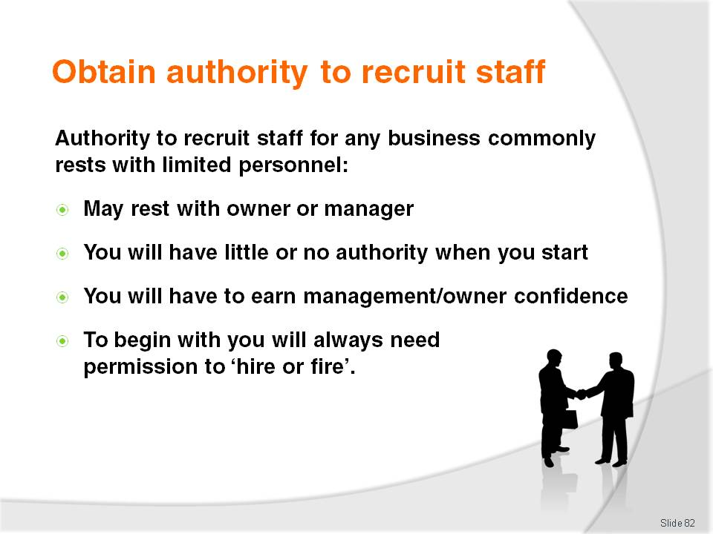
Slide No | Trainer Notes
Trainer highlights to trainees authority to recruit staff rests with very few people in any enterprise.
Sometimes only one person has the authority to permit the recruitment of staff.
Trainer further explains to trainees:
As they progress in the industry, they will find they have an increasing amount of discretionary authority. This means there will be more and more things they are allowed to make decisions about without having to consult anyone else
They will have to earn the confidence of management before this happens – based on their workplace decisions and actions
They will never be allowed to make any hiring decisions early in their career – they will always have to seek permission to hire and fire staff.

Slide
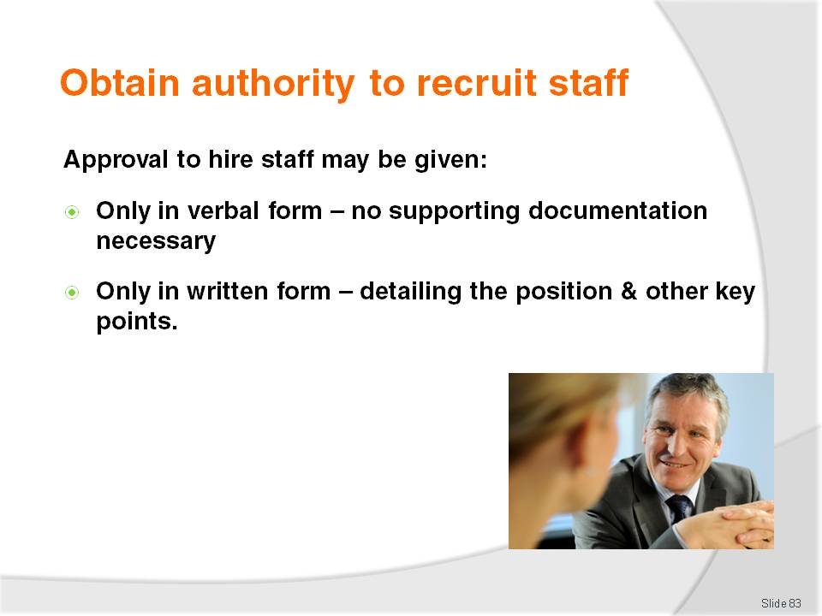
Slide No | Trainer Notes
Trainer informs trainees approval to hire staff may be:
Verbal approval only – this is common in most enterprises. It means there is no written authorisation given, at all
Written approval – a formal document identifying relevant key points:
The positions
Numbers of staff for whom recruitment permission is granted
Department recruitment applies to
Remuneration for each position for which authorisation is given
Timelines – for recruitment and selection.

Slide
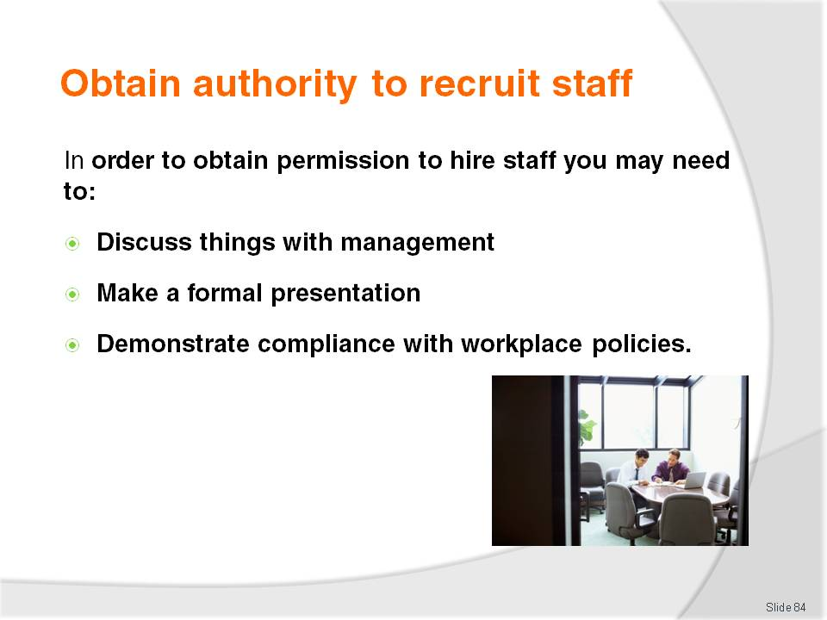
Slide No | Trainer Notes
Trainer explains to trainees in order to obtain approval to hire staff they may need to:
Verbally discuss the need for staff with management – this may involve:
- Explaining why staff are needed
- Making recommendations about numbers, job types and sometimes suitable people to promote, hire or train
- Justifying and defending proposals made to management
- Detailing the costs involved – in advertising and labour costs
Make a formal presentation – identifying the need for identified staff
Demonstrate compliance with internal enterprise policies – in recruitment and selection activities.

Slide
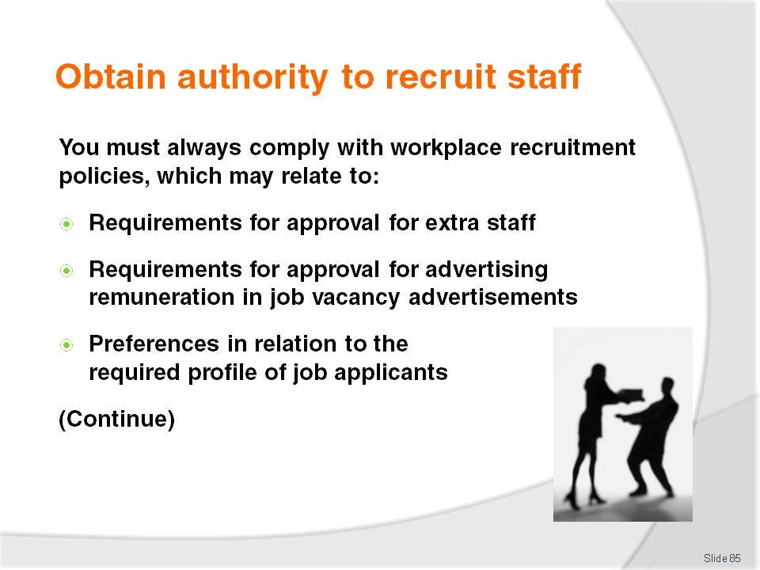
Slide No | Trainer Notes
Trainer states there is always a need for trainees to comply with enterprise policies in relation to recruitment.
These policies may embrace:
Approval processes for additional recruitment –from senior management or Head Office
Approval processes in relation to advertised remuneration – some businesses steer away from specifying remuneration in their advertisements. Sometimes the salary range for supervisors, managers and executives may be advertised but hourly pay rates for bar staff, waiting staff, room attendants and other operational-level staff cannot be advertised
Required profile of potential employees – are management are prepared to employ trainees for a certain position or whether they want fully-trained and experienced staff. Some businesses have a standard orientation to new staff:
- Some say they want untrained staff so they can teach them the way their organisation operates, do not come with inherent bad habits or other baggage from previous employers. Where government provides a wage subsidy (plus other benefits) for trainee positions, this can be a significant factor in determining who is targeted for a nominated position
- On the other hand, some businesses will say they only ever employ fully-trained staff because this saves then time and money on training, plus they are 100% work ready when they arrive
- Another variation is to aim for a blend of new staff with experienced and fully-trained staff. Some workplaces will also aim for a gender balance, and a balance between different ethnic backgrounds to maximise the languages spoken.
Slide
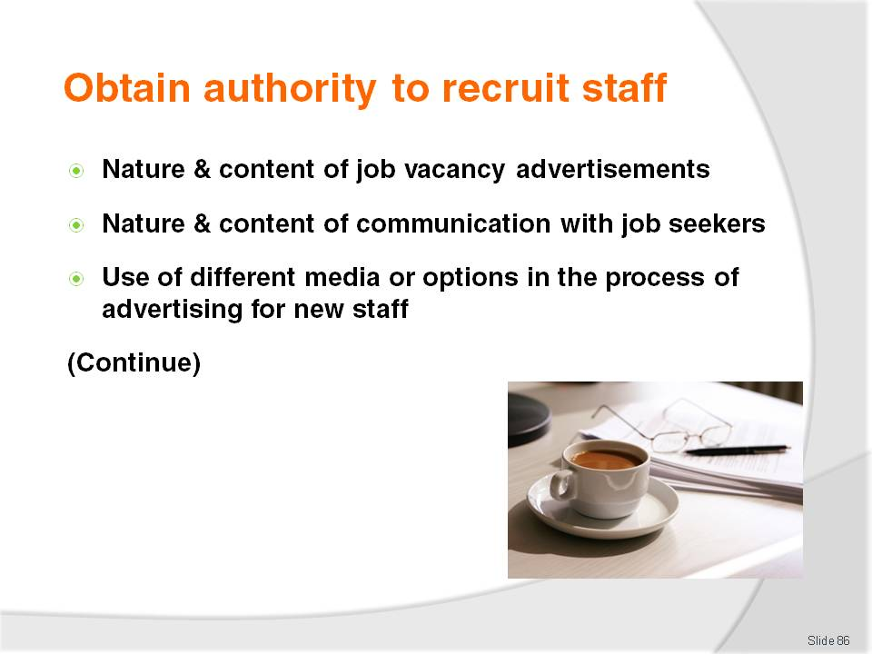
Slide No | Trainer Notes
Trainer continues to provide information to trainees regarding the need to comply with enterprise policies in relation to recruitment, which may include:
Nature and content of job advertisements – some premises will insist their telephone number or even name of the business is not included in advertisements
Nature and content of communications with applicants – there is often a standard protocol for those wishing to apply for a job, and this is usually spelled out in the advertisements. Examples may include:
- ‘For more information, phone the Office Manager’
- ‘For a position description, phone the Personnel department on …’
- ‘Those wishing to apply should forward three hand-written copies of a current curriculum vitae to the Head Housekeeper before close of business on Friday, 4th July’
Use of different media in the recruitment process – establishments traditionally use the printed media (predominantly newspapers) whilst other businesses use a range of options. See next Section ‘Identify sources of staff’ for more detail on options.

Slide
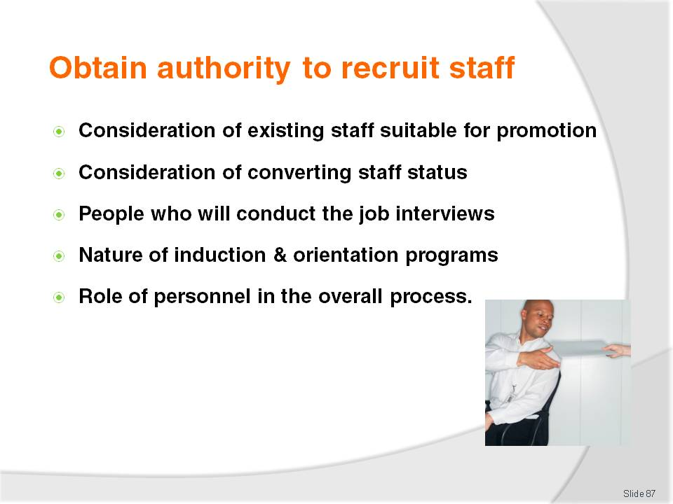
Slide No | Trainer Notes
Trainer continues to provide information to trainees regarding the need to comply with enterprise policies in relation to recruitment, including:
Promoting internally – a business may have a policy of recruiting for higher-level positions from within the company before any external advertisements or searches are undertaken. This policy can act as a motivator for existing staff and demonstrate there is a career path available in the organisation for employees who want to progress
Converting casual staff to part-time or converting part-time to full-time – as opposed to hiring new staff. Again, this policy provides existing staff with job security and demonstrates to workers management value them and are prepared to reward them for good work. Converting existing staff may also save time and expense associated with induction and basic training
Participants in interview panels – not all interviews are conducted using a panel format. Many industry interviews are one-on-one interviews between the department supervisor and the individual job applicant. Where interview panels are used it is common for the supervising manager to be on the panel together with at least one other staff member from the area under consideration. When panels are used, panels of two to three people are normal
Timing and nature of induction programs – these must be conducted early on, and will vary from a quick tour around the department, to a fuller, one to two day affair covering the entire premises. More on this on later slides
Role of different personnel within the recruitment, selection and induction process – these responsibilities may be shared within the one establishment or may be focused within the one individual or concentrated within one department.
Slide
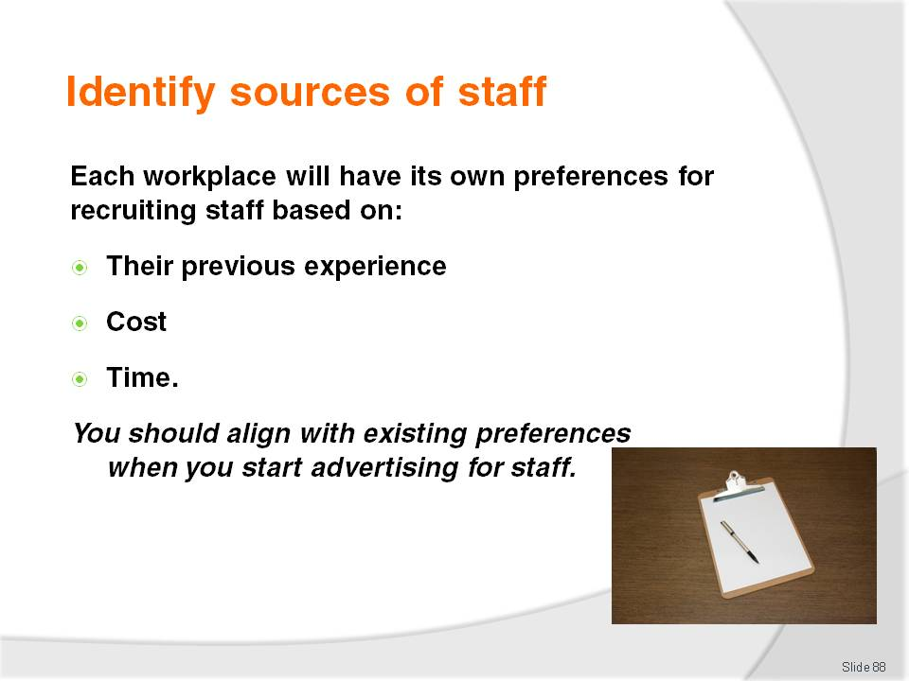
Slide No | Trainer Notes
Trainer tells trainees new staff may be recruited from a variety of sources.
The preferred sources of staff are based on a combination of factors:
Experience – with what is effective and what is not. Every business has experience with what options have worked for them in the past. Businesses tend to re-use options that have worked in the past, and resulted in the hiring of good staff, quickly at an acceptable time and with minimum effort. This highlights many businesses tend to not pay sufficient attention to a critical aspect of staffing – the recruitment process
Cost – employers will seek to minimise the cost of recruiting staff
Time – most businesses will prefer to spend less time of staff recruitment than more time.
Trainer emphasises to trainees when they start recruiting staff, they will be expected to conform with standard workplace practice in this regard.

Slide
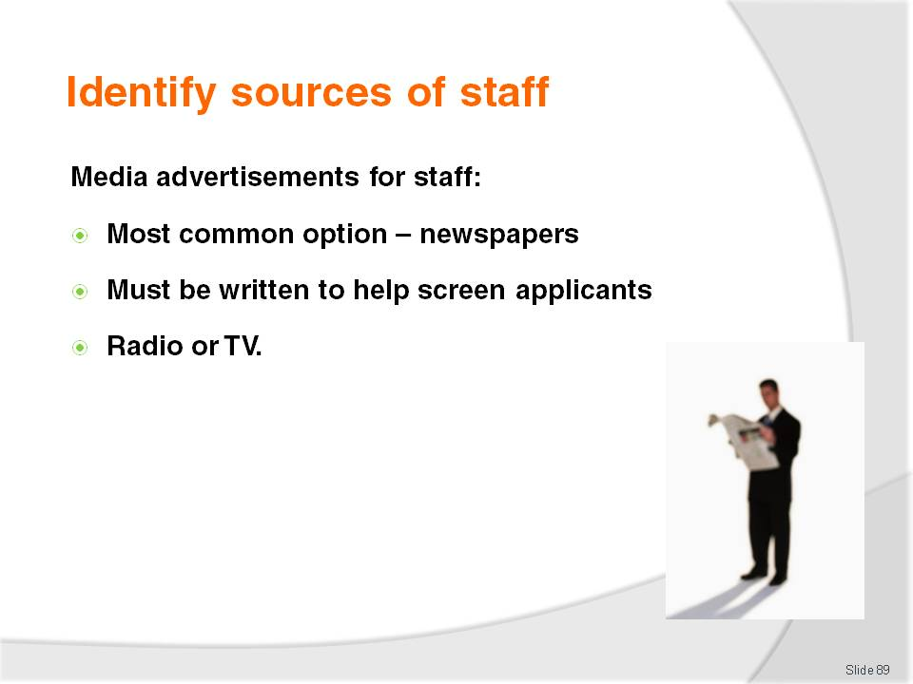
Slide No | Trainer Notes
Trainer introduces trainees to options for sourcing new staff presenting media advertisements as the first option:
The most common media for placement of job vacancy advertisements are newspapers. These are usually local mainstream newspapers but can include international newspapers and smaller circulation local newspapers
Some premises will use a very brief two to five lines in the ‘Situations Vacant’ section of the local (regional) newspapers whilst others will place large, display advertisements prominently featuring the name and logo of the property. The more prestigious the advertisement, the larger the property tends to be
Care and attention should be taken with the construction and wording of job vacancy advertisements as they should assist in the screening process of applicants. For example, if a position necessitates night work this should be spelled out in the advertisement. If applicants must be able to speak English, this too should be mentioned
In rare instances a business may elect to use radio or television to recruit staff but these options are relatively expensive and tend only to be used when other avenues for recruiting staff have failed or there is an urgent need for employees
Businesses can also elect to advertise job vacancies in trade magazines.

Slide
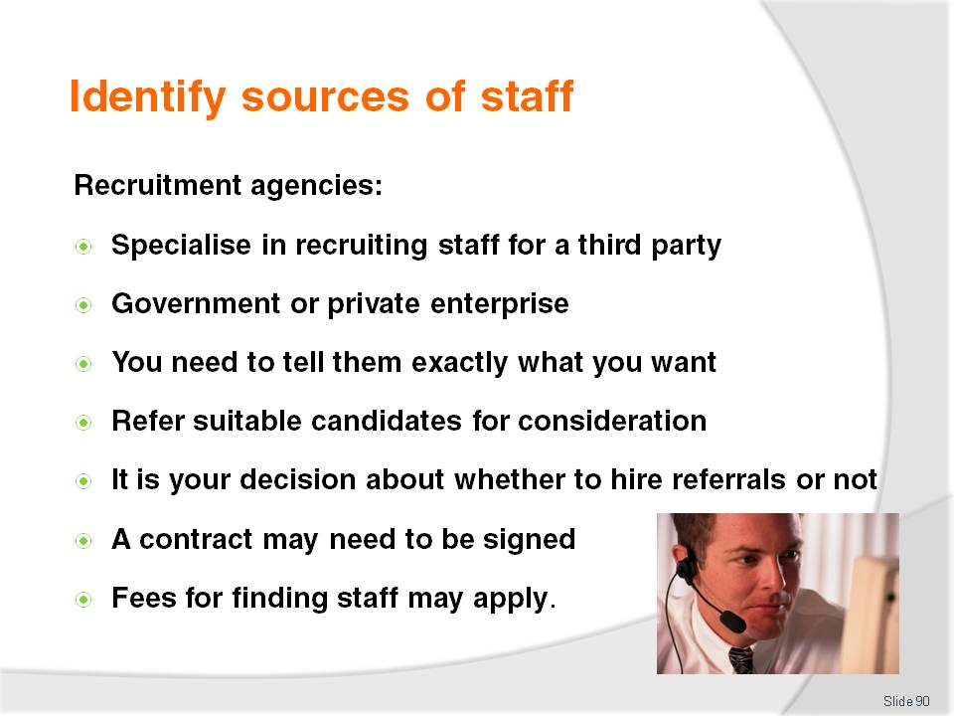
Slide No | Trainer Notes
Trainer presents trainees with information about job agencies and recruitment agencies as possible sources of staff:
These are businesses specialising in the recruitment of staff for businesses. They can be government-funded organisations or private enterprise operations
Most establishments will use the services of only one employment agency with whom they have worked with before and have demonstrated success
Most agencies will strive to develop an on-going relationship with any business using their services and are eager to identify and meet specific needs. There is a need to know what the business requires (in terms of staff required – refer ‘Job Statement information and Key Selection Criteria information) and what specific workplace needs are
When dealing with these agencies they recruit and screen potential staff on behalf of the business, evaluating them against criteria provided to them by the business. They then ‘refer’ (or ‘forward’) applicants they believe meet specified requirements and are worthy of an interview
The final decision about whether or not to hire staff who are referred rests with the business. There is no obligation to employ anyone who is referred
Some agencies will require a contract to be signed before using their services, and some will not
Some government services may be free but commercial organisations will charge for their services
Some agencies are industry-specific and others are general. Some agencies will specialise only in recruiting staff for the hospitality, food, travel business and no other industry type.
Class Activity (1) – Small Group Research Exercise
Trainer provides trainees with internet access and local/national telephone books and asks them – in small groups – to research possible recruitment agencies suitable for them to use.
Trainer suggest trainees visit http://www.jobcyclone.com/business_directory.php as a starting point for employment agencies that may be of use, or do a search on the web or in the telephone book for ‘employment agencies’ or ‘recruitment agencies’.
Trainer checks the agencies trainees have identified and contributes relevant other agencies the trainees have not identified.
Class Activity (2) – Guest Speaker
Trainer arranges for a representative from a suitable recruitment agency to visit and talk to trainees about:
Services provided to industry
Fees and charges, if applicable
Information the agency needs in order to recruit and refer suitable staff
Guarantees about staff referred or hired
What businesses can/should do to optimise the work the agency does on behalf of the business
Documentation associated with the recruitment process and the relationship between agency and employer.

Slide

Slide No | Trainer Notes
Trainer tells trainees there has been an explosion in the use of the internet to recruit staff explaining:
Businesses often include a ‘Work with Us’ section on their website, advertising vacancies available and explaining how to apply
Alternatively there are several recognised and effective businesses operating on the internet – all require employers to register (and pay a fee) before lodging vacancies.
Class Activity – Small Group Internet Research
Trainer provides internet access to trainees and asks them to:
Find relevant industry websites featuring job vacancies on the business website
Find, and investigate the operation of, at least three online recruitment agencies.
Trainer suggests the websites listed below (plus others as applicable to individual industries or geographic locations) as a starting point:
http://www.panpacific.com/en/singapore/offers/index.html?override_form=38
http://www.asianjobsite.co.uk/
http://www.orientpacific.com/goldrec.htm
http://www.escapeartist.com/jobs31/japan.htm
http://skorcareer.com.my/blog/15-popular-job-and-recruitment-websites-in-malaysia/2008/01/15/.
Slide
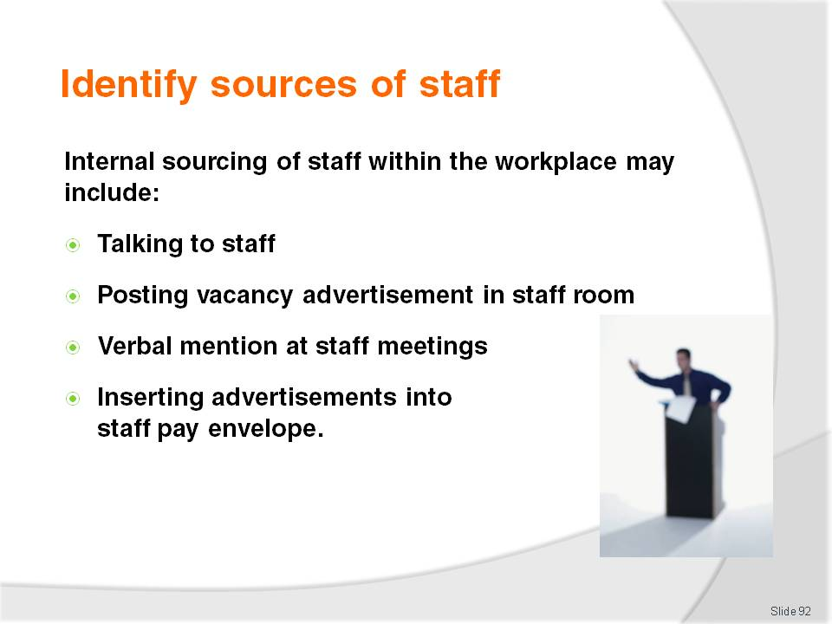
Slide No | Trainer Notes
Trainer states to trainees every business should be alert to the potential for recruiting employees from within their own organisation.
There are many benefits associated with recruiting someone to a position who already knows about the company, its operations, terminology, practices and knows other staff, management and customers.
Trainer informs trainees internal recruitment may include:
Speaking to individuals known to be interested or who have mentioned a desire to extend themselves or change roles
Posting an advertisement in the staff room
Mentioning the vacancy at staff meetings and briefings
Enclosing a copy of the job advertisement in pay envelopes.

Slide
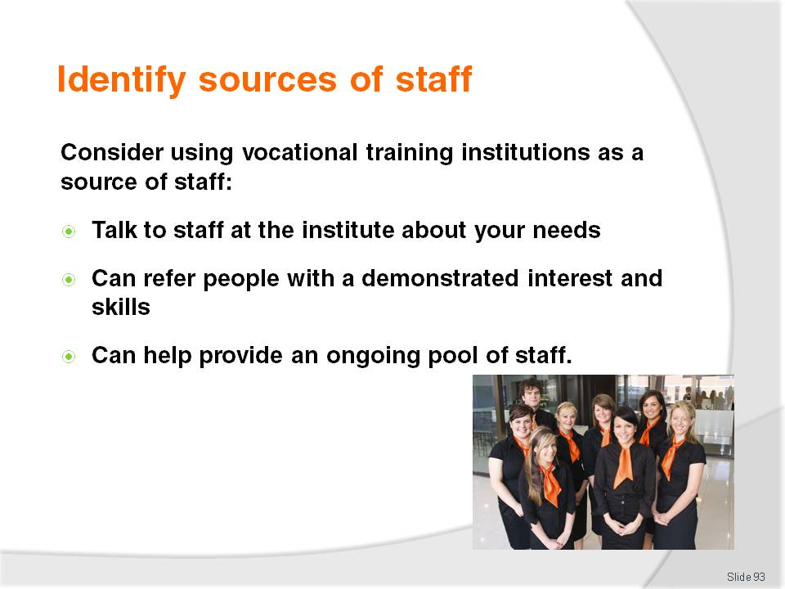
Slide No | Trainer Notes
Trainer advises trainees many excellent staff can be sourced from training institutions specialising in their particular industry, or labour division:
Contact staff at the school and advise them of business needs – this can result in the school referring an excellent worker who has already demonstrated an interest in the industry and who will already have some necessary skills
Forming this type of working relationship can be mutually beneficial and is something many businesses strive to do in order to:
- Help train the next generation of workers
- Guarantee an ongoing supply of trained staff
- Give something back to their country and industry.

Slide
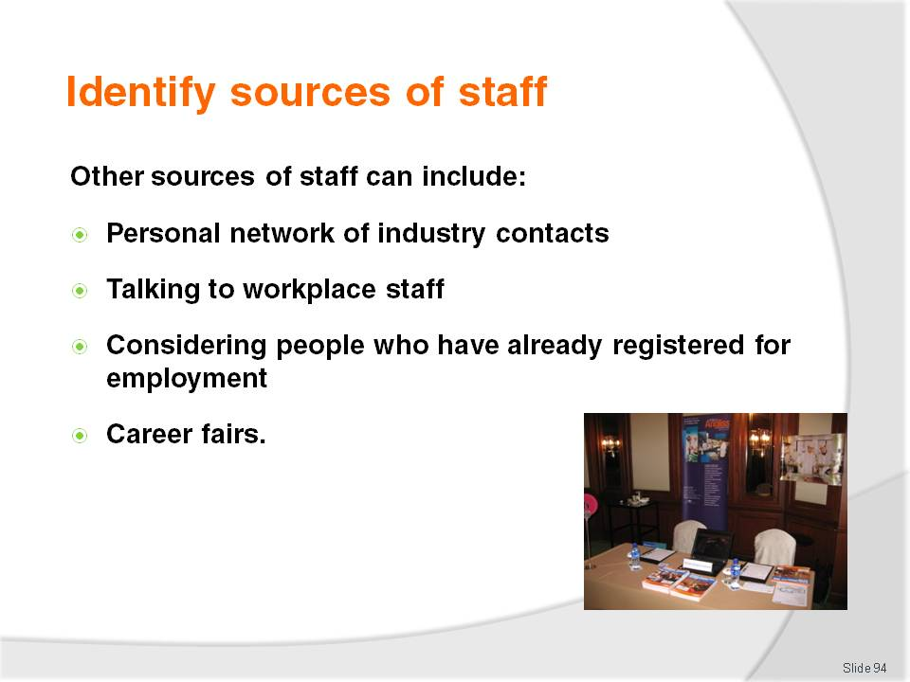
Slide No | Trainer Notes
Trainer explains to trainees further sources of staff may be:
Personal networks of industry contacts
This involves using personal industry network to help identify potential applicants
As experience builds in the industry more contacts will be developed who can assist in identifying individuals who are looking for work
Never be shy about contacting these people and advising them of needs
The industry frowns on one business ‘poaching’ staff from another business.
Talking to workplace staff
This is allied to ‘internal advertising’ but different
It means:
- Talking to in-house trainers – and asking them to identify staff with the potential to undertake work for positions where vacancies exist
- Talking to other supervisors – to see if they have staff who may be suitable, and looking for, a change in position
- Observing staff – to identify possible applicants based on their workplace performance
- Analysing workplace performance assessments – where formal staff assessments are conducted in the workplace, the documentation associated with these can indicate potential applicants.
Considering those who have already registered for work
Many enterprises encourage people who are looking for work to complete a standard application form for work even where no identified vacancy exists
These forms are then kept on file and used/referred to as a staffing source when workers are required
Some businesses also retain applications of those who applied for vacancies in the past but were unsuccessful in gaining a job.
Participating in career fairs
Some businesses participate in regular trade or career fairs as a means of recruiting staff. These fairs are commonly aimed at school leavers but also attract interest from the general public, both those who are unemployed and these seeking a career change
Much planning is required for these to be successfully used as a recruitment tool and there is, of course a significant expense incurred for participation: booths/stands have to be manned, advertising (including the event packages) have to be prepared and the overall image of the establishment has to be maintained
Use of career fairs as a recruitment tool is ineffective as a short-term recruitment solution because most of these events have quite long lead-times (up to six months), however they can be very useful as part of an overall recruitment strategy seeking to actively seek out job applicants and keep the name of the establishment in the minds of job seekers
Some recruitment agencies will act as agents at career fairs – for a fee, they will promote an establishment as an employer and answer questions and register applicants on their behalf
Careers fairs can be industry-specific or generic, and frequently feature employment agencies, schools and various government bodies. They usually feature career advice, tips on how to apply for jobs, writing applications and CVs, interview techniques and how to gain work experience
Online ‘career fairs’ have also become popular.
Class Activity – Internet Research
Trainer provides access to the internet and visits http://www.careersfair.com/ as an example of what is available and what is offered asking trainees to:
Identify upcoming items of interest
Identify how to register interest
Identify costs associated with participating
Identify what they believe they would need to arrange in order for a business to effectively participate in a career fair to optimise its use as a source of new staff.

Slide

Slide No | Trainer Notes
Trainer indicates to trainees the effective recruitment of staff through the media and recruitment agencies:
Is based on the provision of suitable advertisements or information to them
Must reflect business image – and align with how the company wants to project itself in public
May require advertisements and engagement with recruitment agencies to be authorised by management – before any action is taken or commitments made.

Slide

Slide No | Trainer Notes
Trainer highlights for trainees points to consider when writing a job advertisement include:
Business name and contact details – check with the business first however because some establishments prefer not to advertise their name as it can cause too many calls to be made to the premises
Businesses may want to include the address and telephone number – or there may be a requirement not to do so
Job title and job description – providing a brief outline of the tasks required to be carried out. This may need to be highlighted as it is often the element of the advertisement that attracts the attention of potential applicants
Description of the ideal applicant – this must be based on the job description and detail experience, skills, personal qualities and qualifications. It is important this is an accurate and honest depiction of what is required as it enables the advertisement itself to screen out inappropriate applicants.

Slide

Slide No | Trainer Notes
Trainer continues to present points to consider when writing a job advertisement:
The basis on which the person will be employed – permanent or casual, full-time or part-time. If there are a set number of hours per week this should be included. If there is the potential for overtime it is good to include this too
Benefits of the job – this will depend sometimes on the position being advertised. Some establishments only include this information for management level jobs. Information that might be included may relate to pay rates, flexible hours, free parking, employee discounts
Indication of how to apply – as and where appropriate give contact details including name of person to contact, a telephone number, fax number, email address or postal address. Indicate whether or not the applicant is to telephone or write for an application form
Tell applicants if the selection criteria are available to them and indicate if hand-written or computer-generated applications are required
Some organisations also offer tips on applying for positions with the company
Closing date for applications.
Class Activity – Handouts
Trainer assembles a wide range of newspaper job vacancy advertisements relevant to the trainee cohort and:
Distributes and discusses them
Asks trainees to evaluate them from the point of view of a person seeking employment:
- How good or bad are they?
- Do they provide enough information?
- What extra information should have been included?
- Which adverts seem most effective and why?
Highlights the media used
Examines the days of the week the advertisements are lodged.

Slide

Slide No | Trainer Notes
Trainer advises trainees the following are tips to assist them write better job vacancy advertisements:
Write clearly – avoid jargon and enterprise-specific terminology
Write a draft – and be prepared to revise and revise it
Refer to previous similar advertisements – and use them as a basis
Include relevant information from the most recent job analysis – to help identify what the job involves and to help screen out unsuitable applicants
Name a contact person – so applicants can ask questions or obtain further information
Read the advertisement from the perspective of an applicant – try to see the advertisement through their eyes. Consider asking someone else to read the draft advertisement and provide feedback.

Slide

Slide No | Trainer Notes
Trainer continues to provide trainees with tips on writing job vacancy advertisements:
Do not waffle – stick to the necessary points. Do not load the advertisement with irrelevancies
Consider alternative ways for applicants to respond – options include:
- Paper-based application form – useful where it is important for applicants to have good hand-writing
- Online application form – at company website
- Hand-deliver application
- Post applications – to designated address, agency or box number
- Fax application through to given number or agency
Sell the benefits of the job – highlight pay and conditions
Point to additional information available – tell people where they can go or what they should to obtain (where available) KSC, tips on applying, website for the organisation.
Class Activity – Guest Speaker
Trainer arranges for a representative from a local newspaper to attend and:
Explain job vacancy advertising options available through the newspaper
Discuss costs
Give an opinion about frequency of placing job vacancy advertising
Explain the reach and penetration of the newspaper
Provide market research analysis of the impact advertising through the newspaper gives to advertisers
Explain special deal – for multiple adverts and repeat runs
Provide tips on advertising in the press
Explain relevant legislation needing to be complied with when placing a job vacancy advertisement in the newspaper
Distribute examples of good and bad job vacancy advertising.

Slide

Slide No | Trainer Notes
Trainer identifies for trainees additional points to consider when advertising job vacancies:
It is also important to check with the source to be used to identify any special requirements they may have: common requirements can relate to size, terminology allowed, time by which advertisements have to be lodged, quality of the finished product, use of company logos
Check with management to determine how much money is available – for the placement of advertisements. This can dictate the medium to be used, the placement of the advertisement in that medium, how many times it runs and the size of the advertisements
It is always worthwhile getting someone else to proof-read any job vacancy advertisement – to ensure its accuracy and identify whether or not any important information has been omitted
Create and make application forms available – at the reception desk, via phone or fax or on the Internet.
Class Activity – Group Research
Trainer provides internet access to trainees and asks them to:
Find examples of online application forms relevant to the industry type of the trainee cohort
Visit http://www.vibehotels.com.au/default.asp?page=/about-vibe/careers-at-vibe-hotels/employment-application-form to view an example of an online application form relevant to the hospitality industry.
Slide

Slide No | Trainer Notes
Trainer advises trainees some businesses develop an ‘event’ or ‘information’ package to support their efforts at recruiting staff.
This package may contain:
Details about the history of the business – where, when and who started it
Statistics – outlining size and scope of the business, number of people served, number of staff employed or turnover
Awards – detailing any industry awards or prizes the business has one over the years.

Slide

Slide No | Trainer Notes
Trainer continues to identify to trainees the content of an information package that could be used to support recruitment activities:
Rates – sample menus, wine lists, room rates, schedules, time tables
Locations of the business – detailing where the organisation has properties, outlets, offices or agencies
Career paths – outlining the positions available for employees within the business
Policies – containing essentials of the specific employment-related company policies
Photographs – showing the facilities and thereby indicating the expected (dress and personal presentation) standards required from employees.
Class Activity – Handouts
Trainer obtains information kits used to support recruit activities for businesses and:
Distributes then to trainees
Asks them to discuss and critique them
Identify why inclusions have been included – why was the information included?

Slide

Slide No | Trainer Notes
Trainer emphasises it is necessary for them to identify and become familiar with the specific legal obligations imposed on employment advertisers.
Job vacancy advertisements should:
Make it clear all people with the right skills, qualifications and experience will be considered for the position – thereby indicating compliance with EO requirements
Mention any flexible working arrangements in place or that will be considered for the right person – to highlight preparedness to hire mature age people, working parents and care-givers
Avoid words such as ‘young’ and ‘mature’ as well as specifying age ranges or limits are unlawful – so the wording of the advertisement is age-neutral. If looking for mature age workers, consider replacing the terms 'senior' or ‘mature person’ with ‘experienced’, or ‘able to work unsupervised’.
Class Activity – Guest Speaker
Trainer arranges for a relevant recruitment agency to attend and:
Identify local legislation to be complied with when advertising job vacancies
Distribute information sheets and similar providing advice on how to prepare a legally compliant job vacancy advertisement
Lead trainees on a guided tour of their website.

Slide

Slide No | Trainer Notes
Trainer continues identifying to trainees the possible legal issues they need to comply with when writing a job vacancy advertisement:
Avoid any reference to race, religion, marital & parental status or other personal characteristics – focus the advertisement on the specific skills and qualifications required
Include a statement such as 'we are an age-friendly organisation' or 'people of all ages are encouraged to apply' – to demonstrate there is no age-based discrimination
Contain gender-neutral terminology –for example use ‘Supervisor’ instead of ‘Foreman’, use ‘Room Attendant’ instead of ‘House Maid’ and use ’Waiting staff’ instead ‘Waitresses’.
Class Activity – Individual Exercise
Trainer identifies a range of job positions relevant to the trainee cohort and:
Allocates one per trainee
Asks them to write an effective job vacancy advertisements suitable for placement in the local newspaper
Provides feedback on the advertisements created.

Slide
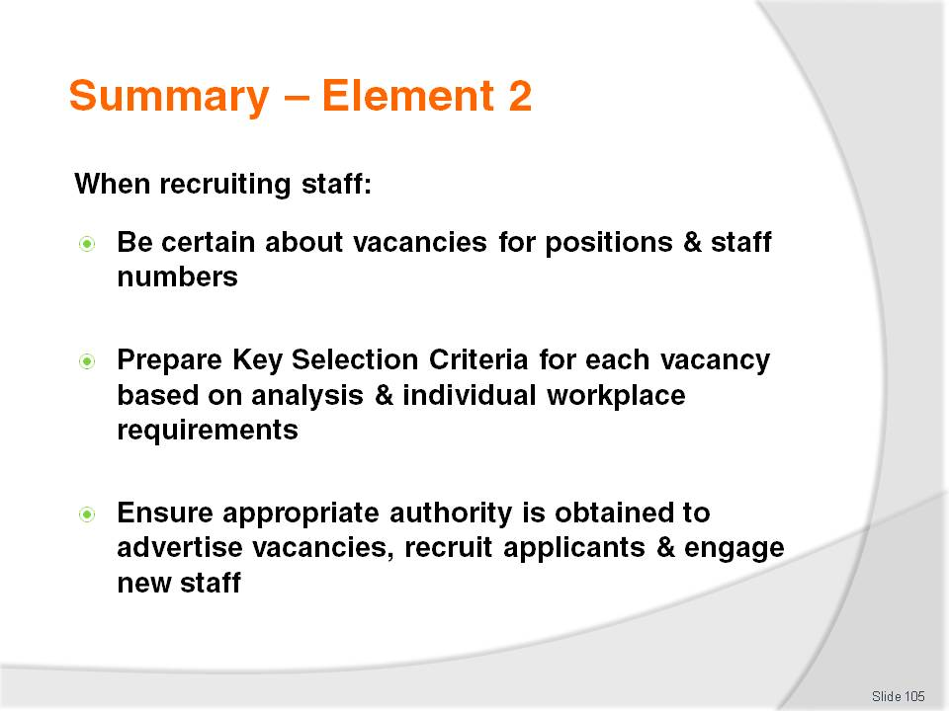
Slide No | Trainer Notes
 | Trainer provides a recap of the Element asking questions to check trainee understanding and responding to questions from trainees, as required.

Slide

Slide No | Trainer Notes
 | Trainer provides a recap of the Element asking questions to check trainee understanding and responding to questions from trainees, as required.

Slide

Slide No | Trainer Notes
 | Trainer provides a recap of the Element asking questions to check trainee understanding and responding to questions from trainees, as required.

Slide
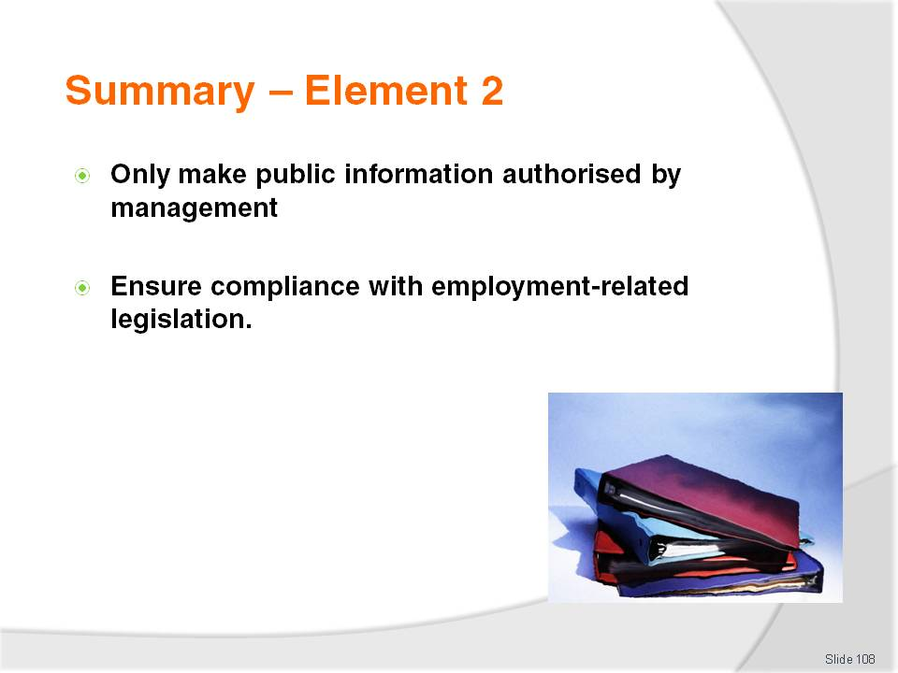
Slide No | Trainer Notes
 | Trainer provides a recap of the Element asking questions to check trainee understanding and responding to questions from trainees, as required.

Slide
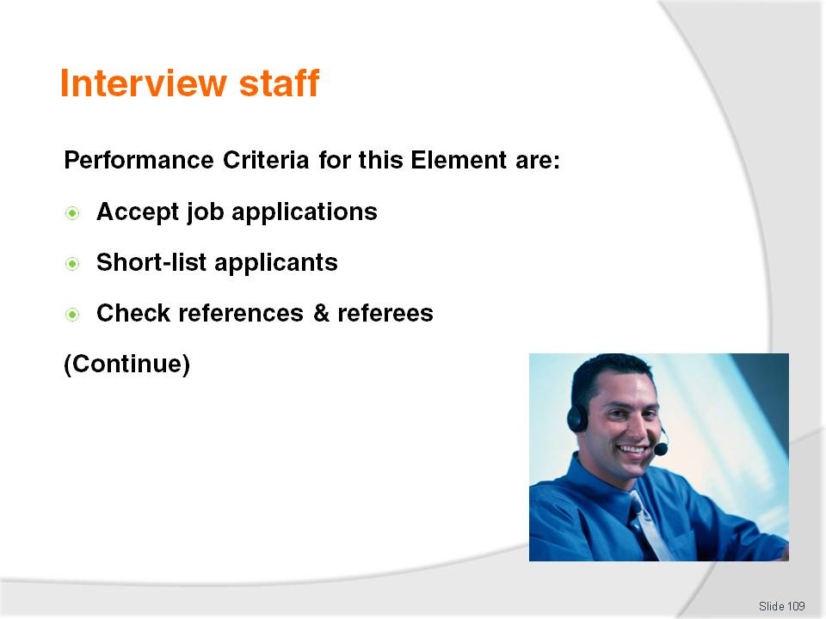
Slide No | Trainer Notes
 | Trainer identifies for trainees the Performance Criteria for this Element, as listed on the slide.

Slide
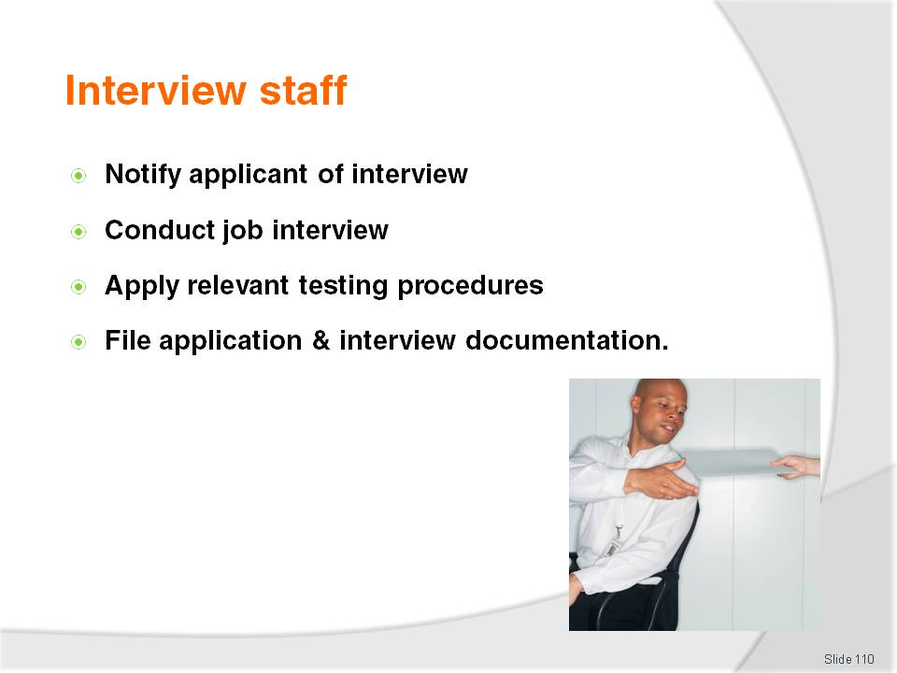
Slide No | Trainer Notes
Trainer identifies for trainees the Performance Criteria for this Element, as listed on the slide.
Class Activity – Discussion
Trainer asks trainees questions regarding staff interviews asking questions such as:
What experience have you had with job interviews?
What is meant by the term ‘short-listing’?
What are ‘references’ and how do they differ from ‘referees’?
Why would a workplace check references and referees of job applicants?
What is meant by a ‘panel interview’?
What testing procedures might be associated with interviewing and selecting staff? Why might these tests be applied?
Why would a business file job application documentation and interview documentation? What might be included in terms of these documents? How and where might they file this documentation?

Slide

Slide No | Trainer Notes
Trainer introduces this part of the course to trainees stating when advertisements for positions have been lodged there will be a need to accept applications for those vacancies advising:
After advertisements have been lodged with the media, and after vacancies have been listed with recruitment agencies applications will begin to arrive – the arrival of applications can be almost immediate
Expect a regular stream of telephone calls and queries in relation to the position being advertised – expect these even where advertisements have not given the name of the business or provided a contact telephone number. Many job applicants can work out where a job vacancy is located by ‘reading between the lines’ of the advertisement:
- Expect calls from potential applicants – seeking more information
- Expect calls or queries from recruitment agencies – wanting clarification of issues raised by applicants
After responding to questions, the primary aim of this stage in the recruitment process is to accept all incoming applications.

Slide
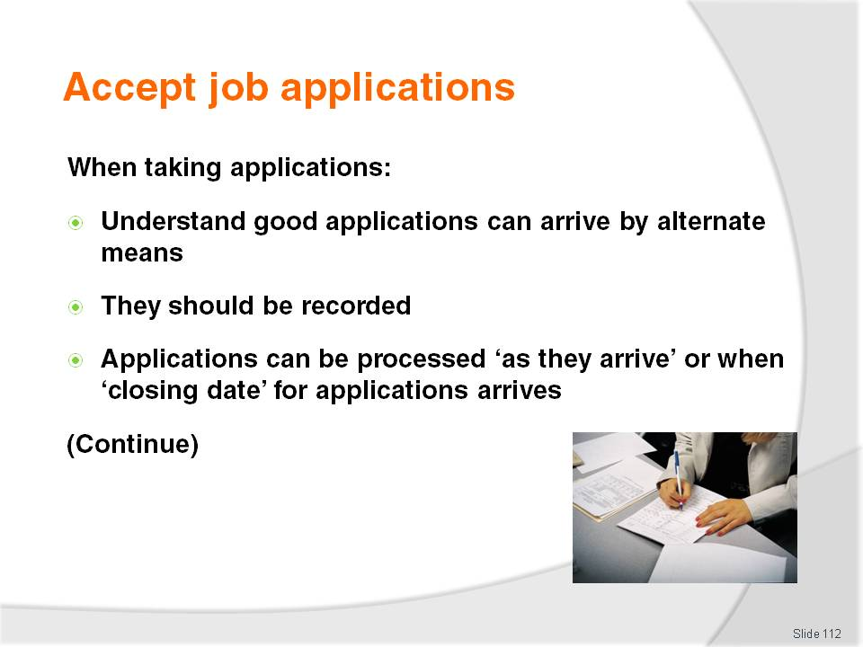
Slide No | Trainer Notes
Trainer provides trainees with advice regarding taking applications:
Despite clear and obvious instructions about applications – for example, that they must be mailed in
Many applicants will hand-deliver their application where they believe their actual personal appearance may positively influence a hiring decision
Sometimes, all applications not complying with stated application requirements to the letter are rejected out-of-hand. This is an understandable approach (“Can’t they even follow simple instructions?”), but it may mean very good people are overlooked
It is a good practice for all applications to go to a central point for ease of administration and in order to facilitate the keeping of records about who, and how many, have applied
A simple register of applicants should be used – to record who has applied, how they applied, and when they applied. A ruled up exercise book with suitable headings or an electronic document is all that is needed
When the closing date arrives, all the applicants can then be processed. Normally applications are assessed more or less as they arrive. This initial processing simply means assessing every application to ascertain whether or not the person actually matches the selection criteria. It is not unknown for people with little or no alignment with stated experience or qualifications to nonetheless apply: if they do measure up, their application passes to the next stage (‘short-listing’).

Slide

Slide No | Trainer Notes
Trainer continues to advise trainees regarding the accepting of job applications stating:
If an application does not meet the basic requirements, it is rejected at this stage and a letter of ‘Thanks and regret’ is sent to the applicant. The sooner this is done, the better. A letter of ‘Thanks and Regret’ thanks the applicant for applying but regrets in this instance their application is unsuccessful. Sending these letters to unsuccessful applicants is sound business practice and also assists in PR for the venue
Some businesses will also send back the actual application, including résumé – check what applies in the workplace
Some businesses will retain the application and keep it on file for future reference – especially where the applicant is deemed to be suitable for other work
Applications may also be kept on file in case:
- The person selected for the position does not accept the offer
- Extra staff for the same position (or similar) are required.
Class Activity (1) – Handout
Trainer obtains a sample Letter of ‘Thanks and Regret’ and:
Shares with trainees
Discusses contents of the letter explaining the purpose of each paragraph
Asks trainees for their feedback on the letter.
Class Activity (2) – Individual Exercise
Trainer provides trainees with basic details of an applicant who has been deemed unsuitable for a job and asks trainees to draft a Letter of Thanks and Regret to send to this person.

Slide
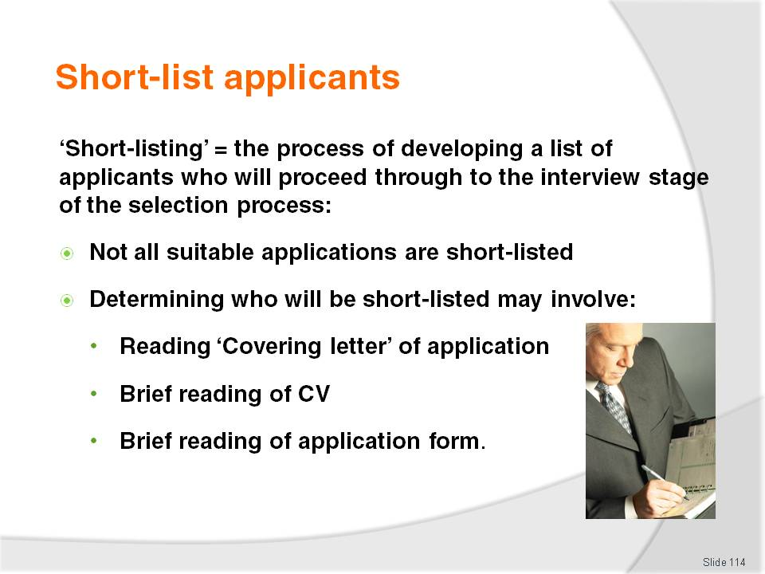
Slide No | Trainer Notes
Trainer explains to trainees short-listing applicants is the process of developing a list of applicants who will proceed through to the interview stage of the selection process, advising them”:
Applicants may pass an initial screening but still not make it to the short-list
Practices for short-listing may involve (depending on the position involved):
- A brief reading of the Covering Letter sent in by the applicant – to gauge their suitability and gain an overview of their experience
- A brief reading of their CV – to determine the extent to which their experience, qualifications and other relevant factors meet the key selection criteria for the position
- A brief reading of the business ‘Application form’ – where such a document is required to be completed by applicants.

Slide
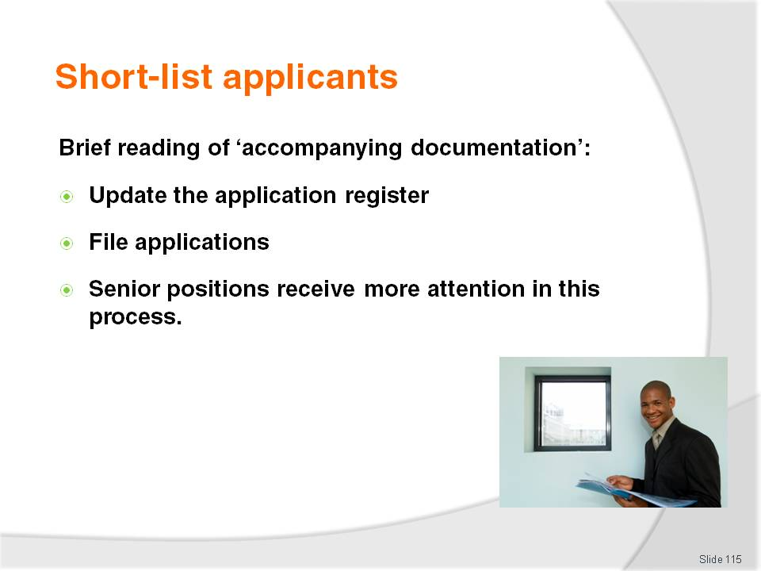
Slide No | Trainer Notes
Trainer continues to identify for trainees activities involved in short-listing applications:
A brief perusal of accompanying documentation – such as references and copies of certificates
Updating the register applicants – to identify applicants who have been rejected at this stage
Filing suitable applications – for later use in the interview process.
In reality, the more senior the position, the more extensive the short-listing activities are likely to be.

Slide
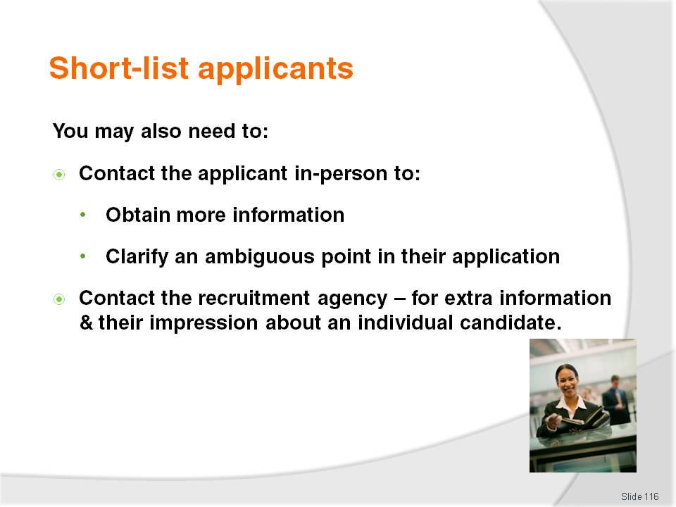
Slide No | Trainer Notes
Trainer informs trainees in some cases there can also be a need to undertake other activities as part of the short-listing process:
Contact a potentially useful applicant – to seek more information
Contact the applicant – to clarify something in their application
Contact the recruitment agency – to obtain different information and to capture their impression about the applicant.

Slide

Slide No | Trainer Notes
Trainer advises trainees following short-listing:
Successful applicants will need to be advised of interview date, time and location – or one will need to be negotiated with them. More on this on later slides
Unsuccessful applicants may have a Letter of Thanks and Regret sent to them – as previously identified
Files will be updated – to reflect those who have been short-listed and rejected, and to identify interview date and time.

Slide

Slide No | Trainer Notes
Trainer tells trainees references are written testimonials about the applicant provided by those who know the applicant.
This can include past employers, previous co-workers, community leaders, religious people or club officials:
References are usually type-written and presented on letterhead paper as a way of proving they are written by the person providing the reference
References usually contain details and information about:
- Date when reference was written
- Name and position of the person writing the reference
- How long the person has known the applicant
- Their character and reliability – making statements about their hard-working nature, how well they performed their job, and how sorry the previous employer was to see them leave
These comments may be work-related or social (remember those applying for their first job will not be able to provide work references because they have not held a job before).
Class Activity – Handouts
Trainer obtains a selection of references (with names of people blocked out) and:
Distributes them to trainees to read
Asks trainees their opinions about them – what do the references tell them about the person?
Points to the fact there is never a bad reference – they are all written in glowing terms.

Slide
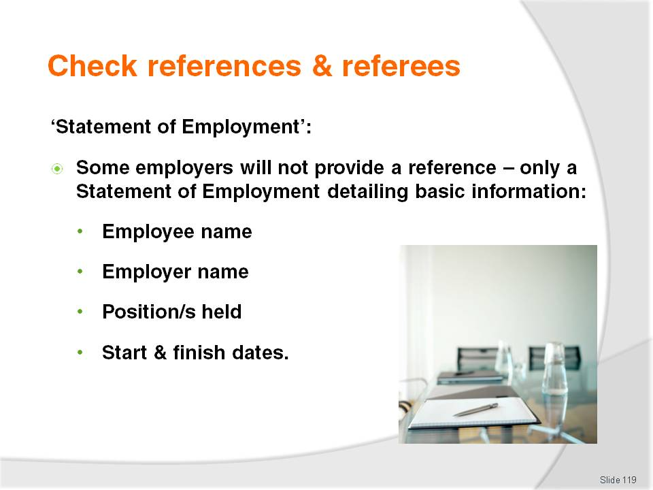
Slide No | Trainer Notes
Trainer introduces trainees to concept of ‘Statement of Employment’ stating:
Some businesses refuse to provide ‘references’ to employees as a SOP – this means they do not provide written references for any staff members
Such businesses will only provide a ‘Statement of Employment’ which is a pro forma document giving only basic information about the employee and providing no individual/personal information at all – the Statement of Employment will simply provide:
- Employee name
- Employer name
- Positions held by the employee
- Time period employed in each position.
Class Activity – Handouts
Trainer obtains a selection of Statements of Attainment (with names of people blocked out) and:
Distributes them to trainees to read
Highlights differences between these and written references
Asks trainees why employers may elect to only write Statements of Employment for ex-employees rather than References.
Possible answers
Writing references takes too long
They can be difficult to research and write
As written documents they could be used by the ex-employee as the basis for legal action (libel).

Slide

Slide No | Trainer Notes
Trainer explains to trainees referees may be seen as:
Anyone who has provided a written reference
A person who has not written a reference but is prepared to speak to a prospective employer about the applicant.
Trainer tells trainees many people will not provide a written reference but are happy to be referees because:
They do not know how to write a reference or do not know what to put into one
They are too busy to do so
They have nothing positive to say about the person who has asked for a reference.

Slide

Slide No | Trainer Notes
Trainer states to trainees to check references or referees.
This involves contacting the people who have been listed on the resume as referees or those who have provided a written reference.
These are checked:
Before interview as part of the short-listing process – to determine whether or not some applicants are worthy of an interview or not
After the interview – to help determine the selected applicant from all those deemed suitable. Doing checks at this point reduces the number of checks that have to be made and the time taken in checking references.

Slide

Slide No | Trainer Notes
Trainer stresses it is important for trainees to check references and referees because:
Modern technology has made it easy for computer literate applicants to generate false reference documentation – there is therefore a need to be able to:
- Verify the applicant has worked for the organisation stated
- Validate they have performed the roles they have claimed
- Validate claims made about their ability or experience
No-one has ever written a bad reference – all references seem to speak in glowing terms about the applicant. As the old saying states ‘No-one has read a bad reference’. This check enables discussion person-to-person with the individual who wrote the reference – and they are often more honest and forthcoming when questioned directly about the person in question
There is a need to be able to verify with the referee:
- Statements made in written references
- Claims made by the applicant.

Slide

Slide No | Trainer Notes
Trainer advises trainees different workplaces have different approaches to reference and referee checks:
Not all employers will check references or referees – they may believe it takes too long to do, or they may feel it will not be of any benefit
Some businesses will only check written references – that is, they will contact the person who wrote the reference
Some businesses will check both written references and those people included as ‘verbal’ referees
All applications should have either references or referees checked – checking both is preferable but not always possible for example, a referee may be overseas, they may have left the job where they wrote the reference or they may have passed away.

Slide
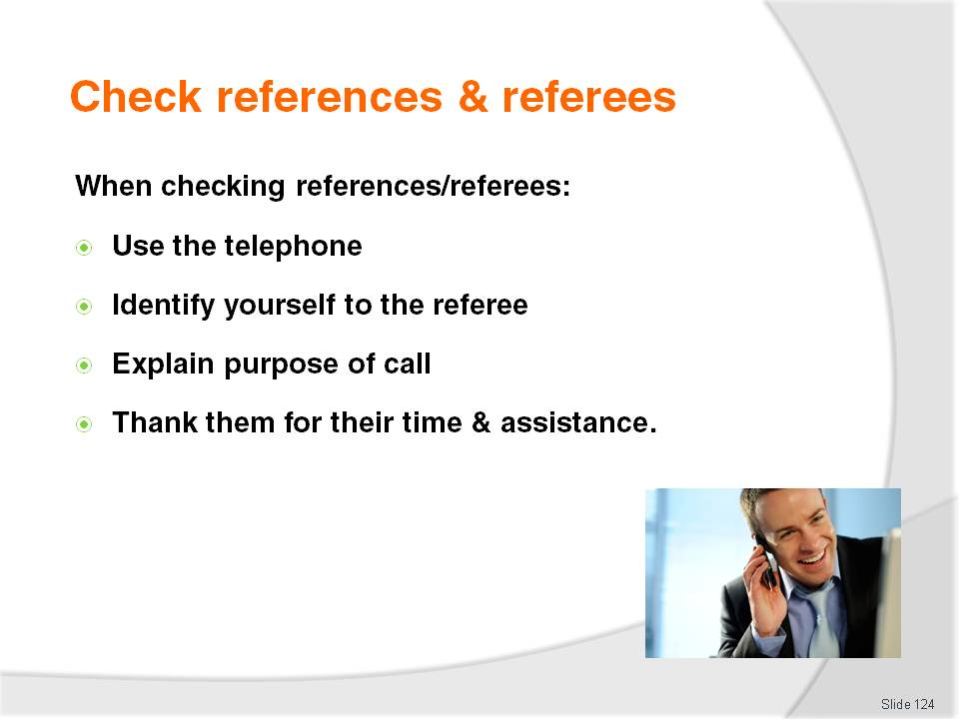
Slide No | Trainer Notes
Trainer advises trainees when checking references and referees:
Telephone contact is the most useful and effective method to use
Identify self by name, position and explain purpose of call them – it is standard practice for applicants to advise referees they have used them for a job application, so they should be expecting a call
Enquire if they are prepared and have the time to answer some questions about the applicant
Thank them for their time.

Slide

Slide No | Trainer Notes
Trainer identifies to trainees checking references and referees requires:
Generation of questions to reflect what needs to be clarified, verified or validated about the applicant – these questions need to be prepared before the telephone call
Many questions to be asked such as:
- What was the applicant’s work ethic like?
- Were they punctual, reliable, honest?
- Did they get on well with other staff?
- Did they get on well with customers?
- Why did they leave?
- Were you sorry to see them go?
- Would you employ them again?
Recording responses given by referees when asked the questions – to make sure nothing important is forgotten.

Slide
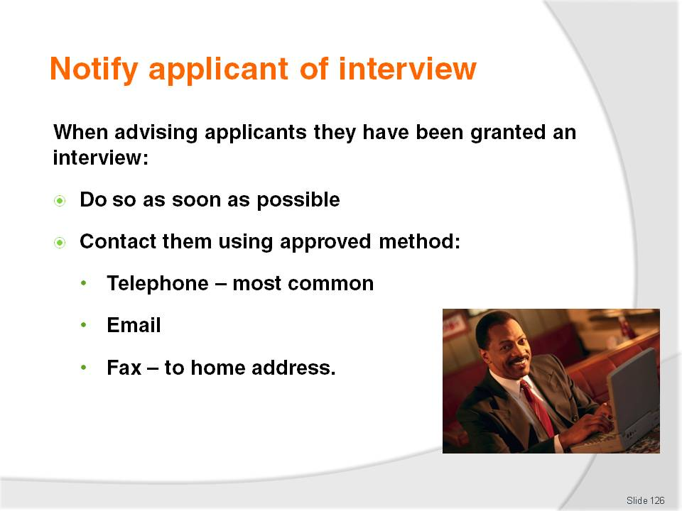
Slide No | Trainer Notes
Trainer tells trainees all applicants short-listed for a position will need to be contacted so a date and time for interview can be arranged emphasising:
Notification should take place as soon as possible -= in case applicant takes another job
Contact should be via method approved by the workplace – telephone is most common and effective as it enables person-to-person communication, is quick and inexpensive. Other options may include email, fax or face-to-face.

Slide
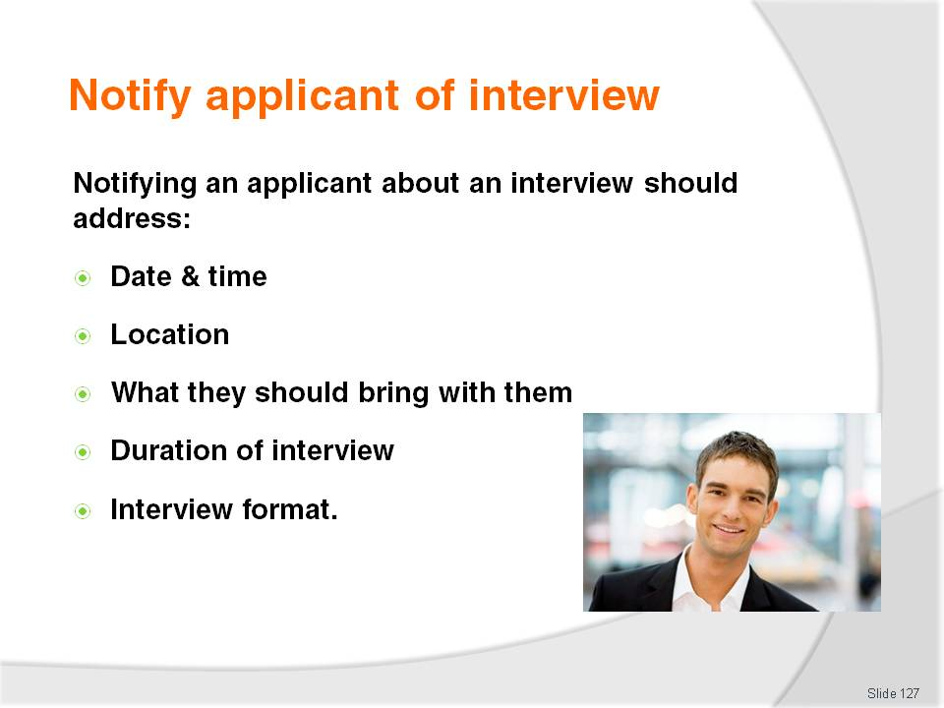
Slide No | Trainer Notes
Trainer advises trainees notifying an applicant about an interview should address:
Date and time of the interview
Location – where the interview will take place. This may include a street address, a floor number or even a specific room name within the business
What they should bring – this may be originals of certificates or examples of work
Expected length of the interview – start and finish time
Format of the interview – is it a one-to-one interview? If it is a panel interview, supply the number on the panel, their names or their position within the organisation.

Slide
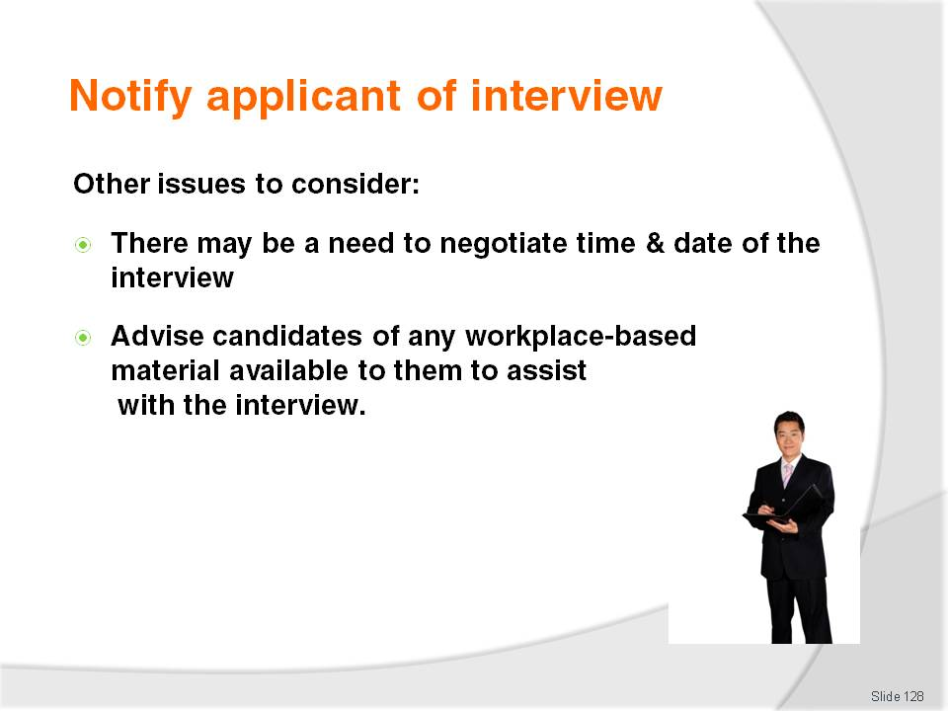
Slide No | Trainer Notes
Trainer suggests to trainees when notifying applicants regarding interviews they should:
Be prepared to negotiate a time and date
Advise candidate about what is available to assist them at the interview – such as KSC, workplace information packs, ‘Tips on Interviews’ and Job Descriptions.
Class Activity – Handouts
Trainer obtains sample business ‘information packs’ and ‘tips on interviews’ sheets, and:
Hands them out to trainees
Discusses contents
Explains why these are provided
Seeks feedback from trainees on their benefit to the enterprise and the applicants.

Slide
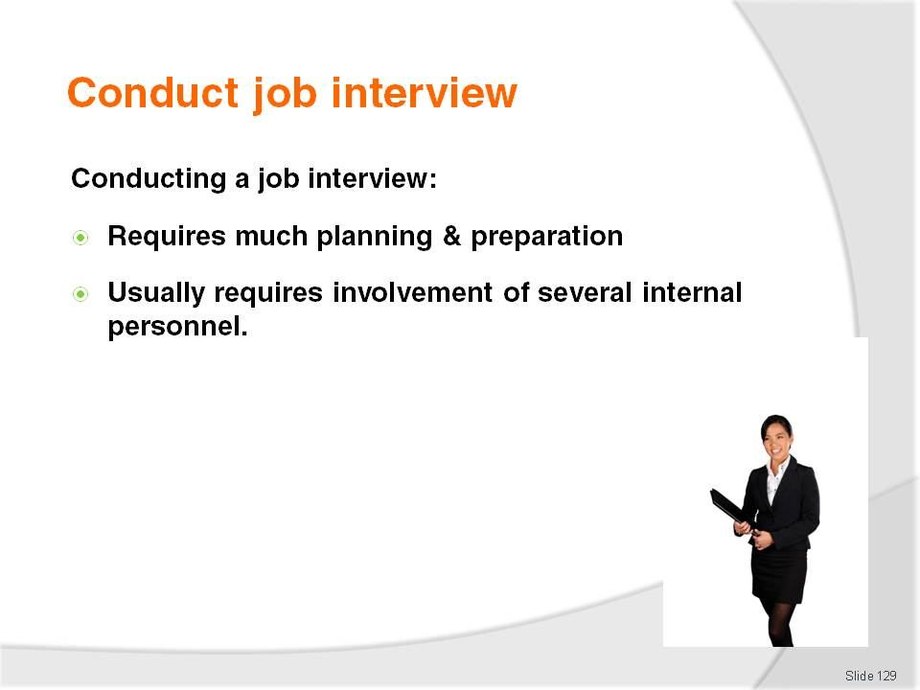
Slide No | Trainer Notes
Trainer advises trainees conducting the interview is the most high-profile aspect of the recruitment and selection process stressing:
There is a need to undertake lots of planning and preparation in order to conduct an effective interview – no effective interview can ever take place unless appropriate planning and preparation has occurred
There is usually a need to involve several other workplace personnel in the planning and preparation – as well as the actual interview itself.

Slide
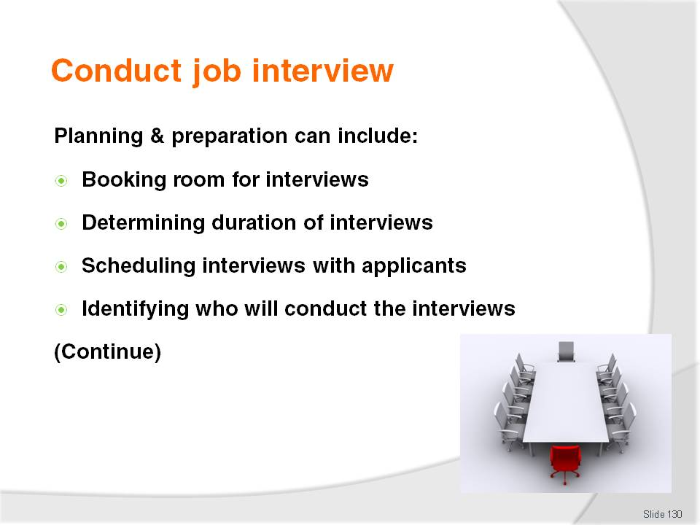
Slide No | Trainer Notes
Trainer advises trainees interview arrangements (‘planning and preparation’) may include:
Booking a room for the interviews – such as the Board room, an office or a section of an unused dining room or bar closed to the public and free of wandering staff
Determining the time to be allowed for each interview and allowing for breaks to be scheduled between each interview so interviews can be reviewed and evaluated and interviewers can discuss the candidate for the job
Scheduling the actual interviews – with short-listed applicants
Identifying who will conduct and participate in the interviews – it is common practice to ensure a gender balance on all interview panels wherever possible.

Slide
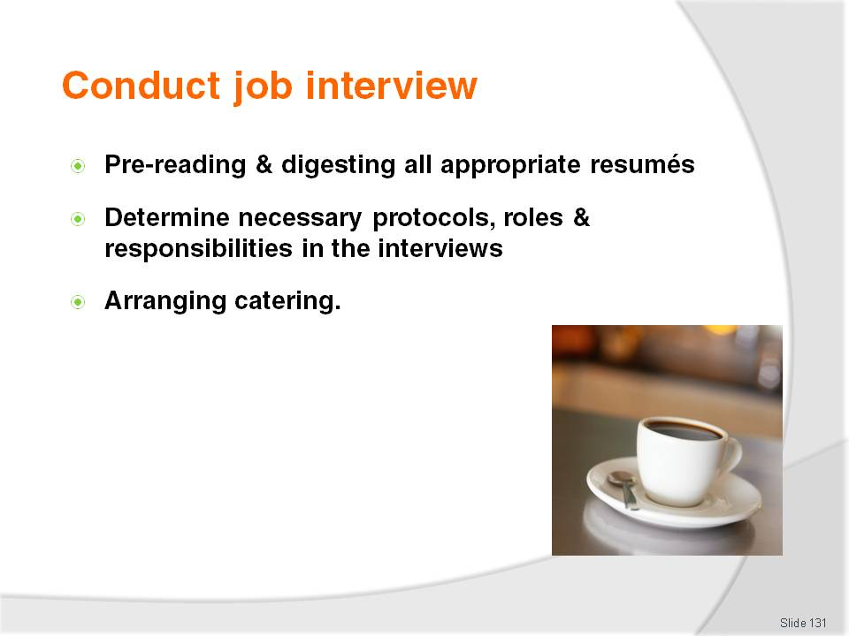
Slide No | Trainer Notes
Trainer continues to provide advice to trainees regarding planning and preparation for interviews:
Pre-reading and digesting all appropriate resumes – to be sure interviewers are familiar with the applicant and their background
Facilitating a meeting between all members of the interview panel or group to:
- Identify the specific format of the interview – see next slide
- Identify the questions to be asked
- Clarify the relevant job description, job specification and selection criteria
- Identify who will lead the interview, welcome the applicant, and terminate the interview
- Identify who will ask which questions, and in which order
Arranging catering (such as coffee, tea or iced water), where required.

Slide

Slide No | Trainer Notes
Trainer explains to trainees the basic job interview options are:
One-to-one interviews – common where the position is for a lower level position and where the person conducting the interview (often the owner, manager of a supervisor) believes they are best placed to determine the best applicant. This interview involves the applicant sitting face-to-face with the interviewer and responding to their questions. This style of interview is quick, requires only one person to be involved but suffers potentially from lack of objectivity. It is very common in smaller, owner-operated businesses
The panel interview – where a number of people (three to five is common) interview one applicant at a time
The group interview – where a number of applicants are interviewed simultaneously by a range of interviewers. Note: some people refer to a ‘panel’ interview as a ‘group’ interview so be sure to determine what term is used in the workplace to avoid confusion
Telephone interview – where one or more people use a tele-conference (of some format – for example, Skype or Lynch) to interview applicants. Telephone interviews are difficult (and arguably of minimum use) for both interviewers and interviewees as both are commonly not familiar with either conducting them or participating in them.

Slide
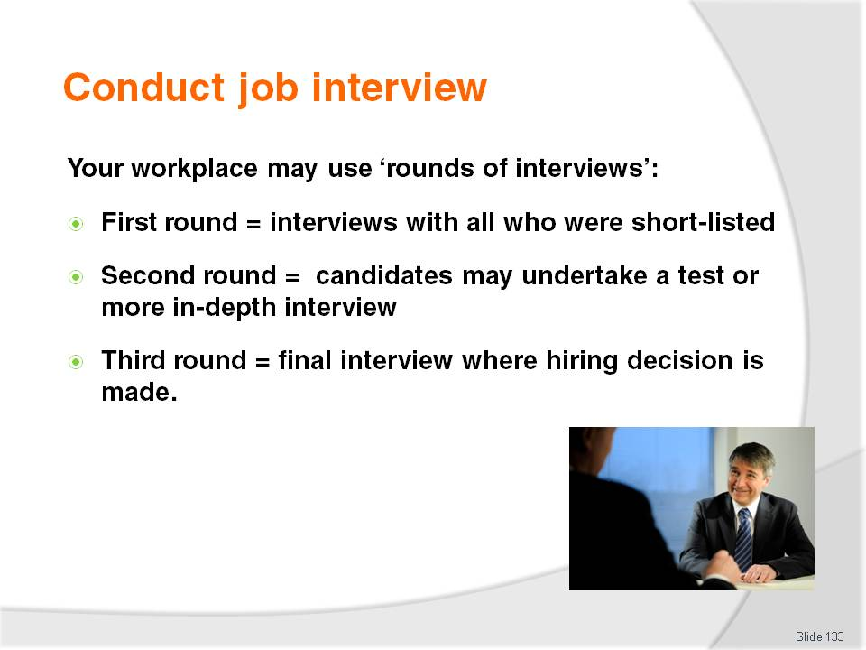
Slide No | Trainer Notes
Trainer states to trainees that in much the same way applicants are short-listed for interview, an interview may be also used to determine if an applicant moves to the next ‘round of interviews’, explaining:
This is not especially common but the practice of ‘interview rounds’ does exist with it being most used for middle-to-higher level positions
The first interview (the first ‘round of interviews’) will involve all those who were short-listed. The interview enables interviewers to meet the applicants, ask some questions and form an opinion. Applicants are usually asked the same questions and evaluated against the same criteria. The focus of the first round questions is ‘can this person do the job?’
Traditionally, a number of applicants are rejected by the interviewers after this first interview for a variety of reasons. Those remaining may be asked to undertake a designated test or task. Their performance may determine if they are asked to attend a second interview (the ‘second round of interviews’)
The second round of interviews focuses more on the individual applicants and questions tend to address their individual ability, history, suitability, attitude, knowledge, and expertise. The focus of this round therefore tends to be ‘why should I employ you for this job?’
At the end of this second round, more applicants are commonly rejected
The third round is the final interview where ‘more difficult’ issued and questions are covered. It is the outcome of this ‘round of interview’ which determines the successful candidate for the job.

Slide
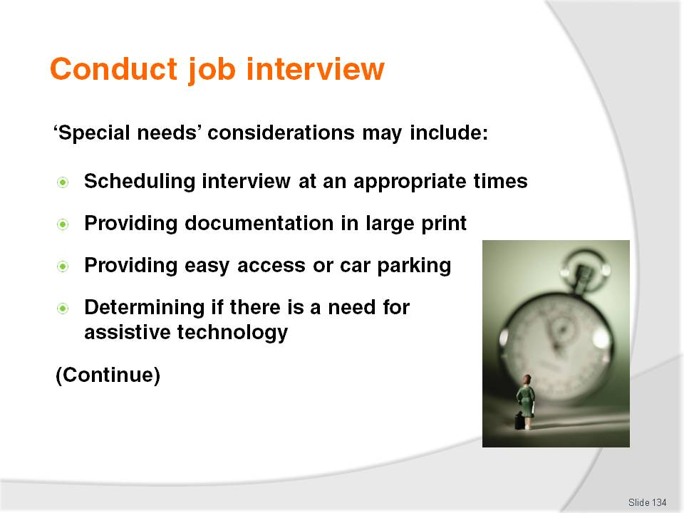
Slide No | Trainer Notes
Trainer recommends to trainees they should accommodate ‘special needs’ applicants if the workplace wants to discharge its EO obligations suggesting possible responses to special needs can include:
Scheduling the interview at an appropriate time for the candidate – to accommodate their transport and other needs
Providing certain documentation in large print – for vision impaired applicants
Providing easy access or car parking to facilitate attendance at the interview for wheelchair applicants
Determining if there is a need for assistive technology and taking steps to provide it where necessary.

Slide
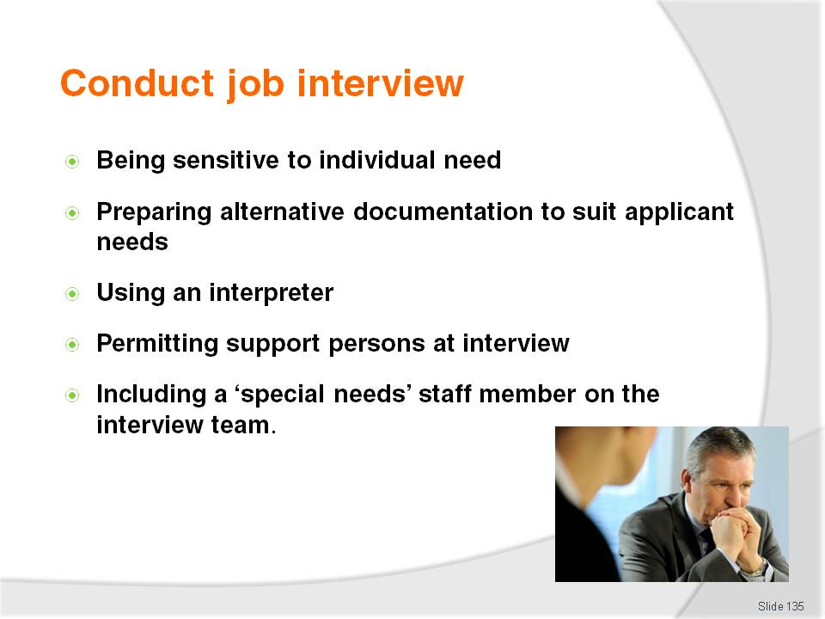
Slide No | Trainer Notes
Trainer continues to make recommendation to trainees about what they might do at interviews to accommodate ‘special needs’ applicants:
Preparing to be sensitive to individual needs at the interview – such as focussing on looking directly at a person who lip reads
Preparing and using visual materials and diagrams in cases where written material is inappropriate
Using an interpreter, as appropriate – including sign language
Allowing support persons to accompany the person being interviewed
Including a ‘special needs’ person as part of the interview panel.

Slide
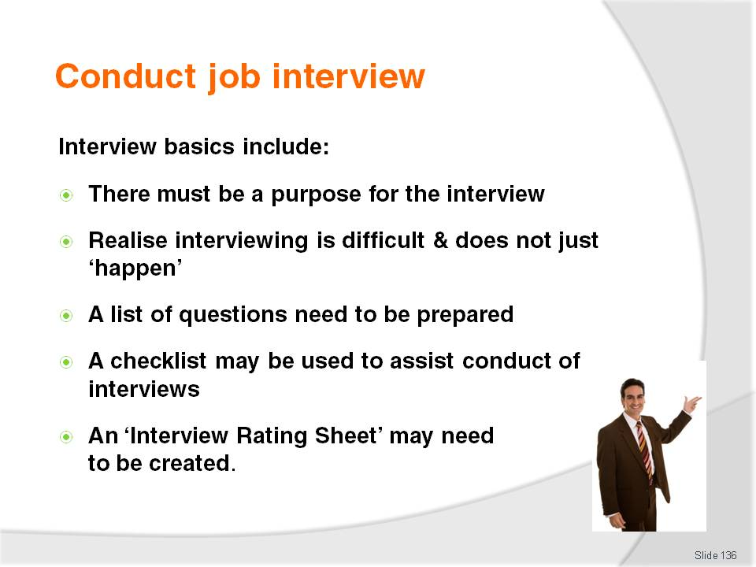
Slide No | Trainer Notes
Trainer explains interview basics to trainees:
Whether the selection interview is one-on-one or a panel type it should be structured and have a focus. It must never simply be a ‘get-together’ for a pleasant chat where anything and everything is discussed. The time spent in conducting interviews is another of the considerable expenses associated with staff hiring
Those involved must realise interviewing is a difficult task and give it the proper attention it deserves and prepare adequately for it – no-one can never just walk into an interview situation ‘cold’ and expect to be effective. Effective interviews never just happen. There is a need to prepare and organise so there is a very clear idea of what is intended to be achieved with each interviewee at each interview
A list of questions needs to be prepared, and the qualities and attitudes being sought for the vacancy being interviewed for need to be clarified
Many interviewers use a checklist to guide them during interviews – a list setting out areas (for example) such as personal appearance, interests, long range goals, personal ideas as to how to improve XYZ, or how to achieve ABC, and the applicant’s manner
An ‘Interview rating Sheet’ may need to be prepared – to use as an objective basis for recording candidate responses during the interview and making the final selection of the successful applicant.

Slide
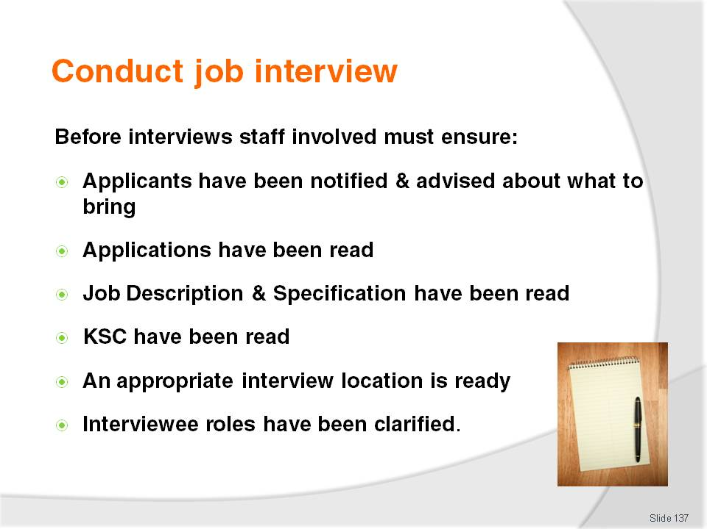
Slide No | Trainer Notes
Trainer tells trainees prior to each interview those conducting the interview must ensure they have:
Notified each applicant well in advance of where and when the interview is to be conducted – this may have to be negotiated with the applicant especially where they are already employed by someone else, so flexibility, discretion and tact is needed
Informed candidates of what they need to bring with them – such as originals of photocopied submissions, certificates, samples, photos of work or additional references
Pre-read the applicant’s original submission – together with any reports generated by others involved in the selection process (regarding possible need for practical tests, further telephone or other checks, queries to be raised during the interview, or perceived anomalies with a resume requiring clarification)
Pre-read the job description and job specification for the job in question – so as to be familiar with what is required and to ensure the thinking of the interviewers is not out-of-date with reality, or out of synch with the advertised requirements of the position
Pre-read the Key Selection Criteria – to reinforce familiarity with non-negotiable requirements of the position
Arranged for a quiet, undisturbed, comfortable, non-threatening environment in which to conduct the interview
Where a panel interview is to be used, determine who will take various roles in the interview – working out who will welcome the candidate, who will introduce the other members on the panel, who will ask which questions, who will go first, who will close the interview.
Class Activity – Guest Speaker
Trainer arranges for a suitable HR manager (or similar) to attend and:
Discuss their views on interviewing applications for vacancies
Present details of the planning and preparation they do prior to an interview
Provide examples of documentation they use related to interviews
Give opinions and tips on effective interview techniques.

Slide
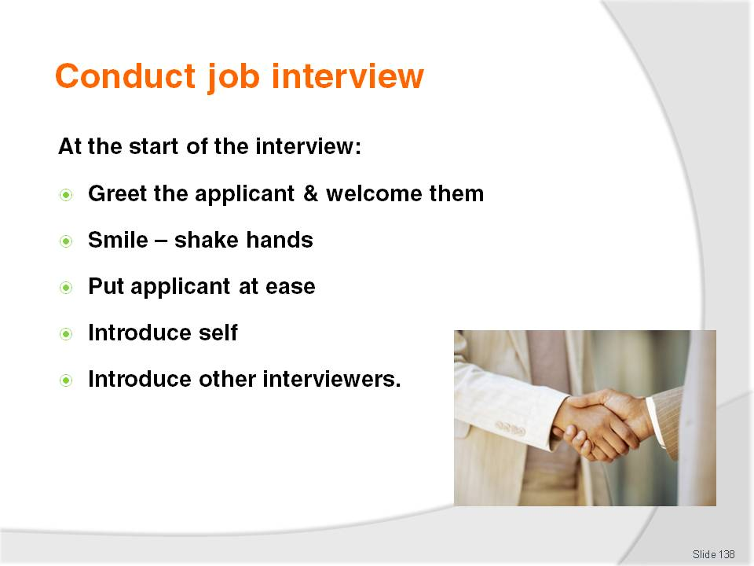
Slide No | Trainer Notes
Trainer describes for trainees the practices that should occur at the start of an interview.
Greet the applicant – this must be done to demonstrate it is a pleasure to see them (body language is obviously very important, and what is said at this stage may also have been planned in advance in order to send the right message). It is vital this greeting does not send the message the process is being rushed, interviewers are upset or under any sort of other pressure
Smile and offer a hand to shake hands with the candidate. Always be prepared for the candidate to offer their hand
Put the applicant at ease – timing for the interview should allow a minute or two to provide some time for the interviewee to settle down and adjust to the strange surroundings of an interview situation. The candidate needs a moment to sum things up – consider offering a beverage in this space, or even engaging in some small talk about the weather
Introduce self – and all other people who are on the interview panel. Make sure this is done clearly and without rushing. It is important the candidate hears what is said and understands who the panel are
Give people’s names and their position within the business together with a quick word as to why they are part of the interview team. The names used when introductions are made should indicate the tenor and formality of the interview.

Slide

Slide No | Trainer Notes
Trainer presents to trainees points to note when conducting the interview proper:
Prove familiarisation with applicant’s application and background by reference to their application form or resume – it is usual to compliment them on some aspect of their achievement or their application, experience or qualifications
State what the purpose of the interview is – options may include to obtain more in-depth information to use as the basis for final selection, to flesh out areas not fully addressed in a previous interview or to gauge their interest in and commitment to a certain area. A quick review of the job description can be successfully used to achieve this. This part of the interview is also the usual time to ensure the candidate is aware of any non-negotiable aspects, or ‘challenging’ parts, of the job. Even where this information has been provided in job advertisements, on the application form or selection criteria it is important it is repeated here
It may also be appropriate to provide a brief background of the organisation to help ‘set the scene’ for the interview – this can include a very brief outline of things such as where the business is heading and the scope and nature of proposed expansion
Check the applicant is legally entitled to work – this is an important part of the process as the business does not want to waste time or money by hiring someone who is not legally entitled to work
When asking questions to the candidate, be direct and clear but try to avoid closed questions (those which can be answered with a simple ‘yes’ or ‘no’) – ask plenty of the ‘how’ and ‘why’ type questions which get the interviewee talking
Questions should have been designed to gain specific insight into areas of ‘concern’ identified as part of the short-listing process (there may be unexplained gaps in their employment history [why weren’t they employed for that period?]; they may have changed jobs every four months [why have they changed jobs with such regularity?]). These questions should focus on the applicant’s personality, ability, skills and suitability for the position.
Class Activity – Demonstration (Mock interview)
Trainer arranges for experienced people (from the Training Institute or an industry workplace) to:
Attend class
Describe a job they will be interviewing for
Arrange the room as required – explaining why this is being done the way it is
Show/explain any prepared questions or documentation to be used throughout the demonstration
Conduct the interview – welcoming the ‘interviewee’, asking planned questions and follow-up questions, demonstrating techniques they apply when interviewing staff
De-brief after the mock interview – explaining what they did and why they did it
Answer questions from trainees.
Trainer may elect to video-tape the mock interview for later analysis.

Slide
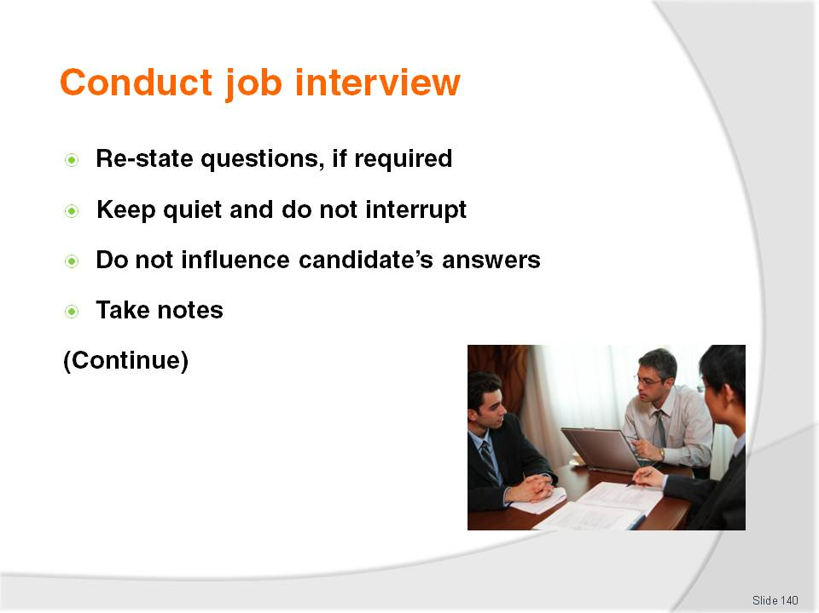
Slide No | Trainer Notes
Trainer continues to present to trainees points to note when conducting the interview proper:
Where specific answers to questions are required do not be afraid to re-state the question if a direct answer is not forthcoming from the applicant. Be on the look out for any reluctance to respond directly to questions especially where previous work or working relationships are concerned
Remember to keep quiet. When a question has been asked let the applicant answer it and listen to what they say. Do not rush them and never finish their sentences for them. Do not interrupt. Many interviewers see interviews as an opportunity for them to talk or to show off their knowledge and this is to be avoided. The intent of the interview is to get the applicant talking, and to find out about them
Try not to unfairly influence the applicant’s answers by giving off hints as to personal preferences, prejudices or bias. The intention is to identify the applicant’s thoughts and attitudes, not to get them to modify their opinions to accord with beliefs of the interviewers
Take notes if this will help – some people believe it only serves to make the applicant nervous, but many feel it is the only way to accurately record answers which are uncovered and the only way to obtain a useful record of events for later reference and decision-making after the interview.

Slide
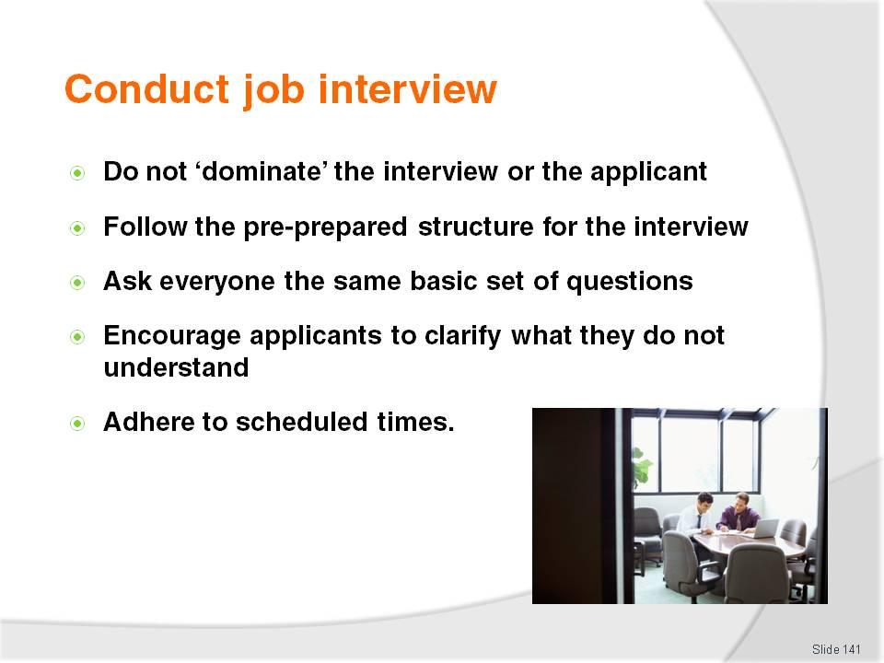
Slide No | Trainer Notes
Trainer continues to present to trainees points to note when conducting the interview proper:
Do not adopt a dominating position during the interview – the applicant is nervous enough without being made to feel more uncomfortable by obvious signs of evident authority. In addition:
- Do not stand while the applicant sits
- Do not have them looking into the sun so they are unable to see properly
- Do not ignore them while they talk – by attending to paperwork, adding up figures, or reading the newspaper
Follow the plan of the pre-determined structure of the interview – cover all the topics identified yet remain flexible enough to follow up any matters requiring extra attention
It is good practice to make sure all applicants are asked the same standard battery of questions, even though certain applicants may be asked additional ones
Encourage the applicant to clarify questions they are unclear about, and provide a time for them to ask questions of their own. Remember the interview is a two-way thing. Not only is the business interviewing them but they are also working out whether or not they want to become an employee
Adhere to scheduled times – finish the interview so the next one can begin on time. Try to avoid running over time.

Slide
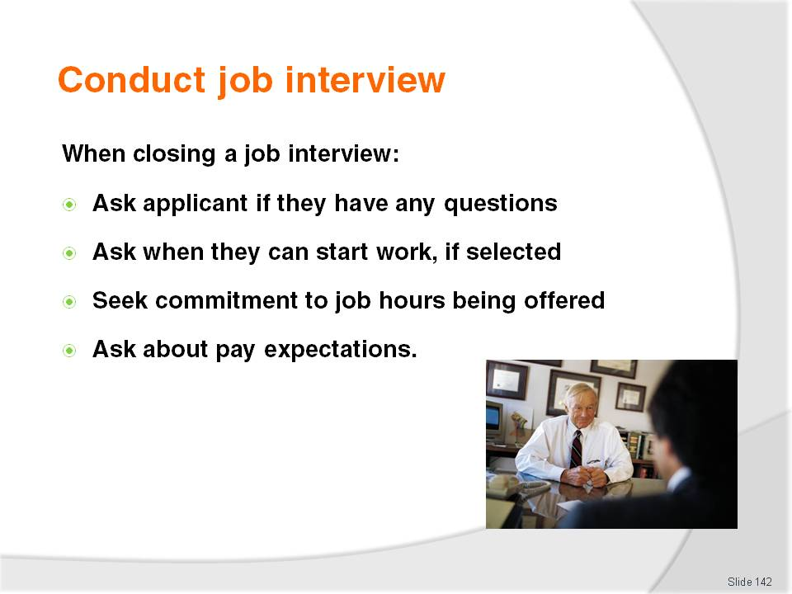
Slide No | Trainer Notes
Trainer provides trainees with advice regarding closing a job vacancy interview:
Ask applicant if they have any further questions – and doing this in a way that encourages them to ask
Ask when the applicant is available to begin work if hired – it is advisable to ask this question of all candidates to prevent the applicant getting false hopes of being hired
Seek commitment from the applicant in terms of the tenure of the job – this requires a question seeking confirmation from the candidate they are willing and able to work the term required for the position
Ask applicant about pay expectations – this may be appropriate in some interviews and not in others: in some interviews, the plan may have already included a statement regarding the pay the position attracts so a question might be asked as to whether or not this pay rate meets their expectations. In many cases pay rates are commonly offered on a take-it-or-leave-it basis. There is usually little or no room for pay negotiation but this should be addressed on a case-by-case basis, and there is an absolute need to be aware of any limitations applying to authority to make a financial commitment on behalf of the organisation. It may be that management are the only ones authorised to negotiate remuneration.

Slide

Slide No | Trainer Notes
Trainer continues to provide trainees with advice regarding closing a job vacancy interview:
Let them know what will happen next – they should be informed as to when they will be notified about how they went, and how they will be notified. Advise them if they are required to undertake any further selection processes such as practical tests or a medical examination
Confirm their contact information – even though they have submitted a resume, people do re-locate and they do lose phones and change phone numbers. It is useful to verify at this stage to verify their current contact details. Where the candidate is currently working with another employer it can also be beneficial to clarify whether or not it is appropriate to contact them at work
Thank for their time in attending the interview – this demonstrates respect for their effort and is obviously the polite and correct thing to do. Determine before-hand whether there will be a hand-shake with applicants as they leave.
Class Activity – Role Plays: Panel Interviews (Mock Interviews)
Trainer prepares several scenarios suitable for trainees to enact a mock interview role play by identifying for a variety of job vacancies:
Position to be applied for
Remuneration
Job description and job specification
KSC
Interview rating sheet.
Trainer distributes above information to selected small groups (‘interview panels’) of trainees and asks them to:
Study the material/information provided
Prepare questions for the interview
Determine the structure of the interview
Conduct the interview with trainer playing role of candidate.
Trainer may video-tape the mock interview for later playback, discussion and analysis.
Trainer to provide feedback to trainees on their performance during the mock interviews.

Slide
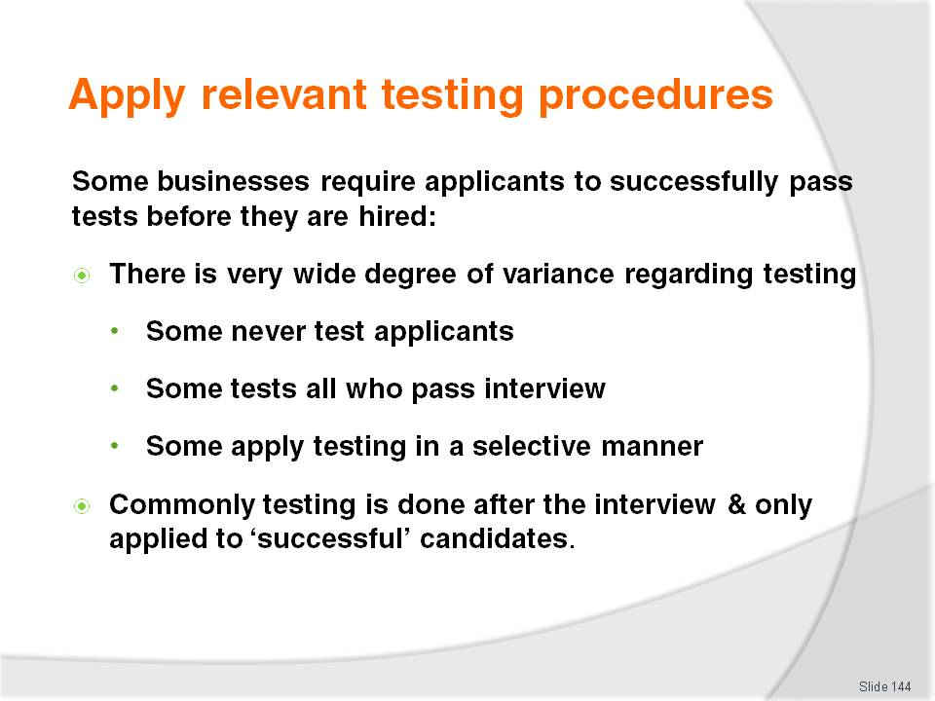
Slide No | Trainer Notes
Trainer explains to trainees it is standard procedure in some businesses for nominated vacancies to require successful applicants to undertake relevant testing before they are hired highlighting:
There is a great difference between businesses in relation to the tests they apply to job applicants
Some organisations apply no testing at all
Others require a standard test for every candidate who has passed the interview process regardless of who they are, the position they are applying for, their age, their background or industry experience
Some apply selective testing – only testing where they feel it is necessary or advisable, or there is some concern about a candidate and their ability or status
Testing is usually done after interview and only applied to those candidates the enterprise feels they want to employ – testing other candidates is time consuming and potentially quite expensive.

Slide
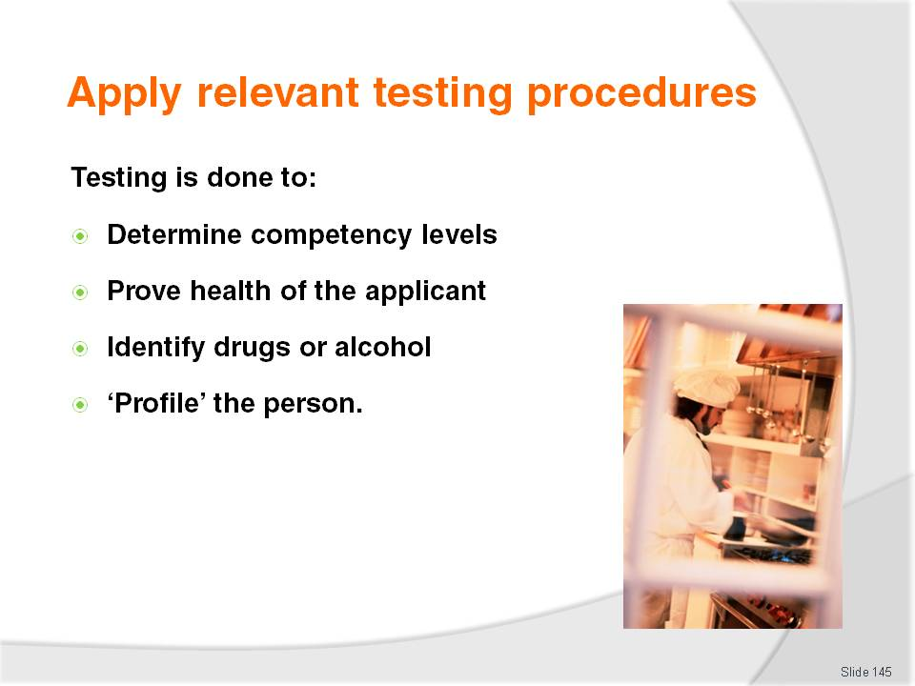
Slide No | Trainer Notes
Trainer explains to trainees tests are conducted to:
Determine competency levels – these are the ‘trade’ or ‘technical ‘tests designed to identify skill and the need for on-the-job training, up-skilling or top-up training:
- These tests are conducted in the business, using workplace equipment, items and ingredients. Tests are observed by workplace management who produce a written or verbal report on the skills of the individual
- Tests require the applicant to demonstrate one or more aspects of the job they are applying for in order, most commonly, to prove they have skills they have claimed
- In some organisations, applicants are paid for their time when they undertake these mandatory tests
Prove the health of the applicant:
- These are standard medical tests where the applicant is sent to a medical practitioner to have relevant tests conducted
- Medical testing may be applied to identify any pre-existing injury or health condition or to verify the applicant’s fitness for work
- A written report is provided by the medical practitioner to management.
Identify drugs and/or alcohol:
- More and more businesses are screening employees to identify if they are affected by drugs or alcohol
- Companies using this approach often have a ‘zero tolerance’ policy meaning any positive result means a potential job offer is withdrawn
Profile the person – by administering a battery of tests/questions to determine the personality profile of the person. This can be useful in matching a person to a job role their personality is best suited to, and can give an insight into the best ways to communicate with or manage the individual.

Slide
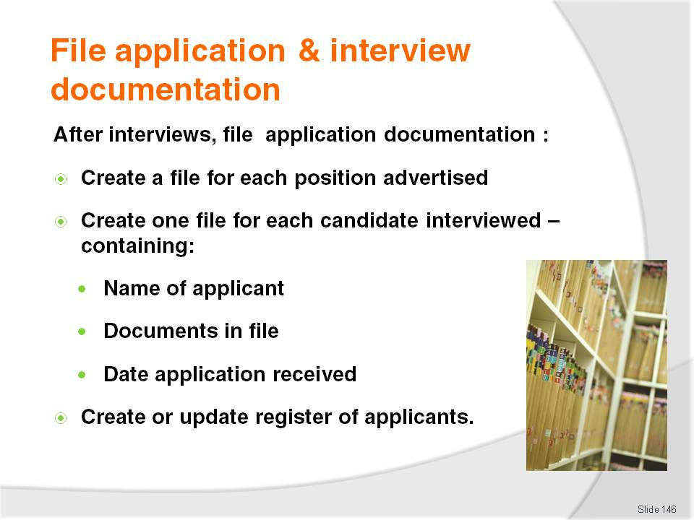
Slide No | Trainer Notes
Trainer tells trainees after interviews have been conducted or testing has occurred, various internal processing and filing activities may occur.
Always follow house policies or established workplace practice when filing application and interview documentation including:
Create a file for each vacancy that has been interviewed for – this may be a suspension file in a filing cabinet
Create a separate file for each candidate interviewed – this may be a manila folder for each applicant
Write on the cover of each manila folder information about the contents of the file – such as:
- Name of the applicant
- Name of every document contained in the file – for example:
- Application form
- Resume
- Names of copies of certificates accompanying the application
- Date application received
Create or update a register of applications – this provides an overview of the names of applicants and the number of applications received. This can be used to decide whether or not the vacancy needs to be re-advertised before interviews are conducted or people selected.

Slide

Slide No | Trainer Notes
Trainer advises trainees activities involved in converting ‘application’ files to ‘interviewed’ files may involve:
Culling files of those who were not interviewed:
- Returning to applicants
- Shredding
- Sending letters of ‘Thanks and Regret’
Retaining and converting files of all those who were interviewed – regardless of whether they received a job offer or not. This is what is meant by keeping an application ‘on file’
Identifying new documents added to the file on the cover of the file – these documents may include ‘Interview rating sheets’ from the interview process as completed by interviewers. It is common practice in many establishments for all notes made during the actual interviews to be filed for future reference
These notes may be required to guide future deliberations, but may also be useful as reference if an unsuccessful applicant alleges impropriety or lodges an appeal with authorities
Update files as required – such as when results of tests and reference checks have been completed
Maintain the file according to house policy – that is, keeping the file for a nominated time period.

Slide

Slide No | Trainer Notes
Trainer advises trainees when filing the materials identified on previous slides they may also be required to:
Detail a list of all the 'Thanks and Regret' letters that were sent – who they were sent to, when and how they were sent
Forward all applications that 'just missed out' to the Personnel department, or various department heads – so a pool of potential staff for future use can be generated
Photocopy and forward all the details and documents of the successful applicants to the Human Resources Department or the department manager – for them to use as the basis for staring up an HR file for each new employee
Notify all relevant departments as necessary regarding the employment of a new person –so they can begin their work obtaining name badges, generating identity codes, obtaining uniforms, registering for induction and orientation.

Slide
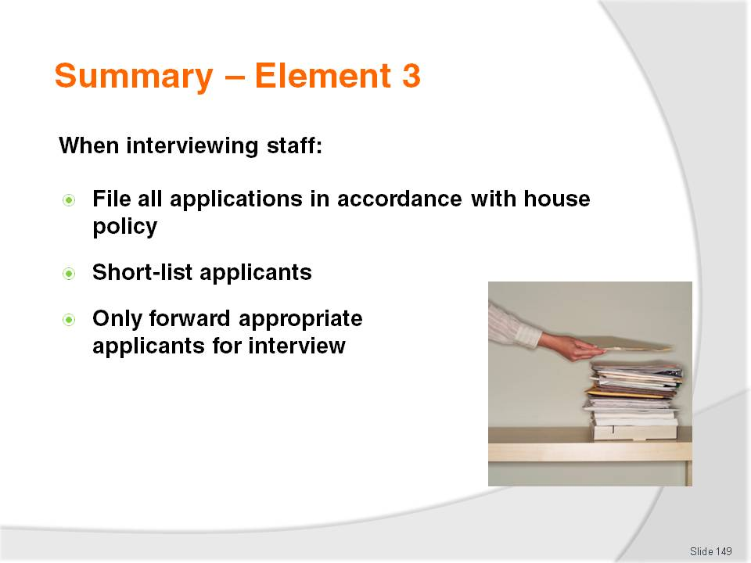
Slide No | Trainer Notes
 | Trainer provides a recap of the Element asking questions to check trainee understanding and responding to questions from trainees, as required.

Slide

Slide No | Trainer Notes
 | Trainer provides a recap of the Element asking questions to check trainee understanding and responding to questions from trainees, as required.

Slide
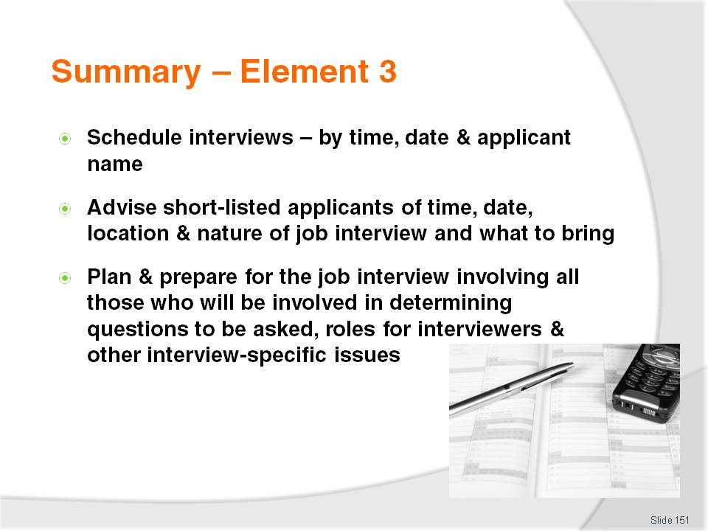
Slide No | Trainer Notes
 | Trainer provides a recap of the Element asking questions to check trainee understanding and responding to questions from trainees, as required.

Slide
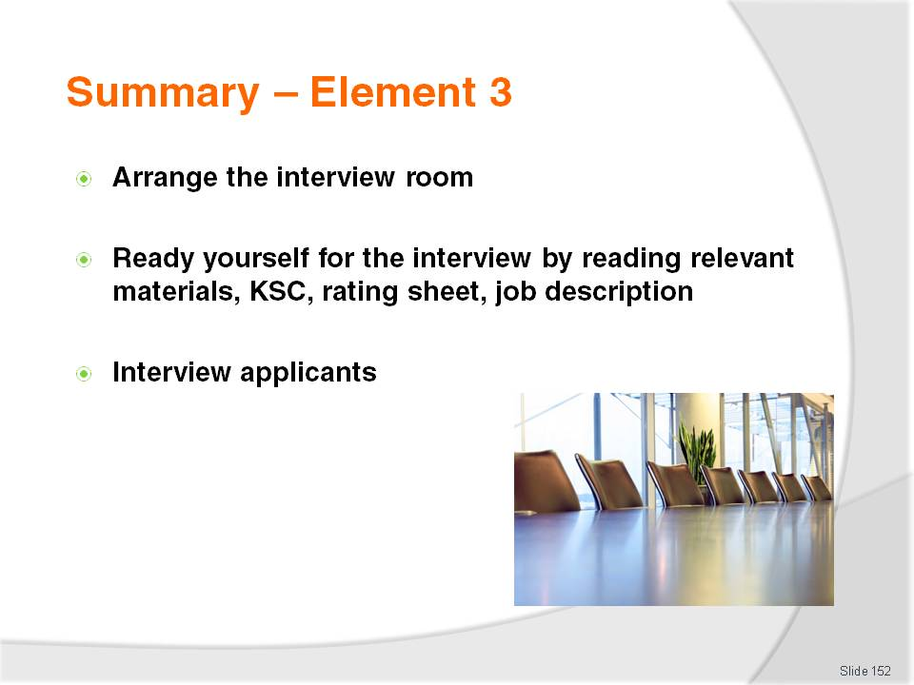
Slide No | Trainer Notes
 | Trainer provides a recap of the Element asking questions to check trainee understanding and responding to questions from trainees, as required.

Slide

Slide No | Trainer Notes
 | Trainer provides a recap of the Element asking questions to check trainee understanding and responding to questions from trainees, as required.

Slide
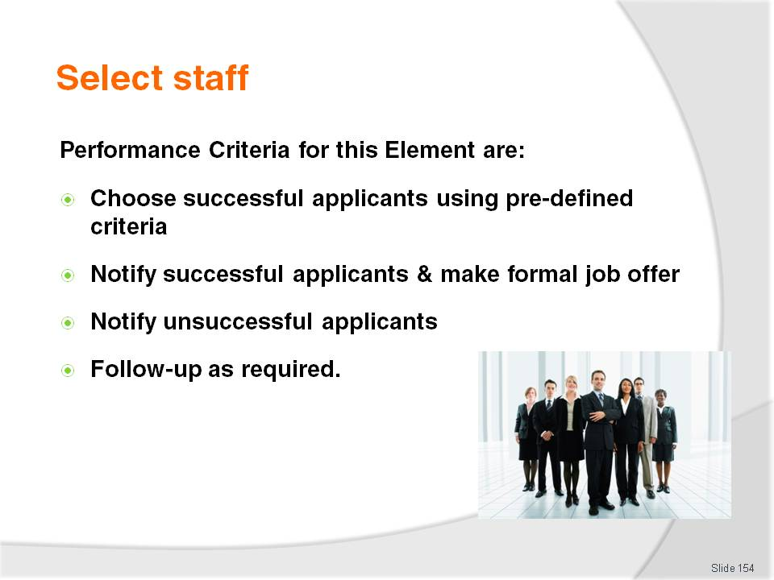
Slide No | Trainer Notes
Trainer identifies for trainees the Performance Criteria for this Element, as listed on the slide.
Class Activity – Discussion
Trainer asks trainees questions regarding staff selection asking questions such as:
On what basis should a hiring decision be based?
How are successful applicants notified they have been successful in gaining employment?
What is a ‘Letter of Thanks and Regret’?
How do workplaces formalise the offer of a job to an applicant?
What follow-up activities might be involved when a new staff member has been selected?

Slide
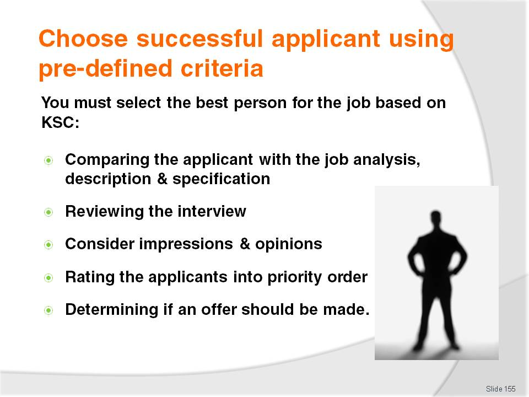
Slide No | Trainer Notes
Trainer advises trainees selection of staff to fill job vacancies should be based on picking the best staff for the job by comparing them to the predetermined key selection criteria for the position.
This stage of the process involves:
Comparing the applicant with the internally generated job analysis, description and specification – and assessing the relevant suitability of each applicant on this basis
Reviewing the interview process and contemplating information obtained from the applicant, as well as opinions and impressions gained by the interviewers – this allows for ‘new information’ discovered at the interview to be taken into account
Rating the applicants into priority order - who is the best candidate? Second-best? Remember the first choice may reject the job offer, may have got another job, or may be waiting for a better offer so it is always useful to pick the ‘top three’
Determining if an offer should be made to a candidate – or if whether there should be more interviews or re-advertising for the position.

Slide
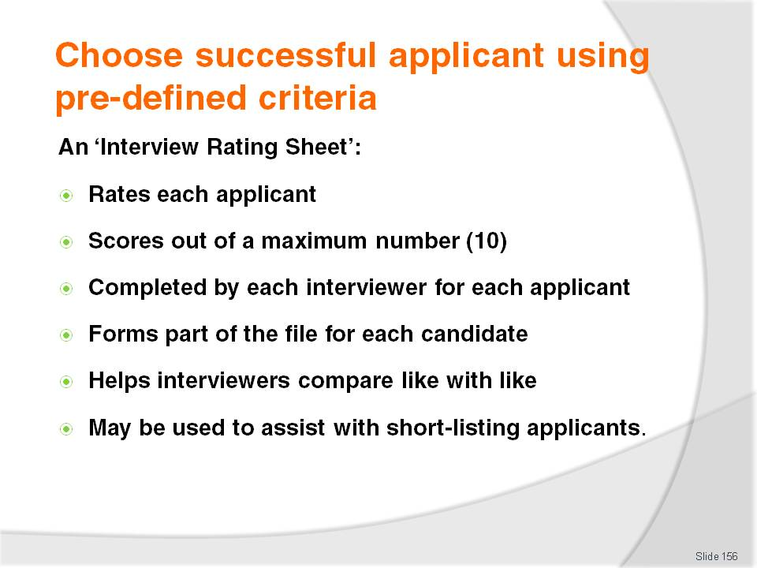
Slide No | Trainer Notes
Trainer advises trainees it is useful to use an Interview rating Sheet to rate every applicant against the selection criteria:
All scores given to an applicant for each criterion are totalled – the one with the biggest score gets the job
Every member of the interview panel should complete their own Interview rating Sheet – and scores are totalled for all interviewers at the end of the interview
This rating scheme is usually a one page form attached to the file of the applicant. The file will contain the applicant’s resume plus any application form, covering letter and copies of any qualifications and references submitted. It may also contain notes made by those who have conducted reference checks
This rating form could also be used during the actual interview process to help record information obtained from the applicant during the interview. They are useful as they help compare ‘like with like’ by ‘forcing’ comparison of different people using the same reference points
This approach can also be used to determine which applicants are short-listed.
Class Activity – Handouts
Trainer copies two sample Interview Rating Sheet provided in Trainee Manual:
Blank ‘Grand Hotel Interview Rating Sheet’
Completed ‘Grand Hotel Interview Rating Sheet’ for the position of Gaming Room Attendant, completed by Sally Kilpatrick.
Trainer:
Distributes blank copy and:
- Explains how the sheet is used by interviewers to score candidates
- Explains all the sections of the sheet
- Discusses need for interviewers to determine criteria to be used
- Identifies how KSC can be integrated into this form
Distributes completed copy and:
- Describes how it has been completed
- Asks trainees to identify who should be offered the job on the basis of the Interview Rating Sheet (Answer: Nicole North)
- Asks trainees who is second-best choice (Answer: Will Williams)
- Asks trainees who is least preferable choice (Answer: Carla Young).

Slide
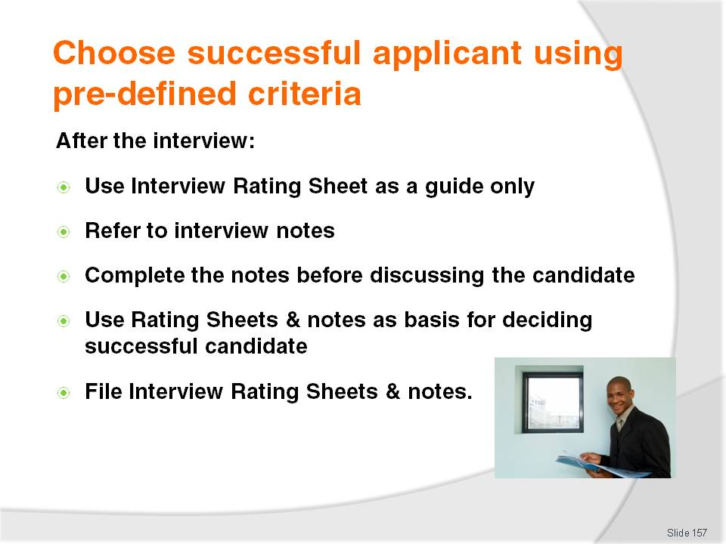
Slide No | Trainer Notes
Trainer explains to trainees other considerations that may need to be factored in after an interview before selecting the best candidate for the job.
Scores on the Interview Rating Sheet may be a guide as to who should get the job as other factors may also impact:
Where notes have been made during the interview, these should be reviewed – usually extra comment will be added on the basis of feelings, reflections and observations regarding the applicant and these can be the cause of concern, or help to verify the most highly-rated candidate really is the best choice
Where panel interviews are being conducted it is best for panel members to complete and review their individual notes before they engage in discussion because the discussion may influence the notes they make
The notes made should be included, along with the rating sheet, in the interview file that has been created for each candidate. These documents can provide a useful basis for reference in the future and also assist in selecting an alternate employee where the first person chosen for the job refuses the job offer made to them.
Class Activity – Individual Exercise
Trainer identifies one work position for each trainee and asks them to:
Prepare a job description and job specification for the position
Develop KSC for the position
Create an Interview Rating Sheet for the position.

Slide
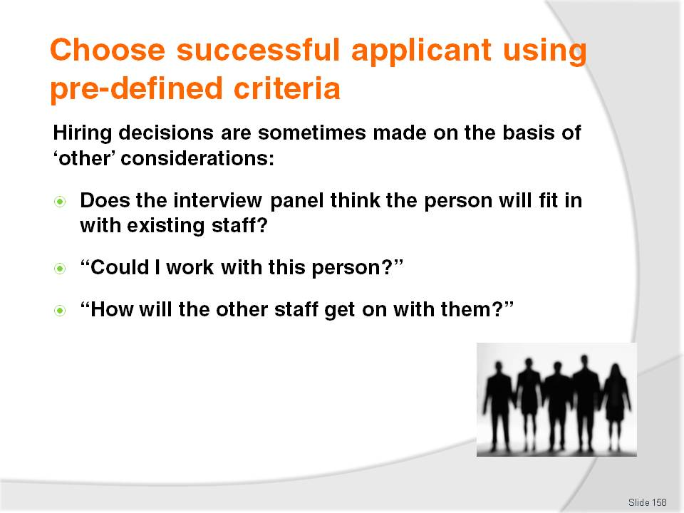
Slide No | Trainer Notes
Trainer explains to trainees the selection of many staff is done on other factors including:
Will the best candidate ‘fit in’ with the existing staff and with the organisation overall. While this consideration is not, on the surface, a very detached or professional one it can be critical in terms of maintaining the unity and cohesion of existing teams and in preserving the ‘happy and harmonious workplace’ that already exist. It may be counter-productive to hire someone who appears to be an excellent choice for the job but who upsets and annoys all the other staff, potentially creating management problems, causing other staff to leave and lowering both productivity and staff morale
This means many interviews are conducted within an environment where interviewers are consistently asking themselves questions such as:
- “Could I work with this person?”
- “How will other staff get on with this person?”

Slide

Slide No | Trainer Notes
Trainer informs trainees when all applicants have been interviewed, or otherwise assessed, it is usual to make an employment offer to the successful applicant(s):
A telephone call is the usual way to do this – but other options may be approved by workplace management
The offer should be accompanies by a formal ‘Letter of Appointment’ – see next slides
Any offers must accommodate the requirements of enterprise policies and comply with any applicable legal requirements
Whilst it is common practice to notify all unsuccessful applicants as soon as possible after a hiring decision has been made, it is also common to keep the ‘next best’ two or three applicants in reserve in case the first choice does not take up the job offer.

Slide

Slide No | Trainer Notes
Trainer explains the use of a ‘Letter of Offer’ (also known as a ‘Letter of Appointment’):
In addition to a verbal offer of employment, employers should provide the successful candidate with a written offer – but not all employers do so unless there is a legal obligation to do so
In some cases, this may be a draft work contract, but a Letter of Offer, or Letter of Appointment is also a popular option
A draft work contract will align with existing workplace contracts, tailor-made for the individual position and is commonly prepared by the HR office.

Slide
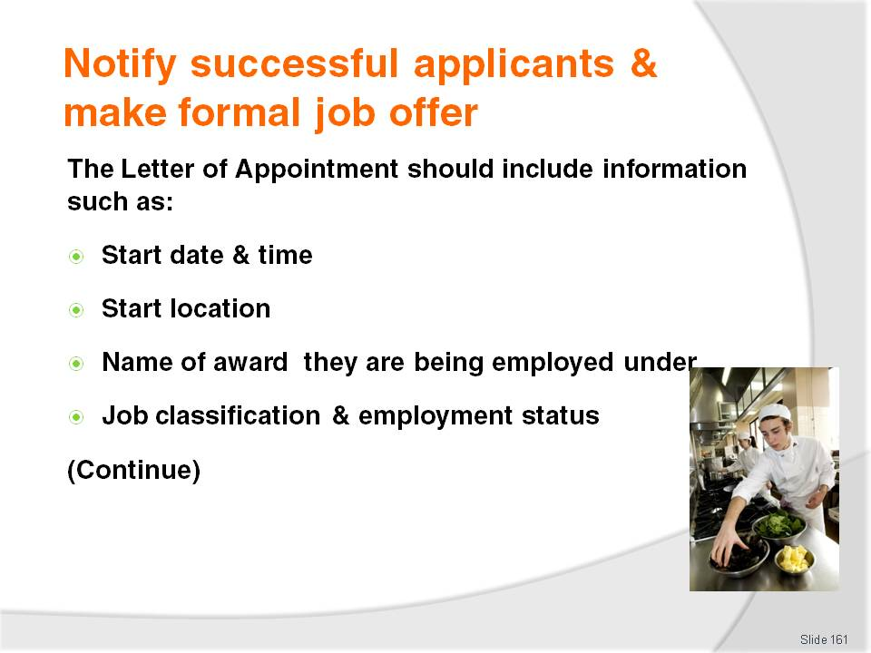
Slide No | Trainer Notes
Trainer informs trainees a Letter of Appointment should include information such as:
When the successful candidate is expected to commence their employment – a day, date and time
The physical location where work is to comment – naming the business, giving a street address and the name of a department where the person will work or attend for initial induction
Identification of any award or agreement the person is to be engaged under – so they understand their conditions of employment
The job classification and employment status attaching to the position the person is being offered – for example ‘Beverage waiter – full-time’, or ‘Receptionist – part-time’.

Slide

Slide No | Trainer Notes
Trainer continues to advise trainees regarding contents of a Letter of Application:
Details of any applicable probationary period – three months is a common term
Entitlements relating to annual leave and sick leave
Specified hours of work identifying start and finish times, hours per week or fortnight or shift work. A statement is often included indicating ‘reasonable overtime’ is to be worked
Remuneration details specifying:
- Pay per week or hour
- Day on which wages are paid
- Method of payment for wages detailing if payment is made in cash, by cheque or via direct deposit into bank account
Advice regarding legislated obligations – such as superannuation, taxation and other issues.

Slide
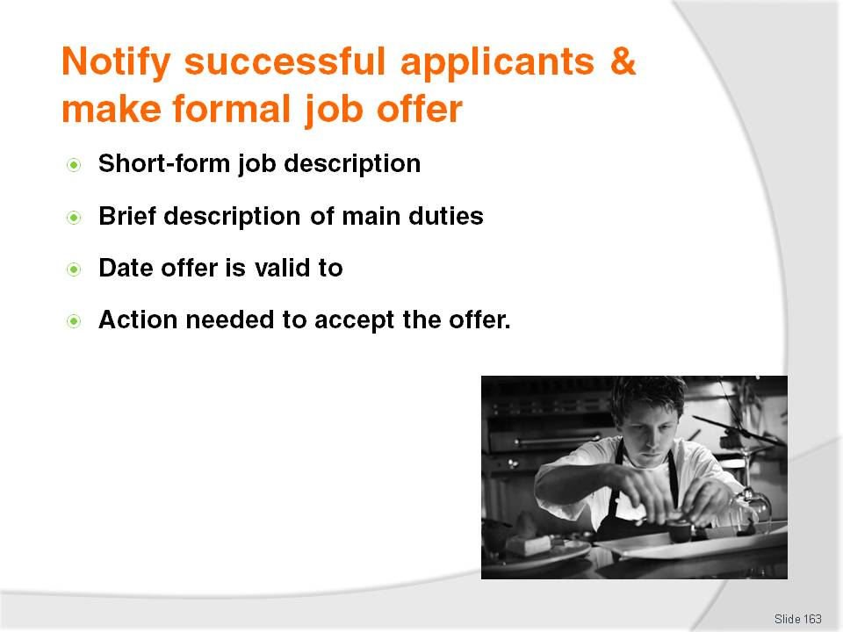
Slide No | Trainer Notes
Trainer continues to advise trainees regarding contents of a Letter of Application:
A short-form job description – providing the basic duties required by the position. This should reflect what was discussed at the interview.
A brief description of the main duties involved
A date indicating when the offer is valid to – and therefore when it expires, and when the offer will lapse
Action the applicant needs to take in order to accept the offer.
Class Activity – Handout
Trainer obtains sample Letter of Appointment or draft work contract and:
Distributes to trainees
Discusses the contents of the document
Explains why each statement is provided.

Slide

Slide No | Trainer Notes
Trainer adds other important points for trainees to note when notifying successful applicants:
Only authorised personnel can make job offers – official approval from management may be required before making an offer
Management should read and approve Letters of Appointment before they are distributed – to ensure they are correct and to make sure they agree with what is contained in them
A copy of the Letter of Appointment should be included in the relevant file for the applicant – with dates identifying when the Letter was given and when the offer expires.

Slide

Slide No | Trainer Notes
Trainer continues advising trainees about additional points to note when notifying successful applicants:
Details of the selection process must be kept private – only those actually involved in the selection process should know how the choice of the successful applicant occurred
Some organisations will allow the Letter of Appointment to be taken away from the workplace
If the Letter of Offer is emailed or posted to the applicant it is a good idea to contact them to ensure they have received it – this is also an opportunity to respond to any queries the candidate may have.
Class Activity – Guest Speaker
Trainer arranges for local industrial relations official to attend and:
Talk to trainees about:
Requirements to be observed when offering employment to a person
Issues that cannot be included in an offer
Probationary periods
Their experience with good and bad offers, and those that have been illegal
Distribute to trainees:
- Copies of relevant legislation, fact sheets, information
- Sample Letters of Offer or work contracts
- Contact details for later follow-up by trainees if required.
Slide
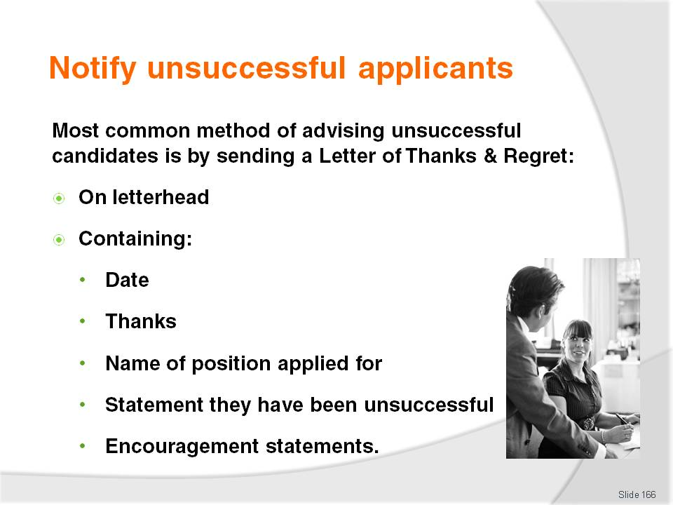
Slide No | Trainer Notes
Trainer tells trainees it is standard ‘best practice’ business practice is to notify applicants who have been unsuccessful in gaining employment.
The most common method of notifying applicants they have not been successful in obtaining employment is to send them a Letter of Thanks and Regret which is a standard ‘template’ letter on company letterhead paper which usually contains the following:
Date
Thanks for the application
Identification of the position applied for – because some people can apply for multiple positions
A statement advising in this instance their application has been unsuccessful
Further statements such as:
- Encouragement in their job seeking activities
- Encouragement to apply for other positions at the organization as they are advertised.

Slide
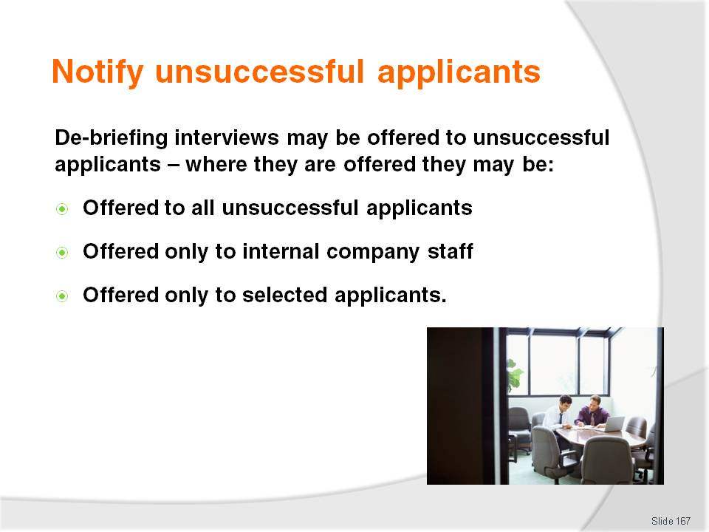
Slide No | Trainer Notes
Trainer advises trainees Letters of Thanks and Regret may, if the enterprise offers them, make mention of de-briefing interviews for unsuccessful candidates.
Where they are offered they may be:
Offered to all unsuccessful applicants – this is unlikely but certainly a good PR exercise and potentially beneficial where sufficient skilled staff are available as the interview can direct applicants regarding the skills and experience they need to gain before making another application
Offered only to internal company staff who have applied for a promotion
Offered only to selected applicants based on their potential to be useful to the company in the future.

Slide

Slide No | Trainer Notes
Trainer advises trainees the de-briefing interview will:
Be conducted by one of the people on the interview panel – so there is first-hand feedback on the applicant’s performance at the interview
Provide feedback on how the applicant presented – and conducted themselves at the interview
Provide advice – regarding their CV and their physical response to the job vacancy advertisement or directions
Provide tips and advice – on how their next interview may be more positive
Identify issues or questions not covered well by the applicant
Encourage the person to continue applying for work
Give advice on what they need to do to address identified gasp in their skills, knowledge or experience.

Slide

Slide No | Trainer Notes
Trainer identifies unacceptable ways of enterprises notifying unsuccessful candidates.
All company policies regarding notifying unsuccessful applicants as they apply to their workplace must be adhered to advising the following may apply:
Email notification is approved in some businesses
Telephone notification is usually not used – as this can involve discussion with the applicant about why they were unsuccessful
The use of texting/SMS is generally unacceptable.

Slide

Slide No | Trainer Notes
Trainer informs trainees when a Letter of Appointment (or similar) has been sent to a successful applicant there can be need to follow-up in order to:
Obtain original copies of documents presented at interviews – so they can be photocopied and included in the Personnel file for the person. Documents may include:
- Birth certificate
- Work permit/visa
- Qualifications, credentials and licences
Explain details of the job offer, contract or other ‘work instrument’. It is to be expected every successful job applicant will have questions of some sort about at least one or two aspects of their new employment. This applies even to successful applicants who have previously worked at the business but are transferring to a new job or position.

Slide
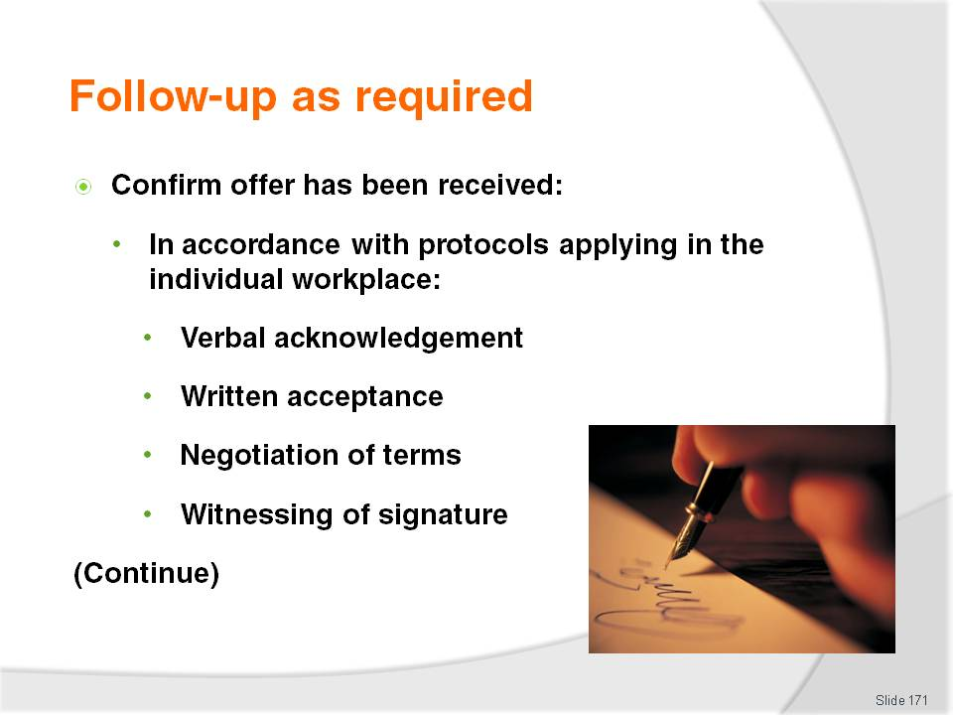
Slide No | Trainer Notes
Trainer continues to advise trainees about possible follow-up activities once a Letter of Offer has been sent to a successful applicant:
Confirm acceptance of the job offer – this may:
- Be an unconditional acceptance of what has been offered in the formal offer of employment
- Require negotiation of terms, conditions or pay rates. It is important only those with the necessary authority are involved in these negotiations
- Be a simple verbal acceptance
- Require the formal signing of the Letter of Appointment or other employment instrument
- Require the signature to be ‘witnessed’ by a designated person within the employing workplace
- Require the signed document to be photocopied and:
- Forwarded to Personnel/HR – so they can initiate payment and other internal requirements applying to the engagement of new staff
- Added to the existing Personnel file for the individual.

Slide

Slide No | Trainer Notes
Trainer completes advising trainees about possible follow-up activities once a Letter of Offer has been sent to a successful applicant:
Offer the job to another applicant – if the first choice of the selection panel refuses the job offer which may entail:
- Contacting the interview person for their advice about who to offer the job to
- Reviewing the interview rating sheets to identify the ‘next best’ applicant
- Obtaining permission to make the offer to a nominated person
- Producing or organising for an alternate Letter of Appointment, contract or employment instrument to be drafted – changes may need to be made to an existing document in terms of:
- Dates – starting date, date for accepting the offer
- Name
- Remuneration – the alternate candidate may be offered a higher or lower rate than first identified.

Slide
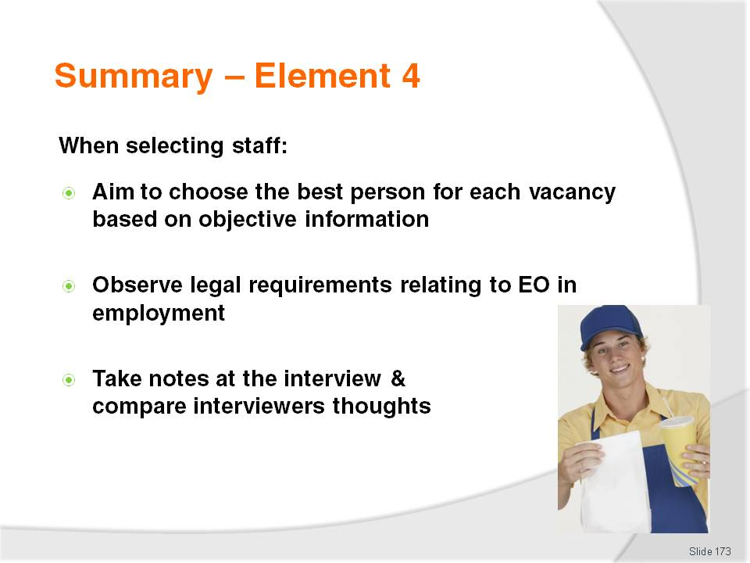
Slide No | Trainer Notes
 | Trainer provides a recap of the Element asking questions to check trainee understanding and responding to questions from trainees, as required.

Slide
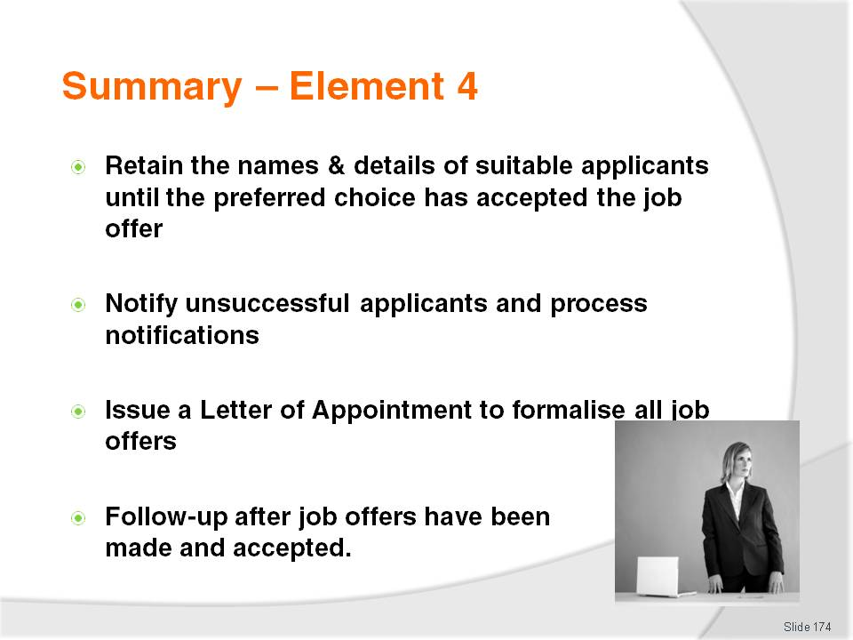
Slide No | Trainer Notes
 | Trainer provides a recap of the Element asking questions to check trainee understanding and responding to questions from trainees, as required.

Slide
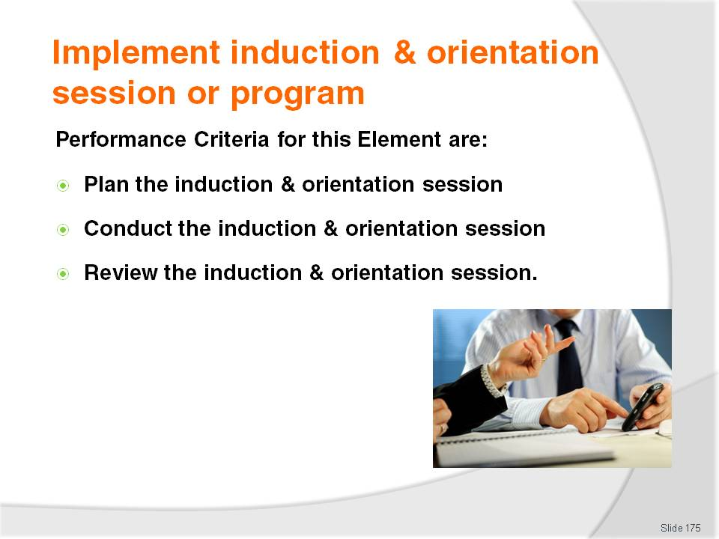
Slide No | Trainer Notes
Trainer continues to identify for trainees the Performance Criteria for this Element, as listed on the slide.
Class Activity – General Discussion
Trainer leads a general class discussion on reviewing induction and orientation by asking questions such as:
What is an induction and orientation session? Why are they conducted and what do they cover?
What experience do you have in relation to being inducted into a new workplace? What was involved? How long did it take? Who did it?
Why is there a need to review induction and orientation sessions?
Who might be involved in such a review?
How often should these reviews take place?
What topics should be addressed as part of these reviews.

Slide
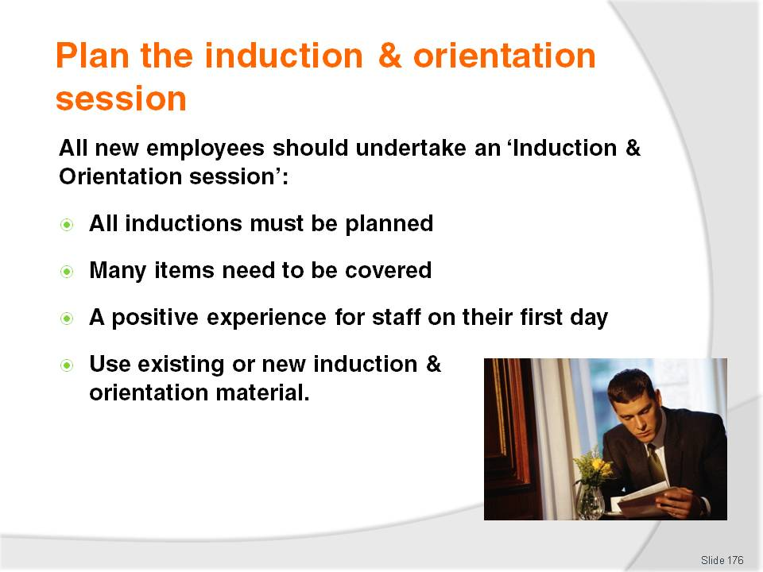
Slide No | Trainer Notes
Trainer explains to trainees it is standard business practice for all new employees to be given some form of induction program (also known as ‘induction and orientation’ programs or sessions).
Trainer emphasis basic requirements for inductions:
They must be planned – it is vital to know what needs to be presented, who will be involved and when things will happen
Many things need to be planned – see following slides for examples
The induction and orientation must give a positive impression to new staff on their first day with their new employer
In organisations where induction and orientations are well-prepared and conducted on a regular basis, much of what is required will already be available and all that is required is to use what already exists
Where little exists in the way of formal induction and orientation sessions much more will need to be organised and prepared.

Slide
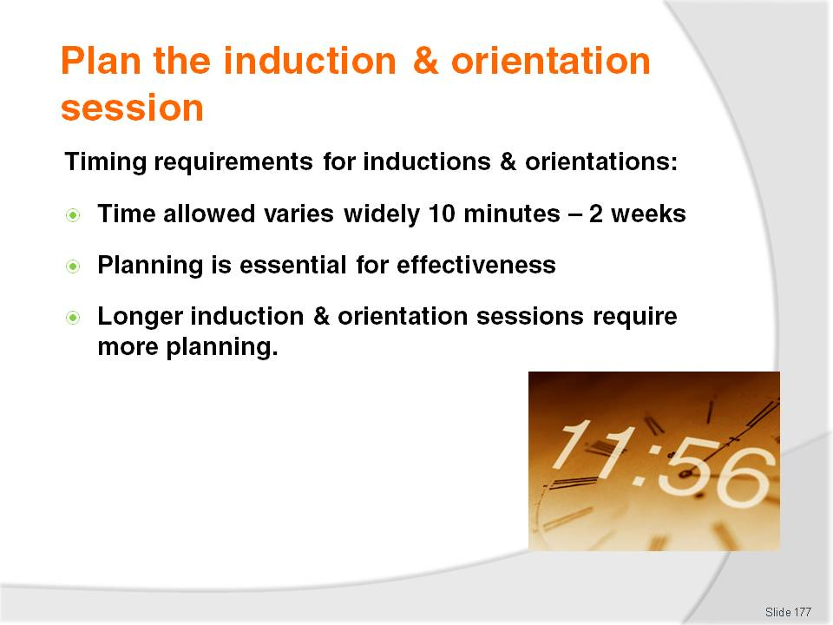
Slide No | Trainer Notes
Trainer talks to trainees about timing requirements for induction and orientation sessions stating:
The amount of time allocated to Induction and Orientation sessions/programs varies enormously from 10 – 15 minutes through to a day or more (or even two weeks) in some larger premises
The more planning and preparation that goes into these programs, the more effective they will be
Certainly no effective induction program simply ‘happens’ of its own accord
The longer the period for the induction and orientation, the more there will be included in the program session so the more need there is for planning.

Slide
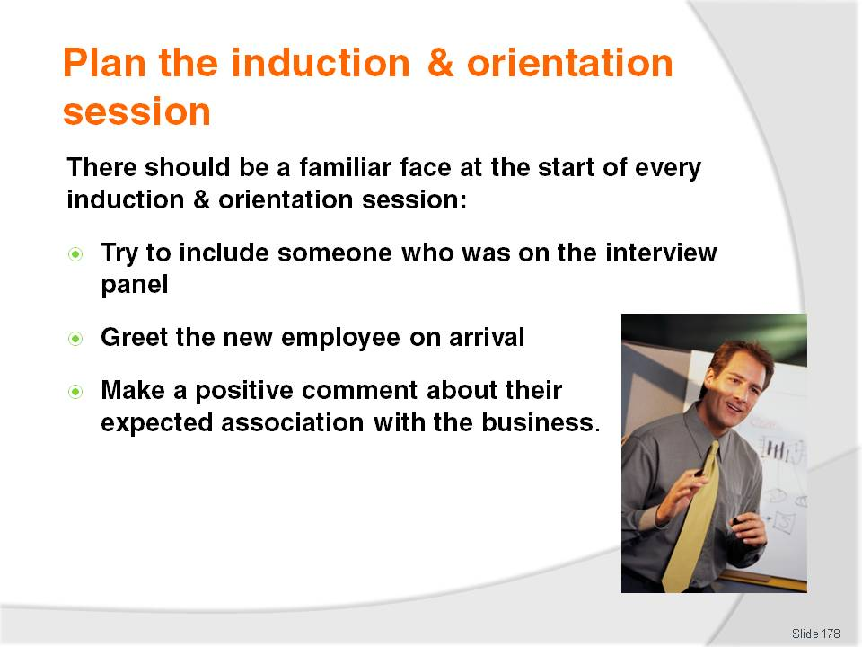
Slide No | Trainer Notes
Trainer informs trainees there should be a familiar face at the start of all induction and orientation sessions:
Whilst practicalities vary between establishments, it is a positive start to a new employee’s association with their new employer if someone present at the interview is there to welcome them on their first day
This provides a familiar face to greet the new employee and demonstrate a personal interest in their welfare and in their association with the business.

Slide
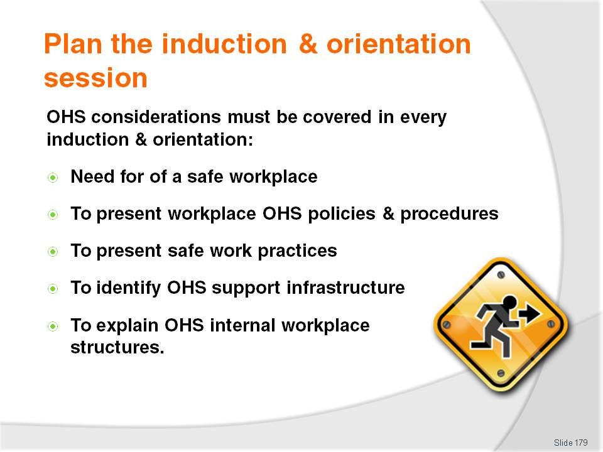
Slide No | Trainer Notes
Trainer explains to trainees an important element of every induction and orientation program is the provision of OHS information to new staff:
This is done to allow operators to discharge their legal obligations in relation to informing staff about potentially dangerous situations and procedures and relevant OHS requirements to be followed
Basic OHS requirements covered as part of the Induction can include:
- Provision of OHS policies and procedures
- Presentation and description of safe work practices
- Identification of location of first aid kits, accident registers, fire extinguishers and evacuation plans
- Explanation of OHS structures (committees and representatives) within the business.

Slide
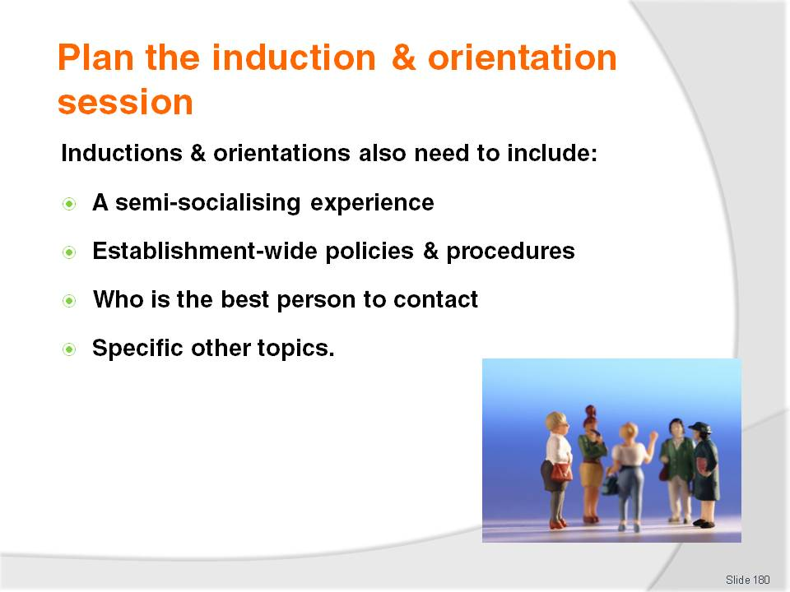
Slide No | Trainer Notes
Trainer explains in addition to what has already been identified an induction and orientation session needs to include:
A semi-socialising experience – getting to know other staff, putting a name to a face and learning their roles
Establishment-wide policies and procedures – such as where to park, general staff-related staff policies, standard operating procedures for generic tasks
Names of best person to contact for work-related queries and their contact details
Specific other topic – see following slides.

Slide
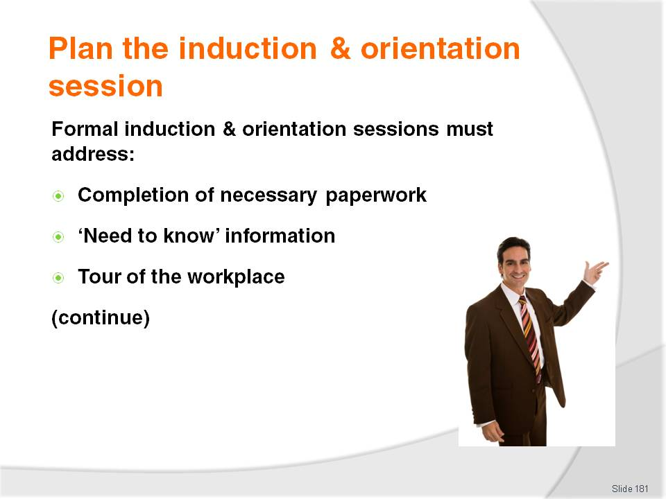
Slide No | Trainer Notes
Trainer instructs trainees about the contents of a formal induction and orientation session;
Completion of necessary paperwork – covering internal and legislative requirements, such as:
- Offer of employment letter (if not already signed and completed)
- Staff uniform form
- Personal details form including identification of ‘next of kin’
- Bank account details form – for payment of wages into the bank
- Personal taxation form
- Superannuation application form
'Need to know' information – names of key staff, location of toilets and change room, where staff can park their cars, how to sign in at the beginning of work, where company policies and procedures are located. This may require:
- Arrangement of access to workplace intranet
- Distribution of copies of policies and procedures
- Handing out staff employee manual
Tour of the workplace – to show the extent of the business, the physical relationship of one area to another, and to allow the new staff member to become more aware about the total nature of the business. Some businesses include a 'Tour Checklist' the new staff member ticks off as they visit certain areas of the property, to ensure they get to see all the necessary areas.
Class Activity – Handouts
Trainer obtains sample documentation as identified on this slide and:
Distributes to trainees
Discusses and explains their role
Tells trainees where these forms may be obtained.

Slide
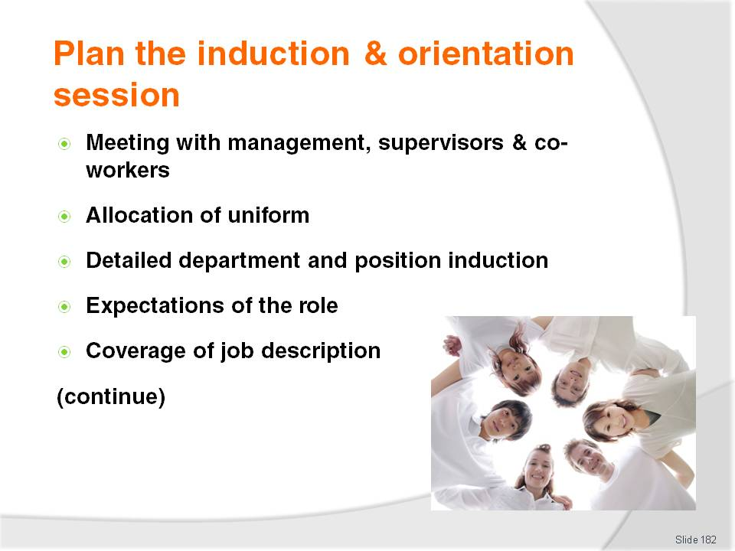
Slide No | Trainer Notes
Trainer continues to provide examples of what needs to be covered in an induction and orientation session:
Meeting with managers, supervisors and co-workers – to introduce the new member and enable them to put a face to the name
Allocation of uniform and relevant badges – issuing of the name badge and uniforms. This may include fittings or ordering of new uniform. A copy of the 'staff uniform policy' may also accompany this, together with a sheet explaining the charges for replacement uniform items
Detailed department and position induction – explaining how the new staff member’s role fits in with other roles in the business and how the department collaborates with other departments to achieve overall organisation aims, identification of where materials, utensils and other work requisites are located
Expectations of the role – setting out what is expected from the employee by management, customers and other staff
Coverage of details in the relevant job description – explaining and clarifying aspects of the job as it applies to the individual. This is a detailed, point-by-point coverage and explanation of the job further explaining the job that has already been briefly addressed during the interview process. This explanation is intended to highlight vital aspects of the job and every aspect considered important.

Slide
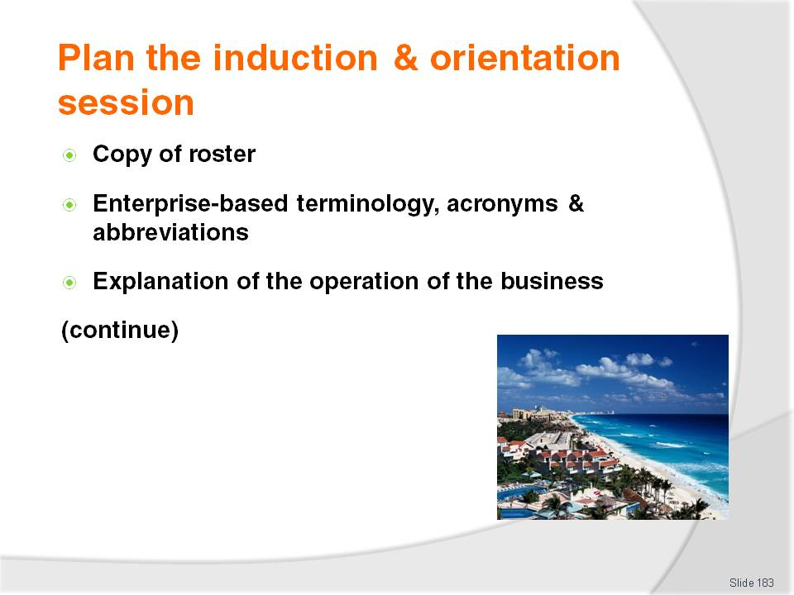
Slide No | Trainer Notes
Trainer continues to provide examples of what needs to be covered in an induction and orientation session:
Distribution of a copy of roster – so the new staff member knows when they are expected to attend for work, when their breaks are, which days are Rostered Days Off
Distribution of a list containing establishment-based terminology – this can be a physical checklist to explain establishment-specific terms and in-house short-hand or accepted abbreviations. For example, most businesses have specific operations abbreviations and terms
A written explanation of the operation of the business – this may cover an explanation of the range of products and services offered, any future plans for expansion, an overview of the different markets serviced, presentation of customer profiles, a list of the hours of operation of different departments and services, how payment is accepted throughout the venue, and even our terms of trade. There is really no end to what can be covered here, and this list is very much something that grows and changes with the business.

Slide
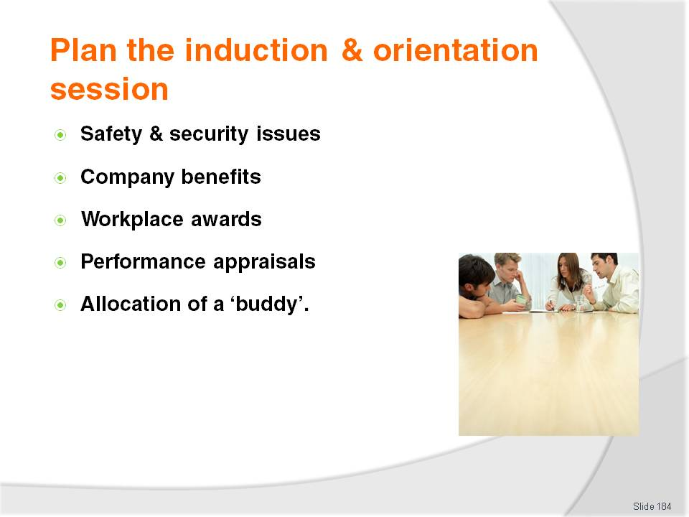
Slide No | Trainer Notes
Trainer continues to provide examples of what needs to be covered in an induction and orientation session:
Explanation of safety and security issues – notification of the emphasis the venue places on the safety and security of staff and customers, explanation of where first aid kits, fire extinguishers, fire blankets, alarms and evacuation plans are located. This may also be accompanied by company policies on evacuations, robberies and other security and emergency situations
Explanation of company benefits – an explanation of staff discounts available, opportunities for promotion within the company, training provided by the company and how to take advantage of it, together with the limits that apply in each instance
Explanation of any workplace awards that may exist – such as 'Employee of the Month', how to win it and what it consists of
Information about performance appraisals– explanation and definition of what these involve, when they will take place, how they are administered and what they are used for. Important in this regard is presentation and explanation of any KPIs the employee will be evaluated against. These could include revenue generated, number of rooms serviced, number of people served, number of meals served or other indicators appropriate to the individual job role
When new staff members start their work, it is common to allocate them a person to be their workplace mentor who they can turn to for advice, information, guidance and further information.

Slide
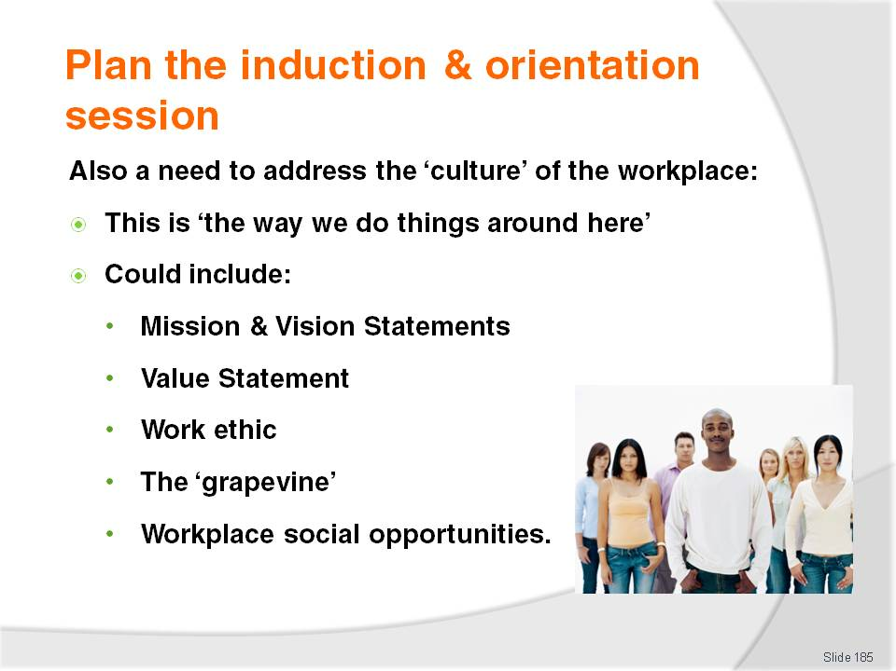
Slide No | Trainer Notes
Trainer identifies the induction and orientation should also address the ‘culture’ of the workplace:
The culture of the organisation is generally described as representing ‘the way we do things around here’. It is important information for a new employee to help them ‘fit in’ with the workers who are already in the organisation.
This information may involve:
- Consideration and discussion of the Mission Statement of the business
- Explanation of the Vision Statement
- Explanation of company Values
- Description of the work ethic of the business
- Explanation of the ‘grapevine’ within the venue
- Identification of social opportunities (such as clubs) within the staff network.
Class Activity – Handouts
Trainer obtains sample documentation as identified on this slide and:
Distributes to trainees
Discusses and explains their role
Tells trainees how these may be developed.

Slide
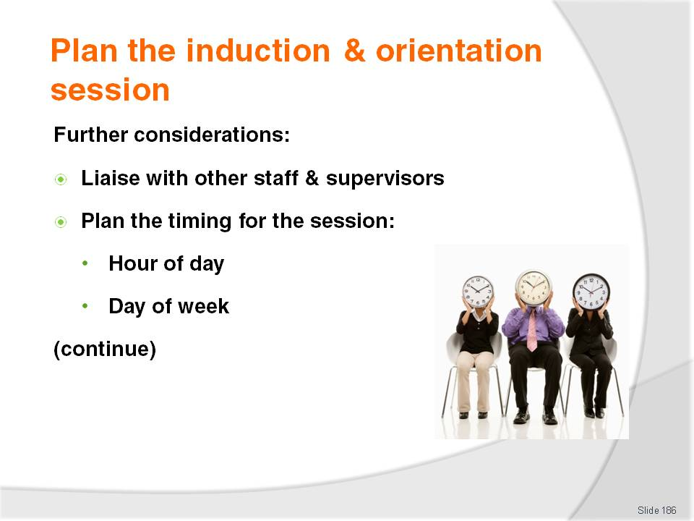
Slide No | Trainer Notes
Trainer presents further considerations when planning an induction and orientation:
When planning an induction for a staff member it is important to liaise with operational colleagues to ensure the induction is implemented in a manner minimising operational disruption
Two common considerations relating to the timing of the induction for a new staff member are:
- The hour of the day the induction is to take place
- The particular day of the week the induction will take place.
This obviously has implications for determining the ‘first day’ for the new employee: it is not a good idea to conduct an induction at a busy time on a traditionally busy day.
Class Activity – Guest Speaker
Trainer arranges for a relevant industry manager to visit trainees to:
Discuss their role and responsibilities and how they came to be where they are
Explain the preparation they do for an induction and orientation session
Present generic material used as part of an induction and orientation session
Explain how they tailor-make induction and orientation sessions to cater for different job positions
Identify how long an induction and orientation session takes and when they conduct them
Identify the activities comprising a induction and orientation session.
Slide
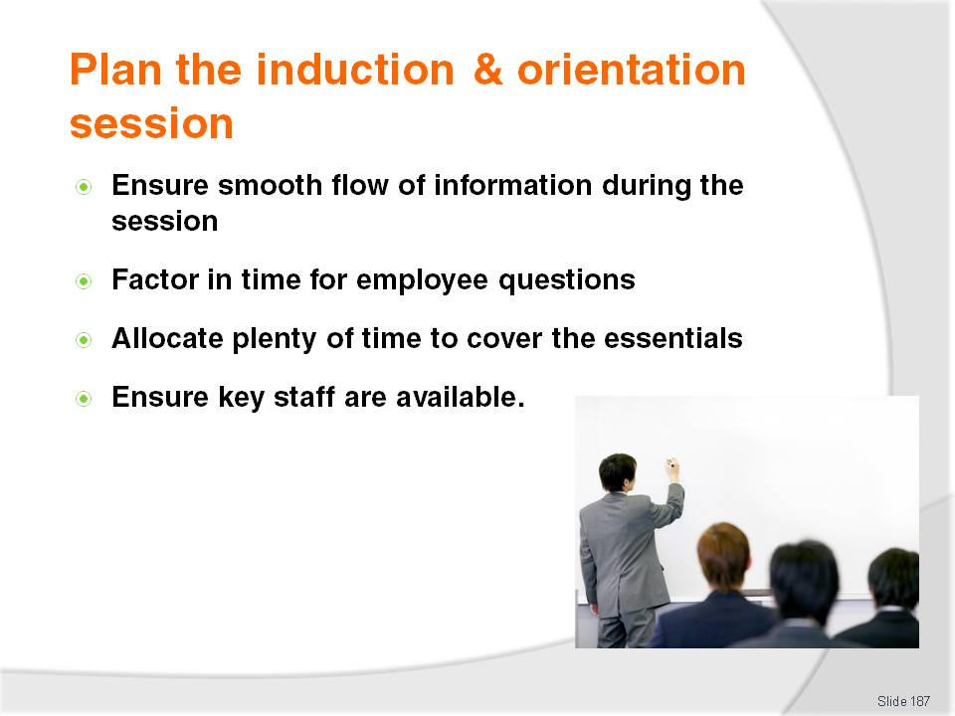
Slide No | Trainer Notes
Trainer continues to present further considerations when planning an induction and orientation:
The smooth flow of information – it is important to think through the proposed induction session so as to check the flow of information to the new staff member. Is there a readily understandable and sequential flow of information or is the information being presented in a random, confusing and disjointed fashion?
Allowing time for the new staff member to ask questions and clarify information – it must be remembered the induction and orientation program should be viewed as an opportunity for the new staff member to ask questions in order to clarify their issues and to find out further information they deem necessary. An effective induction program will feature plenty of encouragement to the new person to ask questions, and plenty of time for their questions to be addressed
Allocating adequate time for covering the essentials – a common problem with induction programs is they are often too rushed. This can be a problem because a new staff member is not likely to complain or question being hurried through their first day at work. They will usually just keep quiet and learn nothing, hoping to pick things up as they go. Where this happens the induction really has been a waste of time and can even be regarded as counter-productive
Ensuring the availability of key staff – this is a difficult thing to organise and very often will require the new staff member take several days to meet all the people seen as 'key' for their role. Given all staff have time off, other duties to perform, may be sick or on annual leave, it is not surprising few new staff get to meet all 'key' people on their first day. The important point to bear in mind is there is a need to identify who these key staff are, and then ensure they are introduced to the new person as soon as possible. This will often involve following-up people many days after the initial induction to introduce them to others.
Class Activity – Small Group Exercise
Trainer divides trainees into small groups and allocates one job position to each group and asks them to develop an induction.

Slide
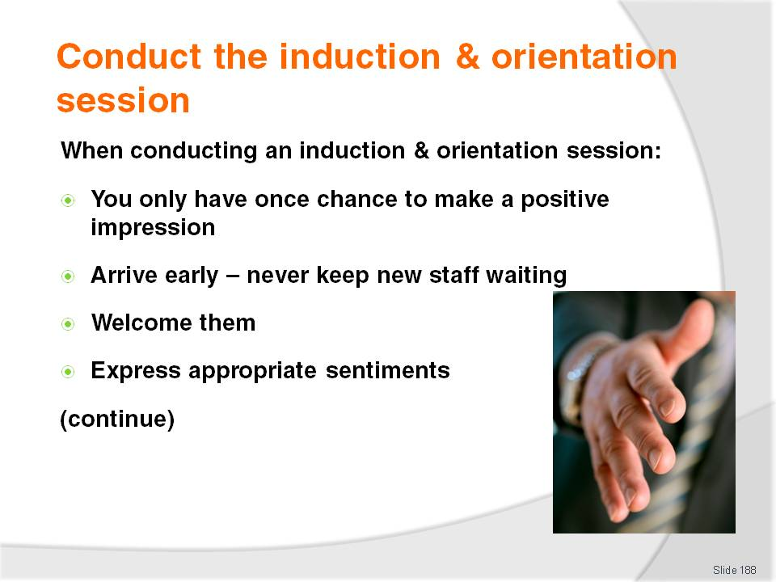
Slide No | Trainer Notes
Trainer advises trainees their role may to conduct induction and orientation for new staff explaining important things to consider when personally conducting induction and orientation sessions are:
There is only one opportunity to make a positive impression in the mind of the new staff member
Arrive early for the session and ensure all the necessary preparations have been made. One of the biggest mistakes is to arrive late for the session and keep the new staff member waiting beyond the advised starting time for the session. This immediately sends a poor message to them about how they are valued and starts their relationship with the company on a negative footing
Welcome the new staff member when they arrive for their induction and:
- Introduce self – where necessary
- Try to make them fee at ease
- Congratulate them on securing the job
Express appropriate sentiments:
- “I look forward to working with you”
- “I hope you have a long and fruitful relationship with the business”
- “I think you will have a rewarding, challenging and interesting time with us”.

Slide
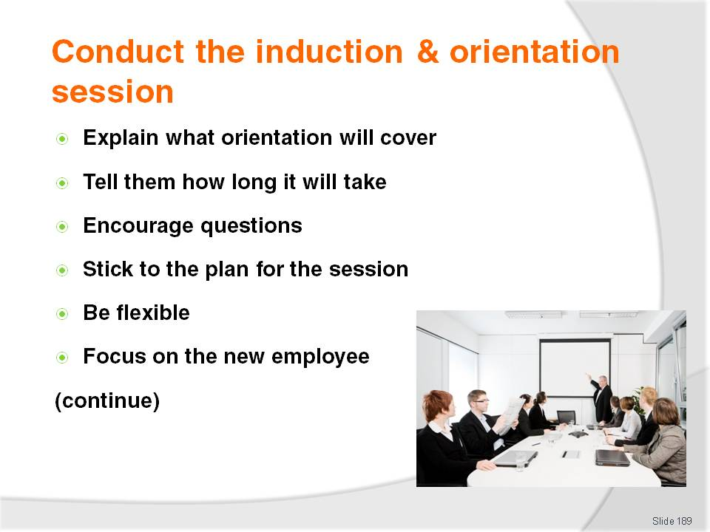
Slide No | Trainer Notes
Trainer continues to provide advice to trainees regarding conduct of induction and orientation sessions:
Explain what the induction and orientation will cover
Identify how long the session will take
Encourage them to ask as many questions as they want
Follow the plan – it is important to adhere to the plan developed for the induction and orientation session. Departing from this plan raises the risk important information will be forgotten, and can also mean the new employee is provided with too much information and feels overwhelmed
Given the need to follow the plan for the session, the person conducting the induction must be flexible. If the plan is to enter a certain area and show the new person around, identify pieces of equipment and locate certain stock items, but there are an uncharacteristically large number of customers in the area and the staff are under obvious pressure, then the tour must be re-scheduled (even to a different day)
Concentrate on the new employee – the focus of the session must be the new staff member. Do not allow other things (telephone calls, other tasks, questions from other staff) to intrude and de-value the session.

Slide
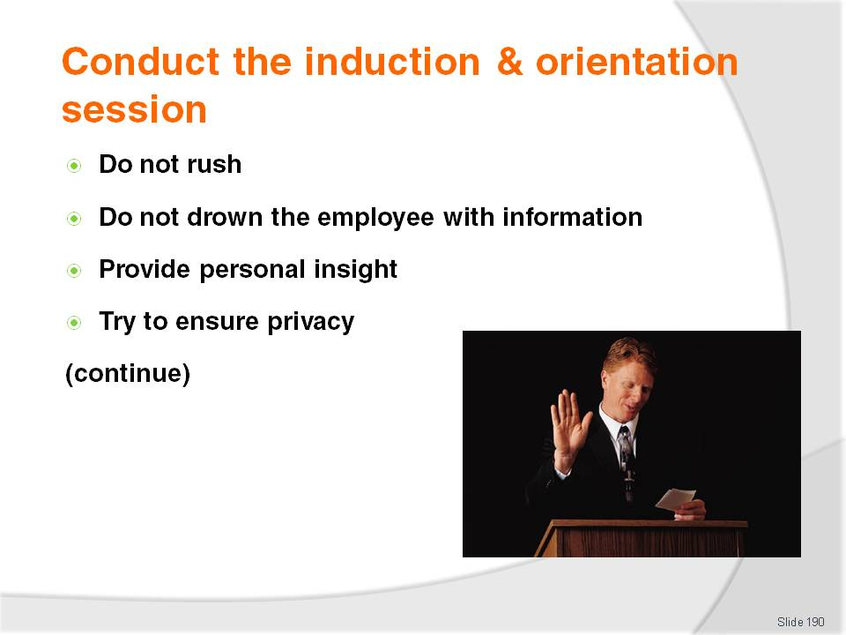
Slide No | Trainer Notes
Trainer continues to provide advice to trainees regarding conduct of induction and orientation sessions:
Do not rush – try to avoid giving the impression:
- There are more important things to do
- The induction session is a chore
Try not to drown the employee with information. It is easy for new staff to be overwhelmed by a mass of information. Stick to the plan
Give personal insight – in addition to ‘structured’ information. Give the new staff member the benefit of personal experience and knowledge. Make sure nothing is said of a negative nature about the business, its practices, staff or management
Try to ensure privacy – when policies and practices have to be explained, when job requirements and expectations and similar are explained. Try to conduct these discussions in a location where there are no other staff or customers. This encourages the new person to ask questions and respects their right to privacy.

Slide
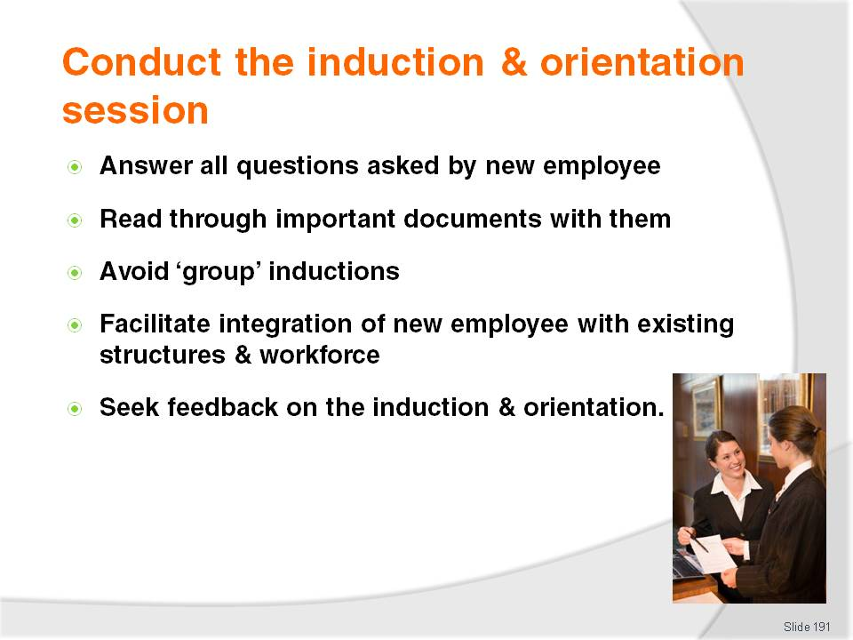
Slide No | Trainer Notes
Trainer continues to provide advice to trainees regarding conduct of induction and orientation sessions:
Answer all questions asked – honestly and comprehensively. Be prepared to find out answers where they are not known
Read through relevant documents with the new staff member – to ensure they understand what is required. Important points should be emphasised
Try to avoid group inductions and orientations – group sessions may appear attractive in that they can save time but the reality is often certain members of the group are overlooked or do not receive proper attention or receive the necessary information. Many group inductions are a waste of time and effort, serving no more useful purpose than ‘ticking the box’ that an induction has been provided
Do whatever is appropriate to facilitate integration of the new employee into existing structures and the existing workforce – show them the operation of the department/staff; explain and show what they are expected to do. Personalise the experience
Ask for feedback on the contents of the induction and orientation program and on your performance in conducing it.
Class Activity – Excursion
Trainer arranges for trainees to visit a local enterprise and:
Talk to management about staff recruitment, selection and induction and orientation sessions
View management offices where they work and see the facilities they have to work with
View relevant management policies and procedures related to staffing functions
Observe a hiring interview – if possible (or a mock interview)
Participate in a mock induction and orientation session.

Slide
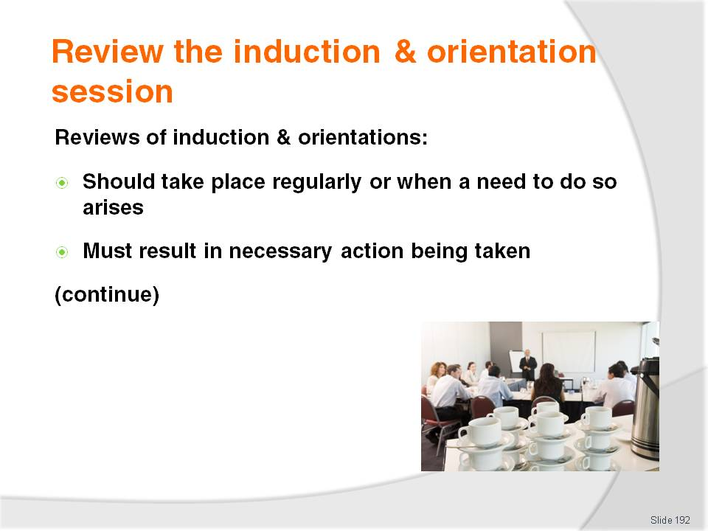
Slide No | Trainer Notes
Trainer suggests to trainees in the same way other activities of the business should be subject to regular review, so too should the provision of induction and orientation sessions highlighting:
Inductions and orientations should be reviewed:
- At least annually, or
- Following a valid complaint from a new employee about their induction and orientation, or
- Following the first induction and orientation session for a newly created position
The key to reviewing induction and orientation sessions is to ensure appropriate action must be taken to address all legitimate concerns. There is no point conducting a review and then failing to act to on the identified issues.

Slide
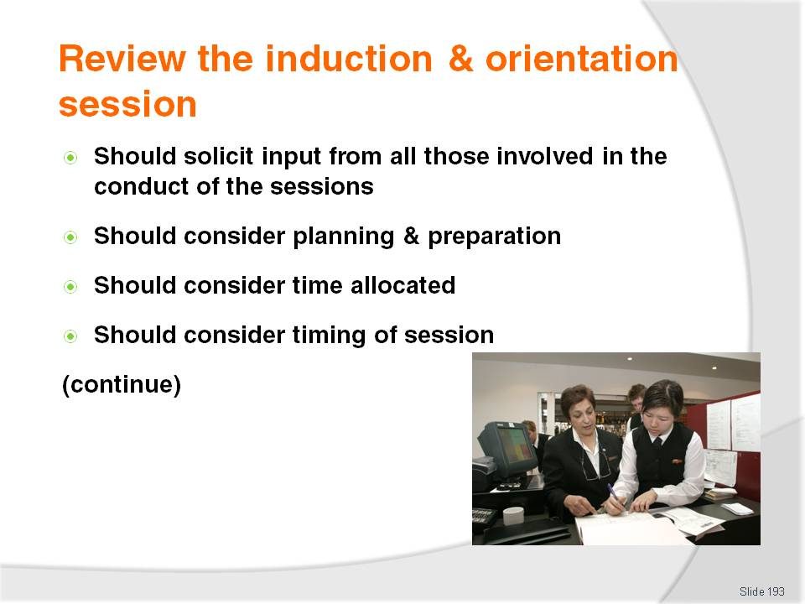
Slide No | Trainer Notes
Trainer continues to provide trainees with advice regarding reviewing induction & orientation sessions:
They should involve all those involved in the session which in practice this means the review should solicit input from:
- Management
- Co-workers
- Supervisors
- Past inductees
- Anyone who conducts the induction and orientation
Consider planning and preparation undertake – was there sufficient time and effort put into this phase of the induction? Often, a poor induction can be traced back to poor planning and preparation
Consider time allocated – was there sufficient time allocated to actually conducting the induction? Or was it too rushed?
Consider timing of the induction – was it conducted on the best day? At the most appropriate time, or at a time when things were too busy and key staff were unavailable because of this?

Slide
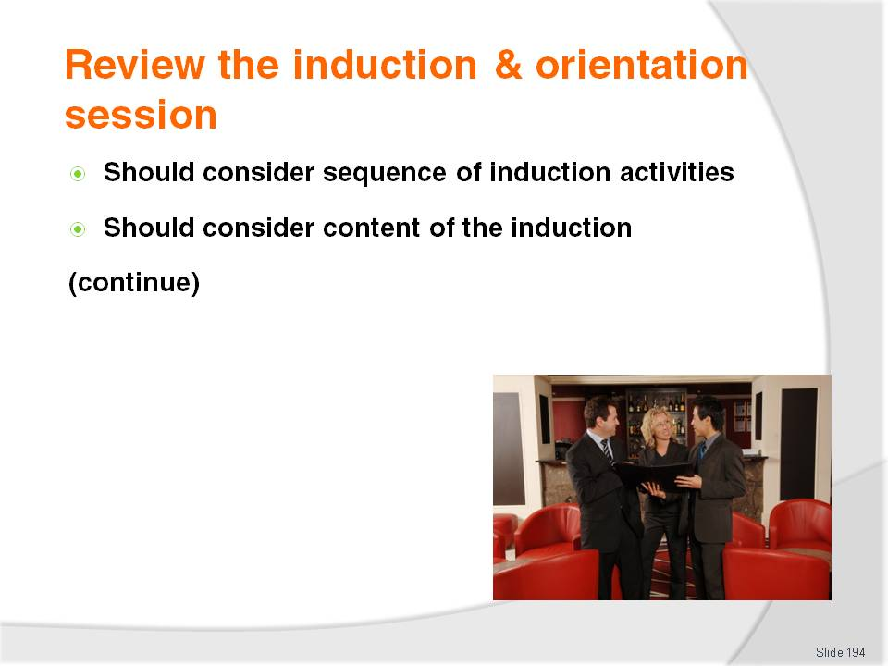
Slide No | Trainer Notes
Trainer continues to provide trainees with advice regarding reviewing induction & orientation sessions:
Consider sequence of the induction activities – the correct items may have been addressed by the session but were items presented in the most effective order? Is there a need to re-arrange some items to enhance learning and make the session more productive?
Consider content of the induction session – were all the necessary things covered? Were there gaps in the content provided needing attention so the new staff member is better informed or made aware of necessary (and perhaps, legislated) workplace requirements. Content is a very large area for consideration as part of the review and should examine:
- Contents of documents provided
- Contents of presentations given by key personnel to new staff
- Items/issues covered by the actual orientation and induction process.
- Basic questions are:
- Were things missing?
- Was printed material legible?
- Have things changed in the workplace necessitating amendments to previous induction sessions?
- Can unnecessary things be removed from the induction?
- Should there be a different emphasis to existing content? For example, perhaps more time should be allocated to X and less time to Y.
Slide
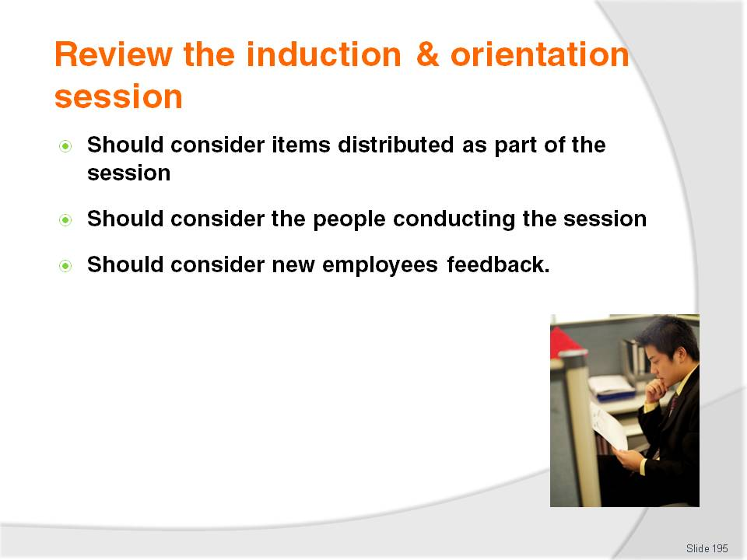
Slide No | Trainer Notes
Trainer continues to provide trainees with advice regarding reviewing induction & orientation sessions:
Consider items handed out as part of the induction – were all the necessary items distributed? Were they current? Did they contain errors or were they incomplete?
Consider person conducting the orientation – looking at whether or not the individual conducting these sessions is the right person for the job. Many people believe conducting an induction session is beneath them and they begrudge doing them. This obviously does not make for effective or positive sessions
Consider feedback from participants – anything a past inductee mentions as an issue for them should be considered. Where there are multiple mentions of the same issue, certainly attention must be paid to this area.

Slide
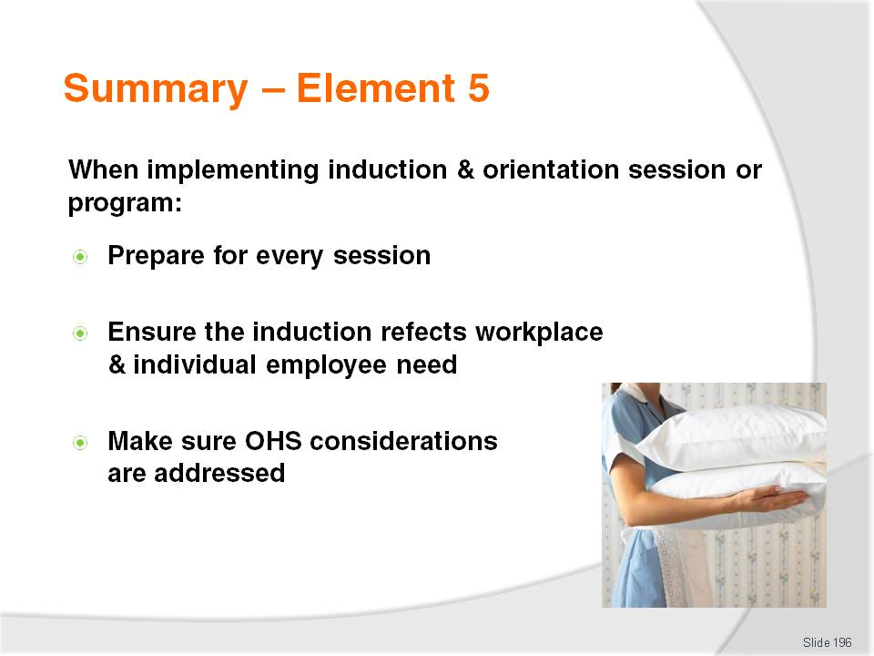
Slide No | Trainer Notes
 | Trainer provides a recap of the Element asking questions to check trainee understanding and responding to questions from trainees, as required.

Slide
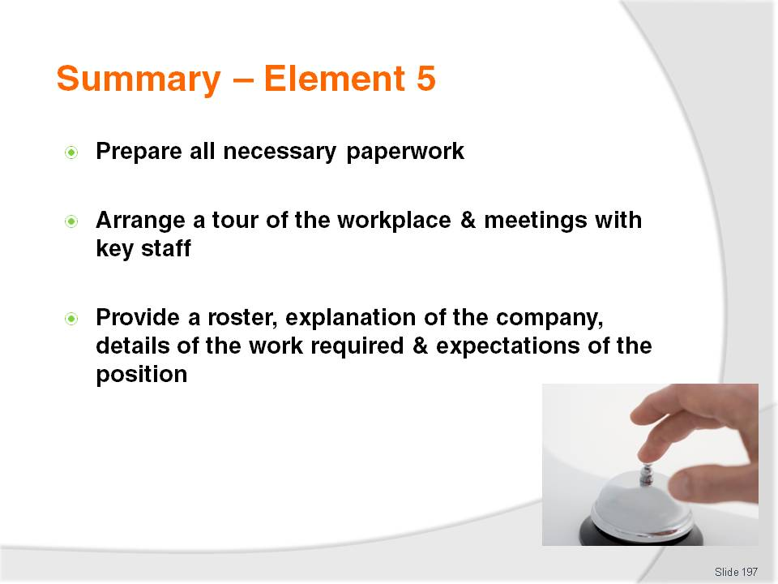
Slide No | Trainer Notes
 | Trainer provides a recap of the Element asking questions to check trainee understanding and responding to questions from trainees, as required.

Slide
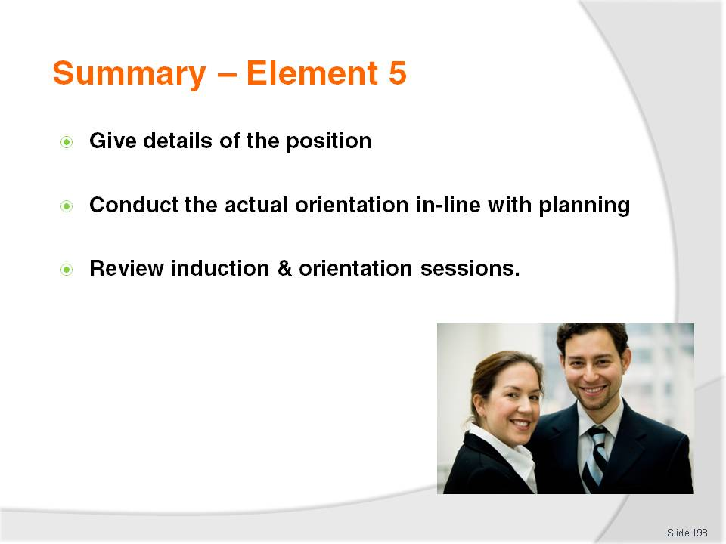
Slide No | Trainer Notes
Trainer provides a recap of the Element asking questions to check trainee understanding and responding to questions from trainees, as required.
Trainer thanks trainees for their attention and encourages them to apply course content as required in their workplace activities.

Recommended training equipment
- Calculators
- Sample enterprise policies and procedures in relation to staffing/the staffing process (recruitment of staff; selection of staff; induction and orientation of staff)
- Sample job advertisements from local newspapers, online sites and employment agencies – to use as examples of jab vacancy advertisements
- Sample organisational charts for a variety of business types/labour divisions – top-down, horizontal and bottom-up
- Sample job-related documentation for the industry sector/labour division, such as:
- Job analysis documentation
- Job Statements
- Job Descriptions
- Job Specifications
- Job vacancy advertisements – from newspapers, recruitment agencies, online recruitment agencies
- Benchmarking - reports or statements for job positions appropriate to the industry sector/labour division
- Key Selection Criteria
- Sample references
- Application forms
- Interview rating sheets
- Letters of Appointment
- Work contracts
- Letters of Thanks and regret
- Staff uniform forms
- Taxation forms
- Superannuation forms
- Event/information kits or packs
- ‘Tips on interviews’ sheets
- Sample ‘Codes of Conduct’ for staff employed in enterprises within the different labour divisions
- Copies of relevant conditions of employment and pay rates for the industry sector and/or country, such as:
- Employment contracts
- Employment instruments appropriate to the country and/or labour division
- Agreements
- Awards
- Copies of relevant legislation for the host country as it applies to the industry sector for:
- Industrial relations
- Equal opportunity (employment related)
- Occupational safety and health.

Instructions for Trainers for using
PowerPoint – Presenter View
Connect your laptop or computer to your projector equipment as per manufacturers’ instructions.
In PowerPoint, on the Slide Show menu, click Set Up Show.
Under Multiple monitors, select the Show Presenter View check box.
In the Display slide show on list, click the monitor you want the slide show presentation to appear on.
Source: http://office.microsoft.com
Note:
In Presenter View:
You see your notes and have full control of the presentation
Your trainees only see the slide projected on to the screen
More Information
You can obtain more information on how to use PowerPoint from the Microsoft Online Help Centre, available at: http://office.microsoft.com/training/training.aspx?AssetID=RC011298761033
Note Regarding Currency of URLs
Please note that where references have been made to URLs in these training resources trainers will need to verify that the resource or document referred to is still current on the internet. Trainers should endeavour, where possible, to source similar alternative examples of material where it is found that either the website or the document in question is no longer available online.

Appendix – ASEAN acronyms
AADCP | ASEAN – Australia Development Cooperation Program.
ACCSTP | ASEAN Common Competency Standards for Tourism Professionals.
AEC | ASEAN Economic Community.
AMS | ASEAN Member States.
ASEAN | Association of Southeast Asian Nations.
ASEC | ASEAN Secretariat.
ATM | ASEAN Tourism Ministers.
ATPMC | ASEAN Tourism Professionals Monitoring Committee.
ATPRS | ASEAN Tourism Professional Registration System.
ATFTMD | ASEAN Task Force on Tourism Manpower Development.
CATC | Common ASEAN Tourism Curriculum.
MRA | Mutual Recognition Arrangement.
MTCO | Mekong Tourism Coordinating office.
NTO | National Tourism Organisation.
NTPB | National Tourism Professional Board.
RQFSRS | Regional Qualifications Framework and Skills Recognition System.
TPCB | Tourism Professional Certification Board.







